Banana Shire Council

Theodore Water Treatment Plant

POWER SYSTEM ANALYSIS
& SITE AUDIT

Rev Nº | Description | Author/s | Reviewed By | Approved By | Issue Date
0 | Issued for Review | L Dias | I Kennedy | I Kennedy | 23/01/2023
1 | Revised as per comments | L Dias | I Kennedy | I Kennedy | 20/02/2023
2 | Revised as per comments | L Dias | I Kennedy | I Kennedy | 04/03/2023

REPORT RPEQ CERTIFIED
NAME: Ian Kennedy
RPEQ NUMBER: 04082
DATE: June 2022

Prepared by:

KW Electric
Unit 2/17 Commerce Circuit
YATALA QLD 4207

Copyright © KW Electric
The concepts and information contained in this document are the property of KW Electric or the sole use of the nominated client for the nominated project. Use or copying of this document without the written permission of KW Electric constitutes an infringement of copyright.

Table of Contents
1 Introduction 3
1.1 Purpose & Scope 3
1.2 Definitions 3
1.3 Abbreviations 4
1.4 Standards 5
1.5 Software 5
2 Switchboard Audits 5
2.1 Purpose 5
2.2 Water Treatment Plant 5
2.2.1 Introduction 5
2.2.2 Findings 6
2.2.3 Conclusion 6
2.2.4 Supporting photos 7
3 Modelling Input Data 7
3.1 Input Data 7
3.2 Assumptions and Clarifications 9
4 Fault Study 9
4.1 Methodology 9
4.2 Fault Level Results 10
4.2.1 Switchboard Prospective Fault Levels 10
4.3 Cable Fault 10
5 Protection Coordination Analysis and Protection Device Settings 11
5.1 Introduction 11
5.2 Water Treatment Plant 11
5.2.1 WTP Protection Devices 11
5.2.2 WTP Protection Coordination 11
5.2.3 Protective Device Summary 12
5.2.4 Protection Findings 13
6 Arc Flash Study 13
6.1 Preamble 13
6.2 Application 14
6.3 Arc Flash Hazard Mitigation 14
6.4 Arc Flash Method of Calculation 14
6.5 Arc Flash Results 14
7 CONCLUSIONS & RECOMMENDATIONS 15
7.1 Site Audit 15
7.2 Protection Study 16
7.3 Arc Flash Study 16
Appendix A - Audit check sheet 18
Appendix B - Recommended Spares 19
Appendix C - Thermal Report 24
Appendix D - Single Line Diagrams 25
Appendix E - Protection Concepts And Guidelines 27
Appendix F - Arc Flash Hazard Mitigation 31
Appendix G - AS3000/2018 Maximum Demand Calculations 43
Appendix H – Arc Flash stickers 44

Introduction
KW Electric conducted a site audit and a power system analysis for the following sites:•Theodore Sewerage Pump Sites (SPS1, SPS2, & SPS3), •Theodore Raw Water Pump Site, •Theodore Water Treatment Plant, •Theodore Wastewater Treatment Plant, in accordance with the brief provided by the Banana Shire Council.
A dedicated software model has been developed for each site using PowerCad, enabling the performance of short-circuit and arc flash analysis. This analysis aims to determine the minimum equipment requirements for each site.
For the purposes of this study, only the main loads at each site were taken into consideration.

Purpose & Scope
The purpose of this document is to determine the condition of equipment at each site.
This report assesses equipment ratings where possible against the short-circuit fault levels, and Arc Flash Analysis. PowerCad has been used to perform the corresponding short-circuit, load flow studies, and Arc Flash analysis.
The report determines the level of arc flash energy presented at each switchboard and the appropriate PPE required.

Definitions
The following definitions used in this report are in accordance with Australian Standards, predominantly AS 3851:
Demand Load – The site measured load current or approximation of the general running conditions.
Diversity – for the purpose of this report is defined as the per cent of time available that a piece of equipment operates at its maximum load. Please note that this definition differs to diversity factor.
Initial symmetrical short-circuit current (Ik”) – r.m.s. value of the a.c. symmetrical component of a prospective short-circuit current applicable at the instant of short-circuit if the impedance remains at zero-time value.
Load Factor – for the purpose of this report this value is multiplied by the rated load value to determine the connected, demand, and design load values.
Steady-state short-circuit current (Ik) – r.m.s. value of the short-circuit current which remains after the decaying of the transient phenomena.
Peak short-circuit current (iP) – maximum possible value of the prospective short-circuit current.
NOTE: The prospective short-circuit current reaches a peak in the first cycle. The magnitude of this peak varies according to the moment at which the short-circuit occurs. The maximum value generally occurs when the short-circuit starts at the zero crossing of the pre-fault voltage waveform.
Prospective short-circuit current – current that would flow if the short-circuit were replaced by an ideal connection of negligible impedance without any change of the supply.
NOTES:
The current in a multiphase short-circuit is assumed to be made simultaneously in all faulted phases.
Without any change of supply’ implies no operation of switchgear or current limiting switching devices such as
current limiting fuses or circuit-breakers.
Short-circuit – accidental or intentional connection, by relatively low impedance, of two or more points in a circuit which are normally at different voltages.
Short-circuit current – current resulting from a short-circuit, due to a fault or an incorrect connection in an electric circuit.
NOTE: It is necessary to distinguish between the short circuit current in the fault and the currents in the network branches.
Subtransient reactance (X”d) of a synchronous machine – effective reactance at the moment of a short-circuit. For the calculation of short-circuit currents the direct axis subtransient reactance saturated value of (X”d) is used.
Symmetrical short-circuit breaking current (Ib) – r.m.s. value of an integral cycle of the symmetrical a.c. component of the prospective short-circuit current at the instant of contact separation of the first pole of a witching device.
NOTE: In AS 3851, Ib is taken as the current in the fault and is not necessarily the current in the switching device.
Arcing Fault Current – the current flowing to a bus fault when the three phases are in contact through an arc. The arcing fault current is calculated from the Bolted Fault Current value using empirical formulae developed by IEEE.
Arc Flash Boundary – the distance from the exposed live parts at which a person could receive a curable burn (2nd degree burn).
Bolted Fault Current – the current flowing into a bus fault when the three phases are in contact and the impedance between them is zero. The value of the bolted fault current corresponds to the Initial Symmetrical Fault Current with zero fault impedance.
Gap – the spacing between bus bars or conductors at the arc location.
Incident Energy – the amount of (arc) energy on a surface at a specific distance from an arc flash. It is calculated using a set of IEEE formulae. The Incident Energy is expressed either as cal/cm2 or J/cm2.
Personal Protective Equipment (PPE) – the PPE category number specifies the required Flame Resistant (FR) Clothing to prevent an incurable burn at the working distance. The PPE category table used in this report is as per the NFPA 70E – 2015 standard.
Trip / Delay Time – the time required for the protective device to operate for the given fault condition. In the case of a relay, the breaker operating time must be added to obtain the fault clearing time. The duration for the induction motor contribution is assumed to be 5 cycles or 0.1 second.
Working Distance – the distance between the arc source and the worker’s body. The arc flash incident energy is calculated at the specified Working Distance.

Abbreviations
ALARP As Low As Reasonably Practicable
BSC Banana Shire Council
CB Circuit Breaker
CBL Cable
CCC Current Carrying Capacity
DB Distribution Board
DOL Direct online
FLC Full Load Current
EF Earth Fault
HV High voltage (> 1kV)
INST Instantaneous Pick Up
JB Junction Box
LRS Liquid Resistance Starter
LT Long Time
LTPU Long Time Pick Up
LTD Long Time Delay
LV Low voltage (≤ 1kV)
MCC Motor Control Centre
MEN Multiple Earthed Neutral
NFPA National Fire Protection Association (of the United States)
OC Overcurrent
PD Protective Device
PF Power Factor
PPE Personal Protective Equipment
PVC Polyvinyl chloride
PC5 PowerCad5
SLD Single Line Diagram
SLG Single Line to Ground
ST Short Time
STPU Short Time Pick Up
STD Short Time Delay
SWA Steel wire armour
TBA To be advised
TCC Time Current Curve
TOL Thermal Overload (Relay)
TX Transformer
SPS1 Theodore Pump Sites SPS1
SPS2 Theodore Pump Sites SPS2
SPS3 Theodore Pump Sites SPS3
RWPS Theodore Raw Water Pump Site
WTP Theodore Water Treatment Plant
WWTP Theodore Wastewater Treatment Plant

Standards
The Standards referenced in this report are listed below.
Standards | Standard Description
AS 2067:2016 | Substations and high voltage installations exceeding 1 kV a.c.
AS/NZS 2081:2011 | Electrical protection devices for mines and quarries.
AS 60076.5:2012 | Power Transformers Part 5 – Ability to withstand short-circuit
AS/NZS 3000:2018 | Electrical installations (known as the Australian/New Zealand Wiring Rules)
AS/NZS 3007:2013 | Electrical equipment in mines and quarries – Surface installations and associated processing plant
AS/NZS 3008.1.1:2017 | Electrical installations—Selection of cables Part 1.1: Cables for alternating voltages up to and including 0.6/1 kV—Typical Australian installation conditions
AS/NZS 61439.1:2016 | Low-voltage switchgear and control gear assemblies – Type-tested and partially type-tested assemblies
AS 3851:1991 (R2015) | The calculation of short-circuit currents in three-phase a.c. systems
AS 60076.5:2012 | Power transformers, Part 5: Ability to withstand short circuit
IEC 60909 (Series) | Short-circuit currents in three phases a.c. systems
IEEE 551:2006 | IEEE Recommended Practice for Calculating Short-Circuit Currents in Industrial and Commercial Power Systems
IEEE 1584:2002 | IEEE Guide for performing arc-flash hazard calculations
NFPA 70E-2015 | Standard for Electrical Safety in the Workplace
Table 1-1 Standards, Acts, Regulations & Guides Standard

Software
PowerCad 5 (PC5) is the software used to assist with the calculations and analysis throughout this study. PC5 develops a single model for the network and provides the capability to analyse load flows, voltage levels, motor starting, fault levels and current-based protection co-ordination.
Diagrams, including study inputs and outcomes, from the PC5 software have been attached to this report as appendices.
The arc flash module automatically obtains the fault current and operating time from the appropriate software modules of PC5 to calculate the arc flash incident energy. If there is more than one piece of equipment feeding an arc fault, the software module considers the arc fault current and the trip time of each individual piece of equipment to determines the total arc flash incident energy.
The arc flash analysis carried out by the PC5 software is based on the following standards:
• IEEE Standard 1584-2002 – Guide for Performing Arc Flash Hazard Calculations.
• IEEE 551:2006 – IEEE Recommended Practice for Calculating Short-Circuit Currents in Industrial and Commercial Power Systems.
• NFPA 70E-2015 – Standard for Electrical Safety in the Workplace.

Switchboard Audits

Purpose
The purpose of the audit is to determine the condition and compliance of the switchboards and to recommend spare parts and operating risk controls to meet compliance and safety standards.
Council has a duty to ensure that electrical equipment is electrically safe. Electrical Safety Act 2002.
Generally, no indication of RCD testing on switchboards, or tests not up to date.

Water Treatment Plant

Introduction
The switchboard is in poor condition. The audit check sheet is shown is appendix A. Thermal images are shown in Appendix C.

Findings
Issue | Description | Solution
1 | Circuit breakers are suitable for operator use however the Quick lag circuit breakers are no longer in production. The busbar chassis that the circuit breakers connect to is also redundant and no other circuit breakers will fit this chassis. The insulation on the chassis is brittle and cracked posing a risk of flash over. | Upgrade to a new distribution board.
2 | The clear water pump thermal overload is over 50 years old and not able to be tested or replaced. | Install new thermal overloads for the pumps
3 | Distribution DB also has unavailable Quick lag circuit breakers. The insulation on the chassis is brittle and cracked posing a risk of flash over. | Replace DB
4 | Electrical Schematics are not available | Re draft schematics
5 | Aged electronic components are at 51deg and susceptible to failure. | Replace with modern components
6 | The main switch is very old and corroded and subject to mechanical failure during operation. As well as operational downtime risk it has an arc flash risk. | Replace main switch
7 | The pump main switches are very old and corroded and subject to mechanical failure during operation. As well as operational downtime risk it has an arc flash risk. | Replace
8 | There is burnt wiring in the switchboard that melted a duct cover. This was very close to setting the switchboard on fire. | Replace burnt wiring and faulty components
9 | Soft starter is mounted horizontally on switchboard floor. Not recommended by manufacturer as the heat sinks will heat the internal components. Showing a temp of 42 degrees. Evidence of burnt wires and covered in mud. | Mount soft starter vertically and install fans.
10 | There are terminals in most cubicles that are IP0X, meaning electric terminals have no protection from inadvertent brushing and electric shocks. This is a working live situation for electricians. | Undertake risk assessment for working live. Most organisations do not allow working live except for testing or if equipment has at least IP2X protection.
11 | There are terminals on the rear of swinging doors that are IP0X (no protection). Needs to be IP2X and have a latch for holding door open, so it does not close on a person. | Replace components on switchboard door with IP2X components or cover with Perspex and fit door stay.
12 | Evidence of water in switchboard | Build a concrete plinth

Conclusion
This switchboard was well built in its day but has had modifications and components are no longer fit for operational reliability or safety.
Recommend replacement of whole switchboard.

Supporting photos
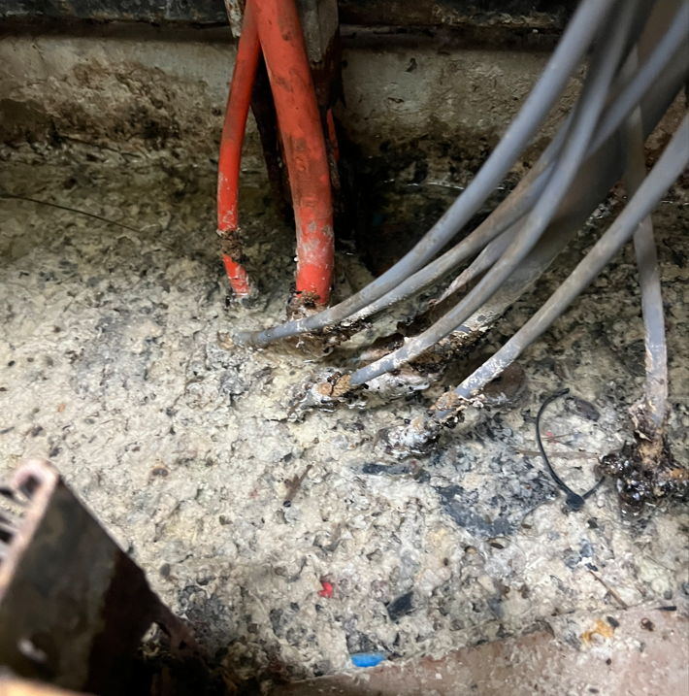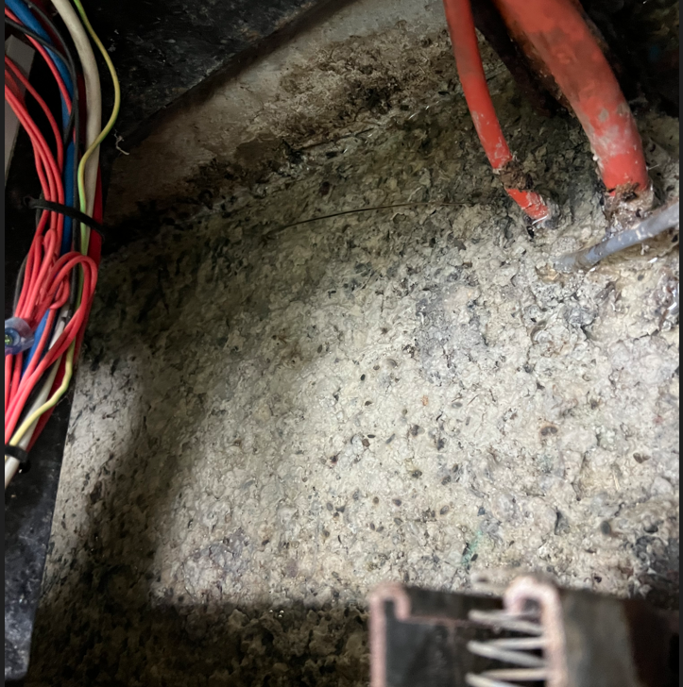

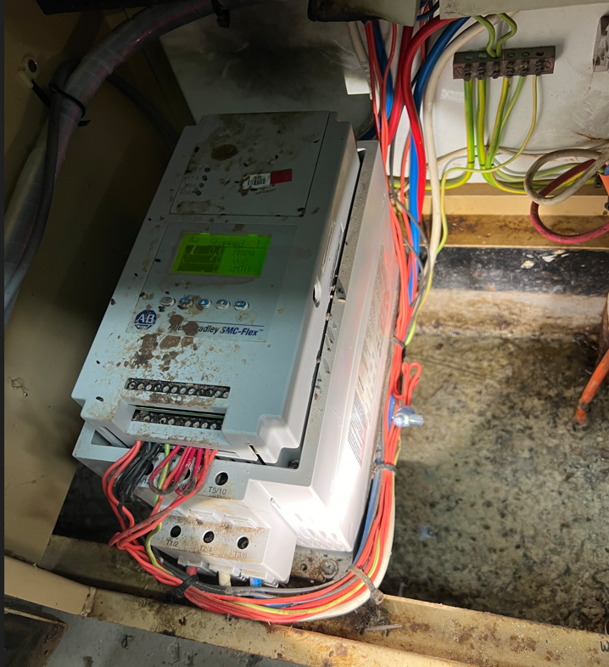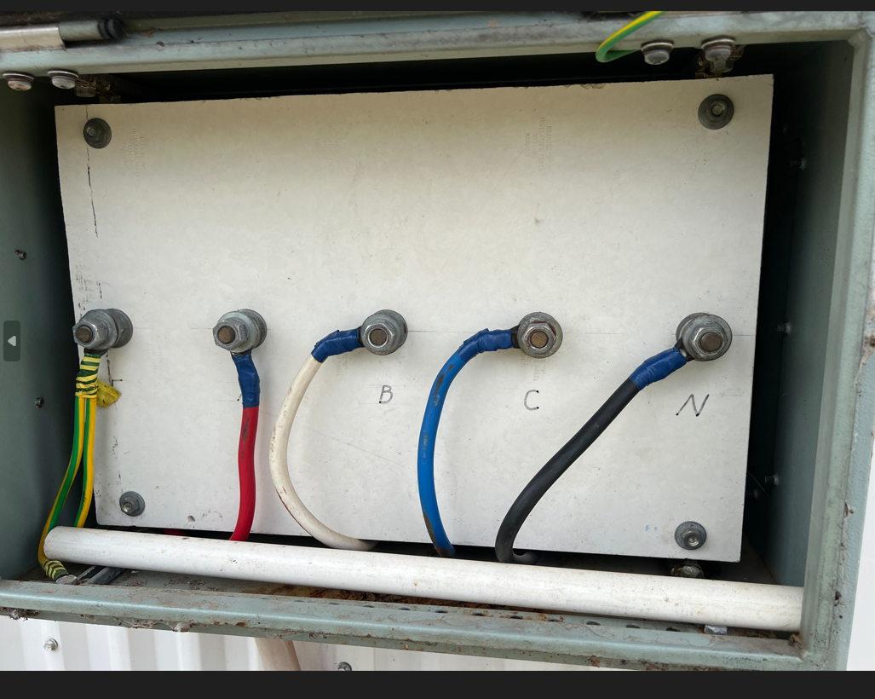

Modelling Input Data

Input Data
KW Electric has based this study on data gathered on site during site visits on 7th and 8th of October 2023.

The PC5 input data used in the production of the output reports is detailed below. The drawing identifies the major parameter values against the relevant items of plant. Values nominated are the basis for the ensuing analyses. Other data that has been used in the compilation of this power system study includes:

- Drawings – Single line diagrams
- Cable sizes and lengths
- Transformer data

In instances where engineering data was unavailable and site verification was not possible, engineering assumptions were necessary to model the power system in PC5. A summary of the assumptions can be found in section 3.2.

A summary of the input data used for the generator at Theodore Water plant site is as shown in Table 3-1.

Item Number | Item description | Size (kVA) | Rated Current  (A) | Rated Voltage  (V) | Xd" | Xd' | Xd | Xo | PF
G-01 | Water treatment plant Generator | 60 | 83.5 | 415 | 0.11 | 0.16 | 2.08 | 0.09 | 0.8
Table 3-1 Generator Input Data

The summary of transformer input data is presented in Table 3-2. In instances where impedance values were not provided, standard transformer impedance values from AS 60076.5 were utilized. Primary and secondary current values were calculated since the nameplate couldn't be visually inspected (applicable to pole-top transformers).

Since all transformers were pole-mounted and visual inspection for identification was not possible, pole numbers were collected as an alternative means of identification.
Site | Pole ID | Rating (kVA) | Primary (V) | Primary (A) | Secondary (V) | Secondary (A) | %Z
Theodore Water Treatment Plant | SP261187 | 100 | 11000 | 5.2 | 415 | 139.1 | 4.00
Table 3-2 Transformer Input Data

Cable suitability for expected loading and prospective short circuit levels as calculated in PC5 has been determined using the conductor current carrying capacity and fault withstand ratings listed in Table 3.3. The cable derating factors have been based on cable installation conditions as noted during the site visit, these include (but are not limited to) assumptions for grouping, soil temperature and depth of burial where information was unknown.

The following derating factors have been adopted based on installation conditions:
- Maximum allowable core/conductor temperature of 70° C – 1.00
- (Note, all cables assumed PVC insulated)
- Cable direct buried at depth of 0.5m – 1.00
- Soil Temperature (Ambient) 25° C – 1.00
- Air Temperature (Ambient) 40° C – 1.00
- Soil Thermal Resistivity 1.2°C.m/W – 1.00
- Maximum of 2 circuits in one trench – 0.90
- Maximum of 3 circuits in one ladder – 0.94
- Note: Deratings are obtained from the AS/NZS 3008.1
Site | Description | Cable Tag | Cable Type | Cable Size (mm²) | Voltage | CCC (A) | #  / ph. | Total CCC (A) | Cable Length (m) | Cond. Fault Rating (kA/ 1sec)
WTP | Incoming feed | WTP-I | 0.6/1kV 4C+E XLPE | 185** | 415 | 363 | 1 | 363 | 50* | 32.3
WTP | Generator feed | WTP-GEN | 0.6/1kV 4C+E XLPE | 50** | 415 | 188 | 1 | 188 | 30* | 8
WTP | Clear Water Pump 1 | WTP-P1 | 0.6/1kV 4C+E PVC | 10** | 415 | 59 | 1 | 59 | 2* | 0.9
WTP | Clear Water Pump 2 | WTP-P2 | 0.6/1kV 4C+E PVC | 10** | 415 | 59 | 1 | 59 | 2* | 0.9
Table 3-3 Cable Input Data
*Cable length was estimated from visual inspection
**When the switchboard had no documentation or the documentation did not match with installation, cable sizes were estimated from visual inspection.

A summary of LV Switchboards covered in the study are listed in Table 2.4.

Switchboard Description | Voltage (V) | Current Carrying Capacity (A)
WTP - 415/240V MAIN SWITCHBOARD | 415 | 200*
Table 3-4 Switchboards

* Ratings have been assumed based switchboard/DB circuit breaker ratings.

Assumptions and Clarifications
The following assumptions have been necessary in the preparation of this study:

• Where transformer impedance values are unavailable, these are assumed to be typical values of impedance and voltage for transformers with two separate windings, as nominated in AS/NZS 60076.5:2012 Clause 3.2.2.3 Table 1 for the appropriate transformer rating.
• The transformer X/R ratio for transformers smaller than 10 MVA is 10 (in accordance with AS 3851 clause 7.3).
• The current carrying capacities and short circuit withstand of all cables are determined using AS/NZS 3008.1.1
• Loads noted as “Estimated” on the load list have been calculated based on available data
and site comment.
• Loads noted as “Confirmed” on the load list have been either confirmed from site drawings or site verification of nameplate data.

Fault Study
This section describes the prospective fault levels calculated for major switchboards and cables throughout the distribution network.

Methodology
The prospective maximum fault level results are based on the PowerCad 5 IEC 60909 fault level calculation module. This calculation method can be used as the Australian Standard for fault studies, AS 3851, is based upon the IEC method for fault calculation and as such, the Standards are equivalent in practice. The use of pre-fault voltage factors is a conservative method of considering the effects of shunt admittances including passive loads and off-normal transformer tap positions. IEC 60909 uses minimum and maximum voltage factors (c) as shown below in Table 1 from IEC 60909.
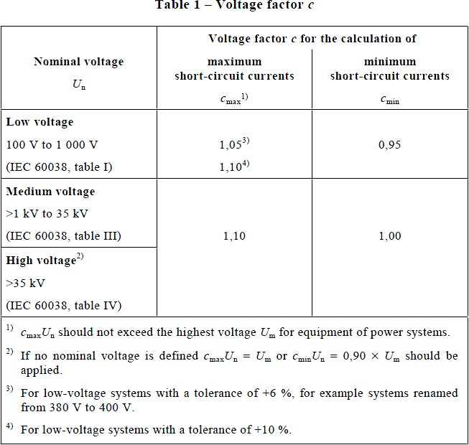
Table 4-1 IEC60909 Voltage Factor c

Although PC5 uses the IEC 60909 calculation method, we have adopted the Australian voltage factors based on AS 3851 as shown below.

Voltage Ranges | cmax | cmin
0 V – 650 V | 1.06 | 0.94
650 V – 35 kV | 1.09 | 0.90
35 kV – 230 kV | 1.10 | 0.90
> 230 kV | 1.10 | 0.90
Table 4-2 AS 3851 Voltage Factor c

Fault Level Results

Switchboard Prospective Fault Levels

The calculated three phase maximum, minimum and single phase to ground bus fault currents are listed in 4.3. They represent the worst-case values in the installation.

Site/ Switchboard | Voltage | Fault Rating (kA) | Min Fault level Ik’’(kA) | Max Fault level Ik’’(kA) | SLG (kA) | Remarks
Theodore water Treatment plant | 415 | unknown | 3.0 | 3.4 | 2.8 | Not enough data
Table 4-3 – Calculated Fault Current

Cable Fault
Prospective fault levels on cables are shown in Table 4-4 below. The results are derived from normal operational scenario. Required protection trip times have been stated in Table 4-4 where the calculated fault current exceeds the conductor fault rating (on the basis of a 1 second fault rating). Where the actual fault level is less than the cable fault rating no required protection trip time is stated, the maximum trip time is to be less than or equal to 1 second to be Protected.

Site | Cable Description | Tag | Cable Type | Cable Size | Cable Fault Rating | Max Fault Level (Ik’’) | Required Protection Trip Time (s) | Remarks
WTP | Incoming feed | WTP-I | 0.6/1kV 4C+E XLPE | 1x185mm² | 32.3 kA/ 1sec | 3.4kA | ≤ 1sec | Protected
WTP | Generator feed | WTP-GEN | 0.6/1kV 4C+E XLPE | 1x50mm² | 8 kA/ 1sec | 3.4kA | ≤ 1sec | Protected
WTP | Clear Water Pump 1 | WTP-P1 | 0.6/1kV 4C+E PVC | 1x10mm² | 0.9 kA/ 1sec | 3.4kA | 3.41kA 0.005sec | Protected
WTP | Clear Water Pump 2 | WTP-P2 | 0.6/1kV 4C+E PVC | 1x10mm² | 0.9 kA/ 1sec | 3.4kA | 3.41kA 0.005sec | Protected
Table 4-4 – Cable Fault Level Summary

Protection Coordination Analysis and Protection Device Settings

Introduction

A protection philosophy, protection specification or basis of design document was unavailable for Theodore water sites.

This protection study covers time current coordination (TCC) curves. These curves show device protection settings against other series protective devices and feeder cable characteristics plotted on the same time/current graph.

The protection settings presented are existing settings.

Water Treatment Plant

WTP Protection Devices
The Theodore WTP main switchboard is equipped with 200A fuses as protective devices. L&P chassis, Ext. Chassis and pumps are equipped with 63A fuses as protective devices, and the MCC Chassis is equipped with 160A fuses as protective devices. PowerCad curves will show the coordination between 200A fuses (MSB Main protection device) and 63A fuses (representing 63A fuses as protective devices for chassis and pumps) and 160A fuses (MCC Chassis).
PowerCad modelling was made considering all fuses are NHP BS Compact

WTP Protection Coordination
Figure 5-5 shows that 63A fuse switch and 200A main fuse switch achieve full discrimination between their time curves.
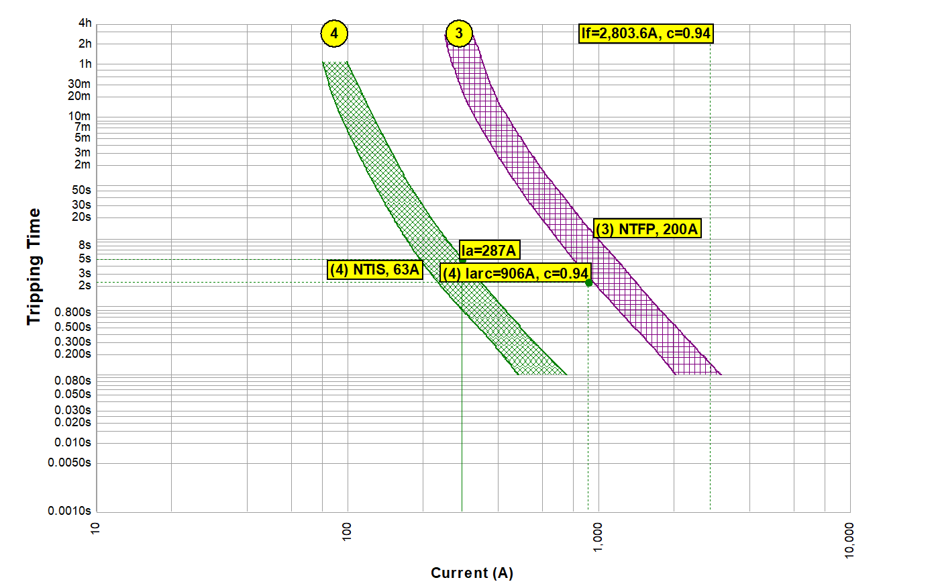
Figure 5-5 – Time/Current curve coordination 1
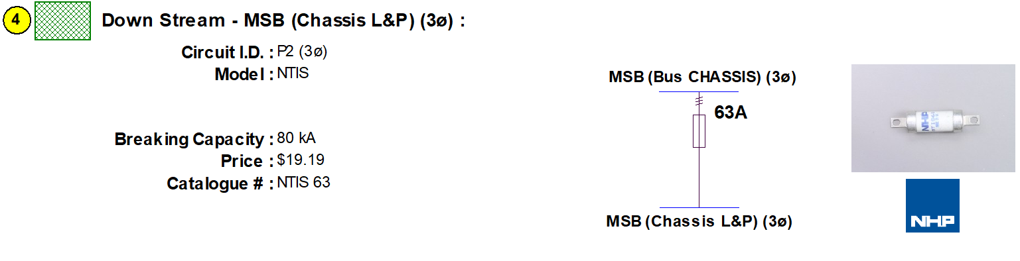
Figure 5-6 shows that 160A fuses and 200A main fuse switch does not achieve full discrimination between their time curves. This amount of overlap is acceptable.
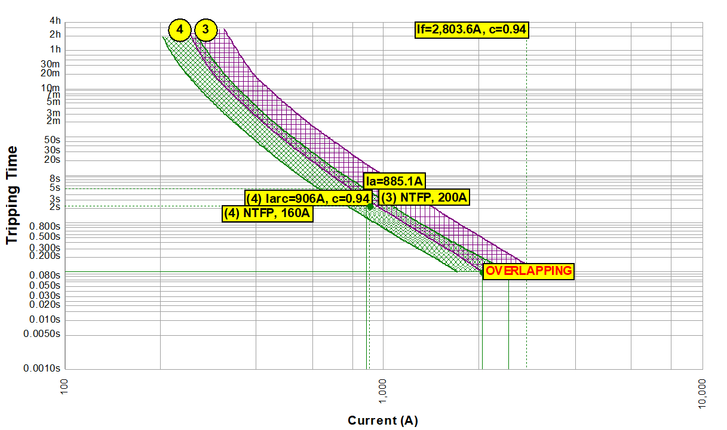
Figure 5-6 – Time/Current curve coordination 2
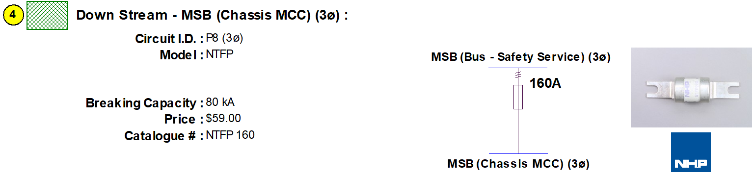

Protective Device Summary
The table below highlights the protective device settings for Time/ Current coordination curve 1.

Circuit Breaker Type | Protection Settings
WTP MSB Main protection device 200A | LPTU = 1 (200A)  INST PU = TBC
WTP protection device 63A | LPTU = 1 (63A)  INST PU = TBC
Table 5-9 Protective Device Settings Summary Coordination Curve 1

The table below highlights the protective device settings for Time/ Current coordination curve 2.

Circuit Breaker Type | Protection Settings
WTP MSB Main protection device fuses 200A | LPTU = 1 (200A)  INST PU = TBC
WTP MMC chassis protection device fuses 160A | LPTU = 1 (160A)  INST PU = TBC
Table 5-10 Protective Device Settings Summary Coordination Curve 2

Protection Findings
The protection configuration also complies with AS3000:2018 Clause 2.5.3 cable current carrying capacity and circuit breaker coordination requirements as shown in the table below. Maximum demand calculations are shown in appendix G.

Cable Description | PC5 Tag | Cable Type | Cable Size | Iz (A)  Derated Cable | Ib (A)  Modelled Demand | In (A)  Nominal Current of Protective  Device | Compliance  Check  Ib ≤In ≤ Iz
WTP Incoming feed | WTP-I | 0.6/1kV 4C+E XLPE | 1x185mm² | 363A | 79.4 | 200A | Compliant
WTP Generator feed | WTP-GEN | 0.6/1kV 4C+E XLPE | 1x50mm² | 163A | 83.5A* | Not Installed | Not compliant
WTP Clear Water Pump 1 | WTP-P1 | 0.6/1kV 4C+E PVC | 1x10mm² | 65A | 53.3 | 63A | Compliant
Table 5-11 Protection Against Overload Current
*Generator full load

Arc Flash Study

Preamble
An arc flash is like a short circuit through the air. During an arc flash, a significant amount of radiant energy is released, which can result in hazardous flames and arc blast. An arc flash can result in severe burns, damage to eyesight and damage to hearing. The pressure waves can also dislodge loose materials such as poorly secured doors and panels with great force. The severity of the arc flash energy is determined by the fault current and the protection device operating time.
AS/NZS 3000:2018 cl. 2.10.3.2 requires that ‘”Switchboards shall be suitable to withstand the mechanical, electrical and thermal stresses that are likely to occur in service, and the environment in which they are installed.
Switchboards complying with the requirements of the AS/NZS 61439 series or AS/NZS 3439 series are deemed to comply with this clause.”
Switchboards greater than 125 Amps and or greater than 10kA fault level need to comply with this standard. So, owners should consider arc flash injuries that could occur in switchboards larger than 125A and or greater than 10kA fault level.
ALL ARC FLASH STUDIES ARE WITH THE SWITCHBOARD DOORS OPEN.
IT IS GENERALLY SAFE FOR PERSONS TO OPERATE SWITCHS AND CONTROLS ON THE SWITCHBOARD DOORS AND ESCUTCHIONS IF THE SWITCHBOARD COMPLIES WITH THE AS/NZS 61439 series or AS/NZS 3439 series.

Application
The new revision of NFPA 70E – 2015 proposes a risked based approach to determining the appropriate safety-related work practices, the arc flash boundary and the required PPE for a given switchboard.

The new standard now provides two approaches to selecting arc flash PPE. As per previous revisions of the standard, the incident energy analysis method is still available with a number of implementation changes. This method is based on the calculation of an incident energy exposure level at a given working distance from the persons face and chest.

The standard has also added the arc flash PPE categories method, which utilises tables to select the appropriate PPE for a given activity and a given installation. The new method has attempted to make it easier for smaller sites/businesses to implement safety around switchgear, where previously it may have been cost prohibitive. When using this method, the new standard effectively provides a worst-case result based on the supplied conditions (and in many cases this may be overly conservative).

It is still beneficial to large commercial and industrial sites to use the calculated incident energy method to determine the arch flash boundary and required PPE. This method uses the calculated incident energy level and Table H.3(b) in Annex H of NFPA 70E – 2015, along with risk assessment to determine the required PPE for a given switchboard. This report has thus provided the required values (Section 6.5.2) in compliance with NFPA 70E – 2015 Clause 130.5(D) for application at the Theodore Water treatment sites.

Arc Flash Hazard Mitigation

There are several options available to reduce the arc flash hazard to personnel in an installation. The two main forms of hazard reduction are segregation and energy reduction. Further detailed examination of these hazard reduction methods can be found in APPENDIX F. It should be noted that the methods used to manage the risk associated with arc flash will vary from site to site and should take into account the state of the electrical equipment and the site operating procedures.

Arc Flash Method of Calculation

This report uses the method laid out in IEEE 1584 which outlines the following steps in performing arc flash hazard calculations. These steps are shown in Appendix F.

Arc Flash Results
The results shown in this section are presented in tabulated format for the relevant switchboards to facilitate simplified reading and interpretation of the arc-flash incident energy calculations. In addition to the overall arc-flash results obtained directly from the PC5 software (as shown in Section 6.5.1 of this document) the tables convey the following information:

  - Switchboard section.
  - Switchboard fault location.
  - Arc-Flash scenario.
  - Nominal system voltage.
  - Arc-Flash boundary.
  - Working distance.
  - Arc-flash incident energy (Cal/cm^2)

The arc-flash incident energy levels calculated for the line and load sides of each switchboard's main switch and main load protective device, considering the switchboards connected to pole-mounted transformers, are indicated in Table 6.1. For the Water Treatment site, we have also provided calculations considering the supply coming from the generator; the results are shown in Table 6.2. The emphasised results represent the highest incident energy in each switchboard.
Working Distance; is the nominal distance a person’s torso is from the exposed electrical components or working arm’s length.
Arc Flash Boundary; Is the distance a person without additional PPE.

Site | Description | Arc-Flash Scenario | Nominal System  Voltage (kV) | Arc-Flash Boundary (mm) | Working Distance (mm) | Arc-Flash incident  Energy (cal/cm^2)
WTP | Main Switch | Line  Side | 0.415 | 493.8 | 455 | 1.4
WTP | Main Switch | Load Side | 0.415 | 593.8 | 455 | 1.9
WTP | Ext Chassis – Main Switch | Line  Side | 0.415 | 495.9 | 455 | 1.4
WTP | Ext Chassis – Main Switch | Load Side | 0.415 | 292.8 | 455 | 0.6
WTP | L & P Chassis – Main Switch | Line  Side | 0.415 | 496.7 | 455 | 1.4
WTP | L & P Chassis – Main Switch | Load Side | 0.415 | 292.4 | 455 | 0.6
WTP | MCC Chassis – Main Switch | Line  Side | 0.415 | 495.7 | 455 | 1.4
WTP | MCC Chassis – Main Switch | Load Side | 0.415 | 520.3 | 455 | 1.5
WTP | Clear Water Pump - Circuit Breaker | Load Side | 0.415 | 268.4 | 455 | 0.5
Table 6-1 Arc Flash Results

Site | Description | Arc-Flash Scenario | Nominal System  Voltage (kV) | Arc-Flash Boundary (mm) | Working Distance (mm) | Arc-Flash incident  Energy (cal/cm^2)
WTP | Ext Chassis – Main Switch | Load Side | 0.415 | 438.4 | 455 | 1.2
WTP | L & P Chassis – Main Switch | Load Side | 0.415 | 438.4 | 455 | 1.2
WTP | MCC Chassis – Main Switch | Load Side | 0.415 | 520.3 | 455 | 1.5
WTP | Clear Water Pump - Circuit Breaker | Load Side | 0.415 | 439.5 | 455 | 1.2
Table 6-2 Arc Flash Results Generator connected

Arc Flash Stickers have been added to each switchboard and entry as detailed in Appendix H.

CONCLUSIONS & RECOMMENDATIONS

Site Audit
They audit highlighted, major and several minor issues. The major issue is the WTP switchboard.

It is unsafe with many non compliant hazards. The equipment is outdated and redundant.

- We recommend full replacement of this switchboard. We recommend installing some interim protection devices in the WTP such as an arc flash detection device until a new switchboard can be manufactured.

- We recommend the design and installation of a generator circuit breaker.

Protection Study

Protection for selected devices at the Theodore water plants switchboards have been reviewed and a proposed set of protective device settings has been presented.

TCCs for the systems are included in Section 5.

In some cases, where improved coordination was not possible due to equipment limitations (i.e. circuit breaker size, non-adjustability or fuses), comments or recommendations have been made to rectify or mitigate potential issues.

We recommend a protection be carried out on Raw Water switchboard.

Evaluated parameters | Evaluation criteria | Evaluation outcome
All Switchboards Protected from Overload | Upstream protection device to trip when it is loaded in excess of the rated current of the respective switchboard. | PASS
Incoming Protective Device trips for min and max faults in INST region | Upstream protection device to trip instantaneously during the maximum and minimum short circuit condition. | PASS
Coordination and Protective devices | Discrimination shall be provided between protective device up to the level of an arcing fault current. | PASS*
Table 7-1 Protection Coordination Evaluation

*Except for the Raw Water switchboard, all other switchboards have passed.

Arc Flash Study

Arc flash results have been obtained from PowerCad 5 with system voltages, arc flash boundaries, working distances and arc flash incident energy levels being generated for each switchboard. Arc flash results are highly dependent on the protection settings implemented in section 4 and thus operators should be aware that any modifications to the specified protection settings will affect the arc flash incident energy and boundary results generated in this section of the report. The results of the calculations have been detailed in section 5.5.2.

The following general comments and recommendations are made with respect to the arc flash study:

1. Switchroom doors and switchboard incomer cubicles shall be provided with suitable labelling, indicating that an Arc Flash hazard exists. The label shall include the following details:
a. Nominal system voltage
b. Arc flash boundary
c. Incident energy level and/or minimum arc rating of clothing and/or site specific level of PPE.

2. It is recommended a low voltage rescue kit is located in each switchroom.

3. Consideration should be given to PPE requirements for non-electrical workers in areas where an arc flash hazard exists.

4. In the case of this report, incident energy values have been calculated and NFPA 70E – 2015 Table H.3(b) was used in order to determine the required PPE.

If incident energy values are not to be used, NFPA 70E – 2015 Table 130.7(C)(15)(A)(a) ‘Arc Flash Hazard Identification’ identifies the requirement for PPE while performing specific tasks. It must be noted that the results of an incident energy analysis to specify an arc flash PPE category using table 130.7(C)(16) of NFPA 70E is not permitted.

5. It is recommended that the arc flash risk assessment be updated when a major modification or upgrade occurs. In addition, the evaluation should be reviewed every 5 years (as per the requirements of NFPA 70E-2015 Clause 130.5).

6. Council electrical specifications should detail the target levels for equipment incident energy, standardised PPE requirements, labelling templates, definition of periodic review timeframes, company approach to specification of new equipment (including arc fault containment requirements) and other relevant information.

7. It is recommended that any procedure for live work, switching, testing and maintenance, or operations be updated/completed to ensure personnel are informed of:
a. The arc flash hazards that exist.
b. Their obligations to reduce the risk to ALARP when working on a switchboard with the potential for an arc flash.

8. It is recommended that the operation of each protection relay is regularly tested at a maximum interval of 1-2 years. (This also includes the arc flash detection system if one exists)

9. Particularly in areas subject to vibration, it is recommended that thermographic testing of circuit breakers, contactors, and terminals is conducted annually, to identify burnt-out or welded contacts and loose terminations.

10. It is recommended that available mitigation techniques be reviewed and implemented where possible to reduce the arc flash hazards to ALARP.

11. In order to reduce excessive arc flash incident energy levels, arc flash hazard mitigation techniques such as segregation (e.g. remote racking, boundaries, signage) and energy limitation (UV detection) could be implemented.

12. Protection against arcing fault currents while the equipment is in service, or is undergoing maintenance, shall be provided for switchboards rated at 800A or greater per phase.

Appendix A - Audit check sheet

Appendix B - Recommended Spares

Appendix C - Thermal Report

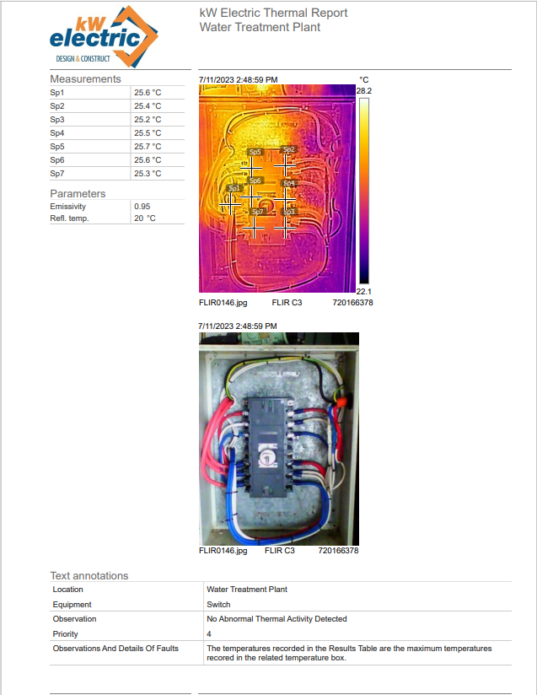

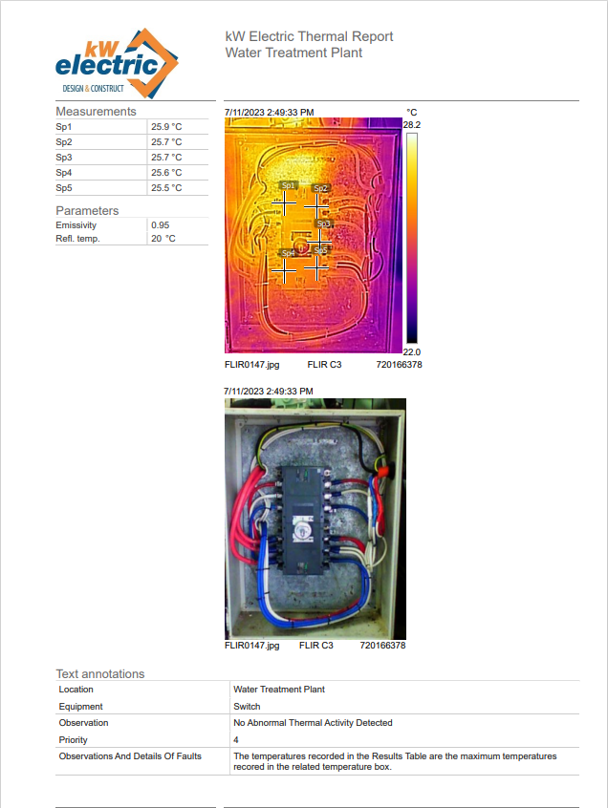

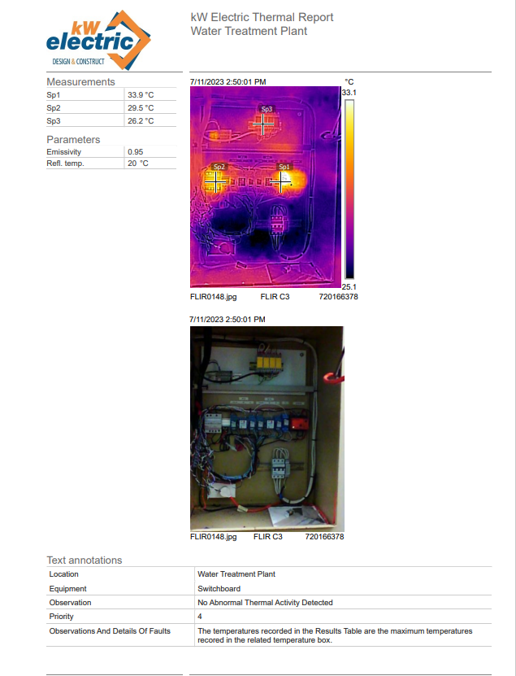

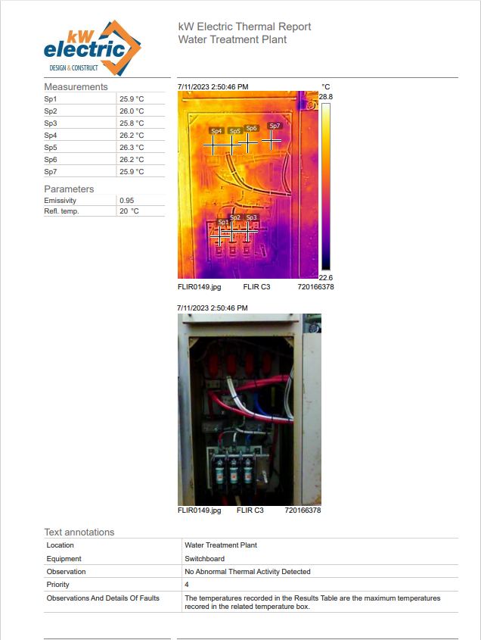

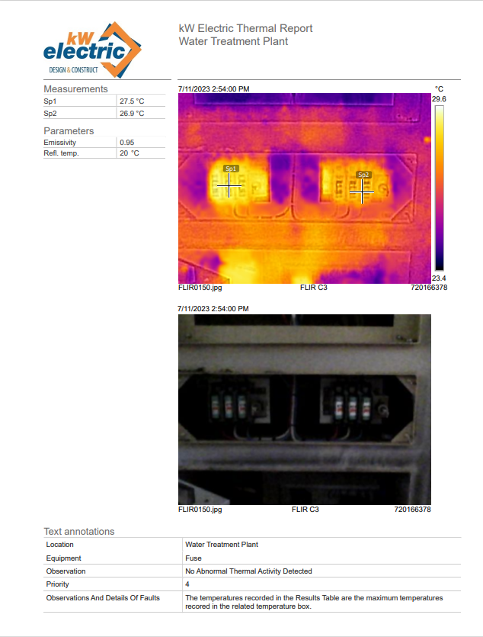

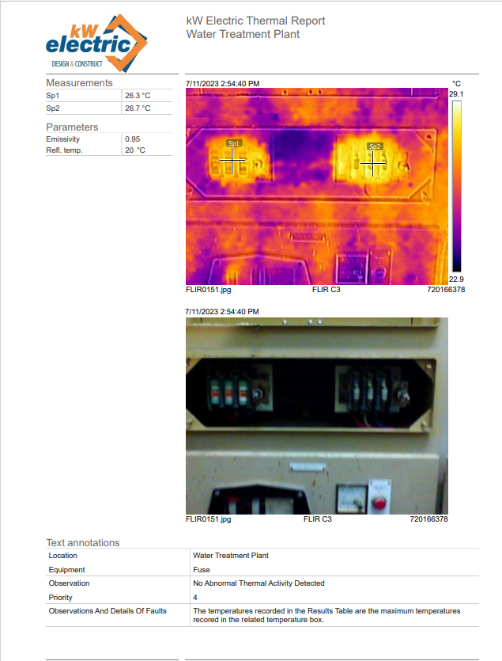

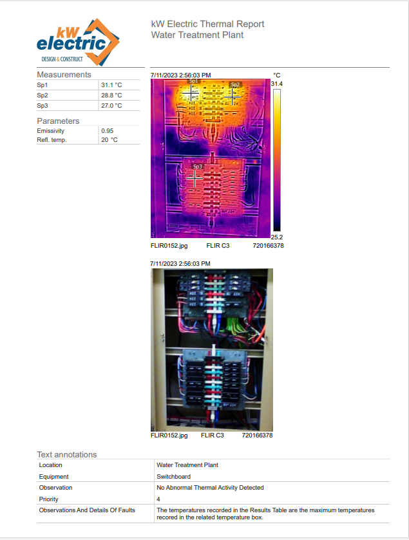

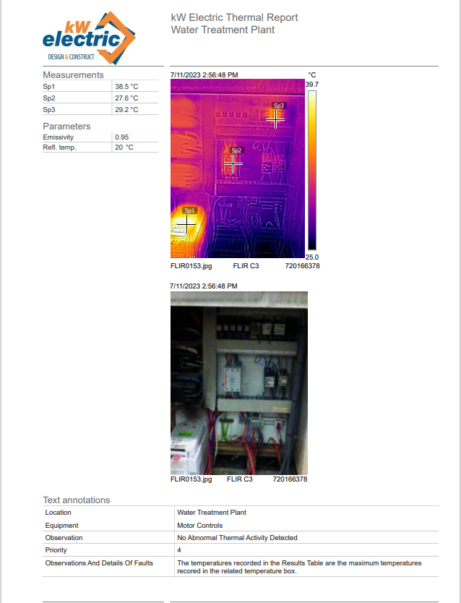

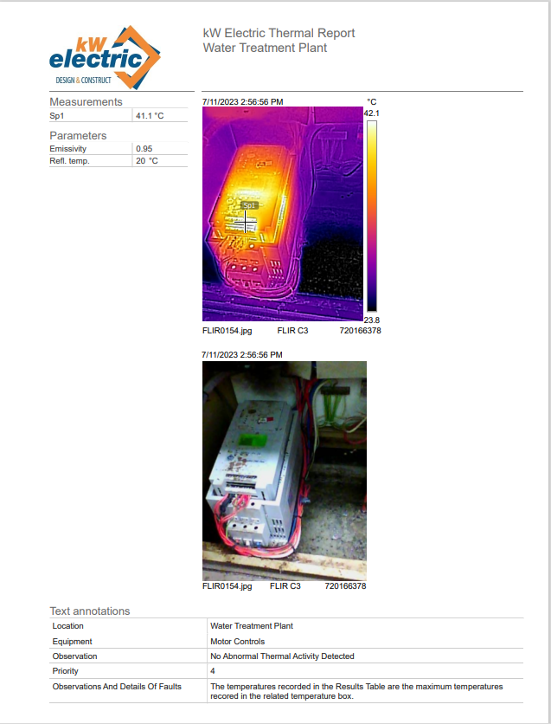

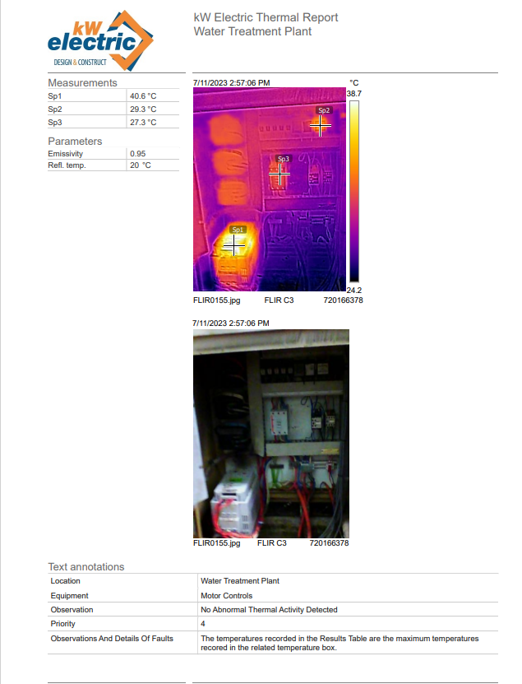

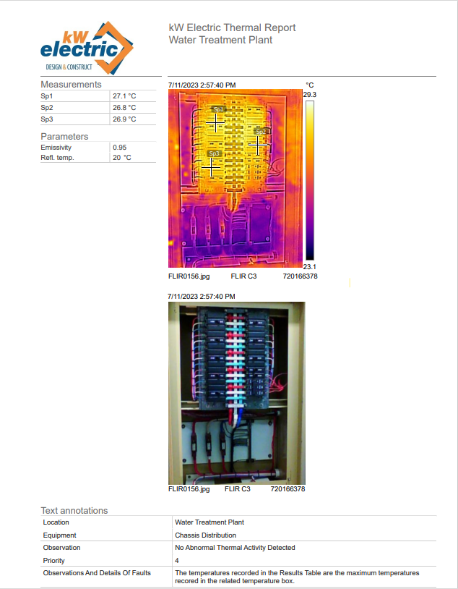

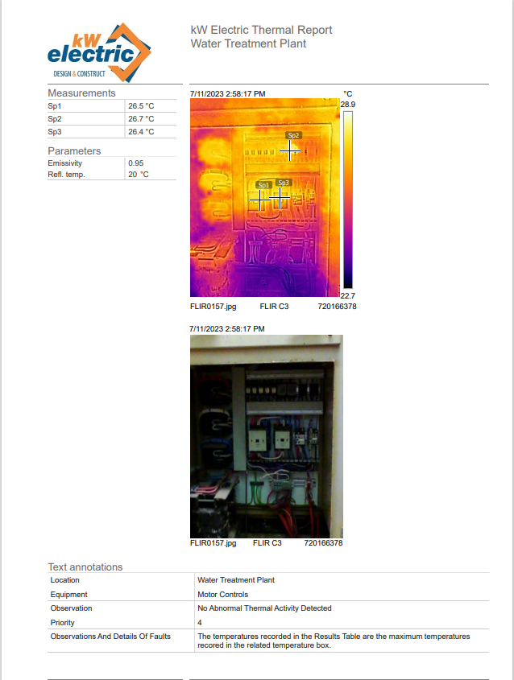

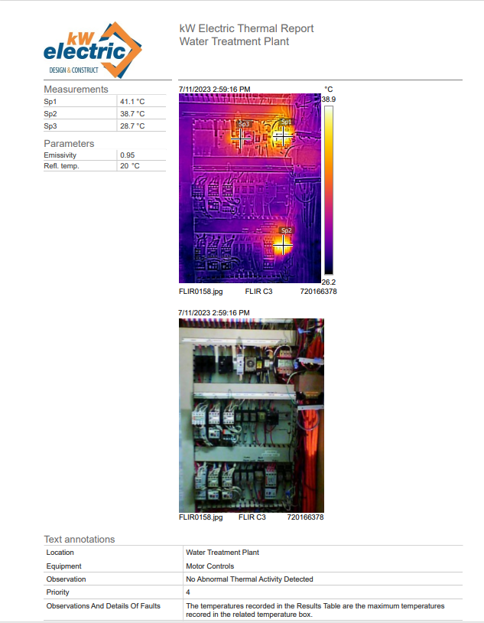

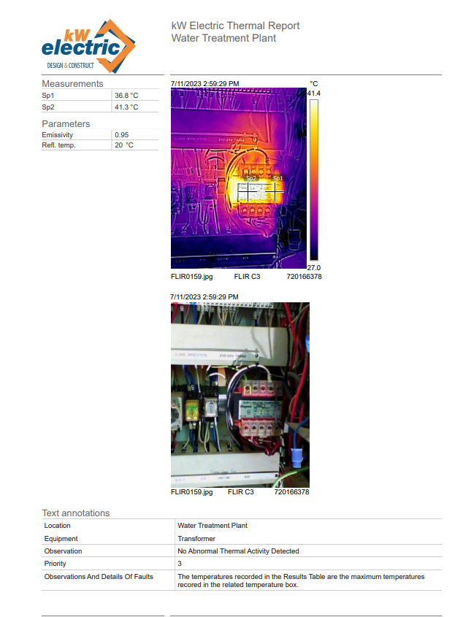

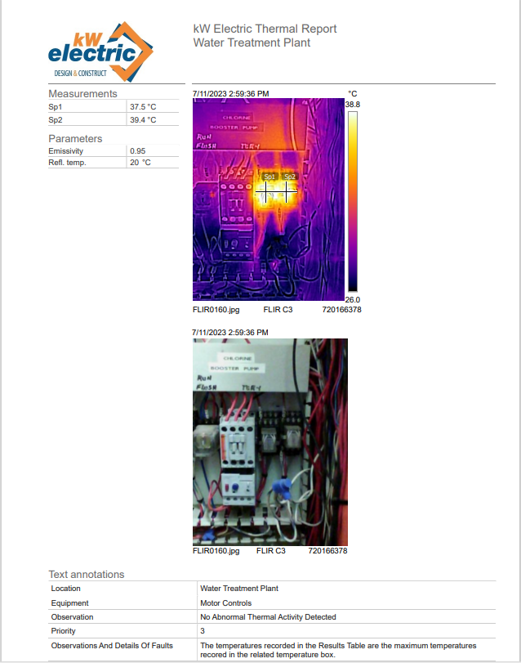

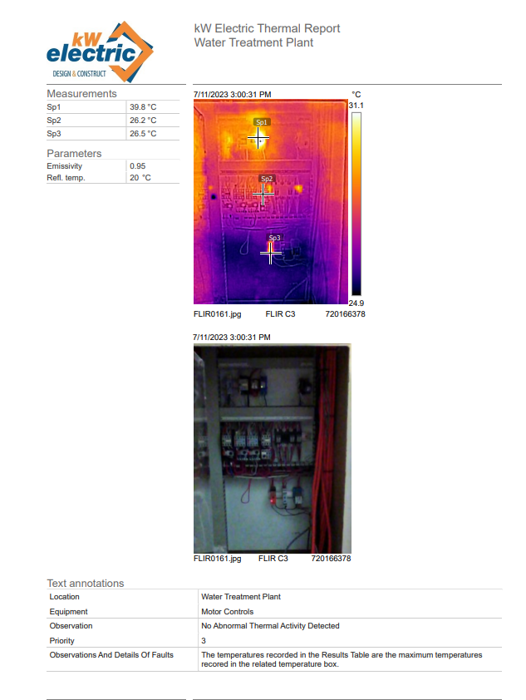

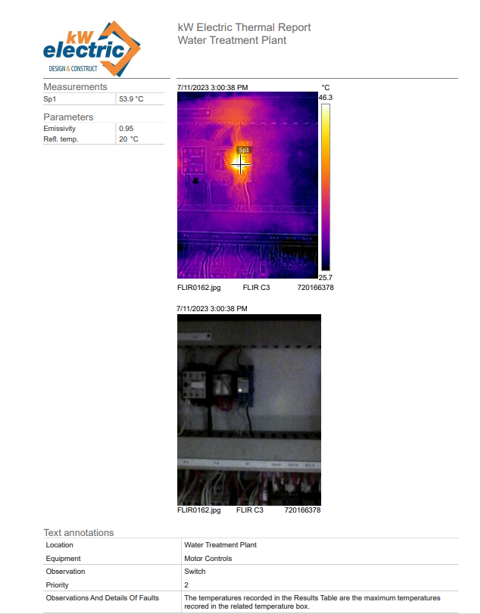

Appendix D - Single Line Diagrams

- Theodore Water Treatment Plant
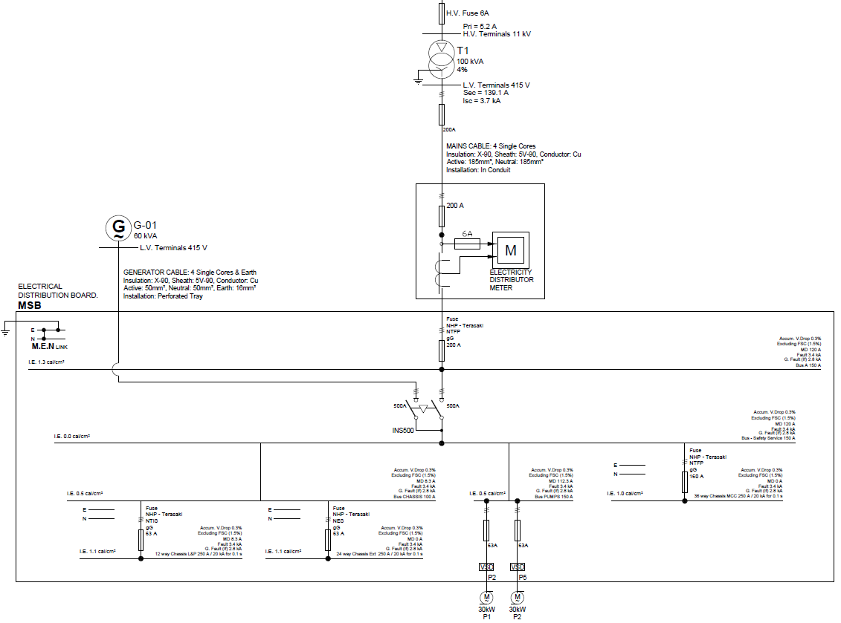

Appendix E - Protection Concepts And Guidelines

The following section outlines some of the principles followed in the review and design of the protection scheme.

Conventional Time/Current Coordination (TCC)
General Principles
Overcurrent protection is the fundamental method used to limit the damage to electrical systems in the event of a short-circuit fault. Basic overcurrent protection schemes will be found on virtually every electrical circuit. Even circuits which are protected by highly sophisticated technologies will generally retain overcurrent protection as a backup measure.
In general, every circuit in an installation will be individually protected by an overcurrent device— either a fuse, or a circuit-breaker with or without a protection relay. Since any one fault could be seen by several protective devices, it is usual to coordinate the protective devices so that the one closest to the fault will trip, and the others do not—this limits the number of circuits which are tripped.
Overcurrent coordination may be achieved using current alone (instantaneous trips), by time alone (Definite Time), or by a combination of current and time (inverse time tripping curves).
Current-only coordination between any two protective devices is only applicable where there is significant circuit impedance (e.g. a transformer) between them, and hence cannot be used in the majority of cases. For example, coordination between the incomer and feeders on a switchboard cannot rely on current-only coordination.
Time-only coordination has general applicability, but it has the disadvantage that the selected time delay intervals must be a compromise between the need for a suitable delay on transient overload conditions (to avoid spurious trips), and the need to trip quickly on heavy fault conditions (to minimize damage). It is often used for situations where the additional damage caused by slow tripping is minimal (for example, for earth fault trips where the earth fault current is limited by earth impedance). In such circumstances, a simple time-only coordination scheme is easy to set up and offers improved timing precision (compared to the time-and- current schemes).
The overwhelming majority of installations use coordination by both time and current. In such schemes, each protective device has an inverse-time tripping curve, where low faults give rise to a trip after a long delay, and high faults give rise to a trip after a much shorter delay.
Coordination of such devices involves plotting the trip curves of each device on a common time/current graph (or the computerized equivalent) and ensuring that the curves remain separated from their neighbors by a suitable grading margin. If the curves touch, this represents a loss of coordination. This loss of coordination is not always an accident: sometimes it is done deliberately (for example, to protect a contactor with a fuse for high faults).
Sometimes, due to other constraints, a loss of coordination cannot be avoided—coordination is only one design goal; sometimes other goals such as the mitigation of damage will have a higher priority.
Modern electronic protection relays offer standardized curves of Inverse Definite Minimum Time (IDMT) form—the “Definite Minimum Time” part of the acronym means that at very high fault
currents, the relay will impose a minimum tripping delay—equivalent to a Definite Time curve. Such curves are easier to coordinate than those which have no minimum time.

Relay Coordination Rules

The following general design guidelines were used when selecting overcurrent relay curves. Sometimes, system constraints mean that not all of these rules can be honored:
- A current-grading margin between current pickup settings of at least 20 % of the lower pickup current is used to cover CT and relay error.
- Relays are set to grade above the energization inrush of downstream transformers (which is taken as being 1200% of the transformer full-load current, for 0.1 seconds).
- Relays are set to grade above the running/starting curve of downstream motors.
- Relays are set to grade below the damage curves for downstream cables and transformers.
- The overcurrent pickup threshold must be below the minimum prospective steady- state fault current, to ensure that the relay will pick up (and eventually trip) even under the lowest fault conditions.
- A minimum prospective steady-state branch fault current should cause relay pickup in at least two upstream relays, so as to provide a main and a backup protection.
- The Time Grading margin is applied at the point of closest approach of the TCC curves. In general, the discrimination current for a pair of curves will be either the instantaneous trip pickup current of the lower curve (if enabled), or the maximum prospective branch fault current (Ik”) at the downstream relay.
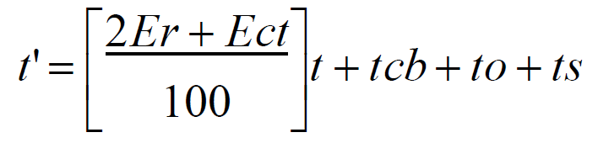
- Where the total time available for grading a group of curves is constrained, allow loss of coordination between feeder and load protective devices on the one circuit, rather than between an incomer and the feeders on a switchboard (e.g., allow reduced grading margin or curve overlap between HV transformer feeder and corresponding LV switchboard incomer). The reason is that if the HV trips first, the footprint of the trip is no worse than if the LV trips (i.e. the trip results in a loss of power to the LV switchboard). If the available grading margin is limited, it is better to use it to ensure coordination between the incomer and the feeders on a switchboard. Endeavour to ensure that relays are coordinated for all prospective fault currents between the minimum steady-state (Ik) and the maximum initial (Ik”) fault currents. When coordinating modern electronic overcurrent relays, we use a time grading margin based on the CT and relay error, relay overshoot, and circuit breaker operating time, with an additional safety margin of 50ms:
Minimum grading margin
Where:
Er is relay basic timing error (e.g. 5 % for typical IED relay).
Ect is CT current-ratio error (generally 5 % for new switchboards and 10 % for older switchboards).
t is the operating time for the lower relay curve at the discrimination point. tcb is the circuit breaker interrupting time (generally 80 ms or less for the new switchboards).
to is the relay overshoot time (35 ms for typical IED relay).
ts is the safety margin (allow 50 ms).

When coordinating Definite Time (DT) curves, the CT error Ect is omitted (set to zero in the above equation); furthermore, the relay’s timing error is reduced to 2 % for DT timing.

- For molded-case circuit-breakers and the like, where the manufacturer’s information provides a tolerance band for the action of the trip unit and circuit-breaker (i.e., the curve on the TCC chart appears as a wide band, rather than a thin line), a time safety margin of 50 ms (for electronic trip units) and 100 ms (for electromechanical or thermal/magnetic trip units) is applied between the tolerance bands.

Coordination of Relays with Fuses

- Extremely Inverse (EI) curves will typically give the best fit to the fuse curve.
- Relays graded above fuses will generally require a pickup current of not less than three times the fuse rating.
- When grading above a fuse, the fuse curve used is the Total Clearance Time.
- When grading above a fuse, the grading margin used is 400 ms (when using fixed grading margins) or 0.4 t + 150 ms (where it is the total clearance time of the fuse at the conditions under consideration).
- At high prospective fault currents, the fuse clearance time will be typically less than 10ms. We assume a minimum time of 10ms under these conditions (giving a grading margin of 154 ms under high fault conditions).
- When grading below a fuse, the relay curve should be graded below a curve calculated as (Fuse Total Pre-Arc Time) *0.75 (i.e. do not exceed 75 % of the total pre-arc time, or the fuse may suffer damage even if it does not blow). Below this curve, use the standard relay grading margin calculated as in Section Relay Coordination Rules.

Instantaneous Trip Elements
There is no coordination between relays whose instantaneous elements have been activated. In general, to maintain coordination, for any fault condition the instantaneous element at just one location in the circuit should be activated. Instantaneous trip elements are of use where there is a significant circuit impedance (for example, a transformer) between the relay under consideration and the next relay downstream, and hence the fault level at the downstream relay is much lower than at the relay being considered. For fault currents which exceed the downstream fault level, we know that the fault must be between the two relays, and hence there is no point in delaying a trip to achieve coordination.
This means that, in general, instantaneous elements should be used with relays on transformer feeders, but not on bus incomers or bus-ties. In general, we set the instantaneous elements in each relay to 120% of the highest prospective branch fault current at the next relay downstream. The 120% factor accounts for CT and relay error, transient overreach in the relay, and uncertainty in the calculated fault current.
For incomers or bus-ties, the downstream fault level and the fault level at the relay will be essentially the same. The instantaneous element is being set higher than the fault level at the relay and will never operate. For this reason, it may as well be disabled (or not physically present). The preference is to disable such elements, rather than setting them to a high trip current, since this makes the situation more obvious to a casual observer and avoids the risk of a spurious trip if the fault level increases at a later date. In cases where arc flash is a concern, it may be necessary to use the instantaneous element on incomers to reduce the incident energy released in the event of an arc fault. In most circumstances where this method is employed it should be noted that discrimination is not present, and trips could result in widespread outage.

TCC with Directional Overcurrent Protection Elements
Directional overcurrent and earth fault relays are used in networks where there are multiple parallel network paths or multiple sources of supply—for example, a conventional distribution switchboard with dual incomers, a ring main, or a power station with multiple generators and a mains connection.
A directional element will respond for a fault on one side of the circuit breaker, but not on the other. The use of directional elements allows the TCC to be set up so that the circuit breaker(s) closest to the fault will trip first. This usually involves two protection elements at each circuit- breaker—a low-set directional element, paired with a high-set non directional element.

Earth Fault Protection
Faults to ground are the most common type of electrical fault. The effective detection and tripping of earth faults is essential for personnel safety and equipment protection.

In general, zero-sequence currents do not pass through power transformers with Delta-Star winding, core type, with transformer star point earthed, so an earth fault will only be seen by protective devices within the one voltage zone. This means that (unlike the case of phase overcurrent) there is no need to coordinate the protection between voltage zones, and there will typically be only a few devices to coordinate within each zone.

For most circuits, there is no intentional flow of earth current, and hence earth-fault trips can be set up to provide sensitive protection. The lower threshold for earth-fault trip settings is determined by the limitations of the measuring equipment—if set too low, the earth fault relays will give spurious trips due to transient conditions such as motor starting or transformer inrush. Triplen (3rd, 6th, 9th etc.) harmonic currents in the circuit can also cause spurious tripping, unless the relay has good harmonic rejection.
Earth-fault (zero-sequence) currents are most commonly detected using a residual connection of the phase CTs. For this method, the practical lower limit for the earth-fault pickup threshold is about 10 % of the CT primary rating (5 % could be used for high precision CTs)—settings lower than these tend to cause spurious trips on transient conditions.
Furthermore, there is likely to be a “phantom” earth fault current which appears during phase fault conditions, which will cause the earth fault element to pick up in the event of a phase fault. This phantom current (resulting from CT error and saturation) could be up to 5 % of the phase fault current. Under phase fault conditions, the phase fault element should trip first (otherwise there may be a loss of coordination). Hence, the earth fault element should be arranged to have a longer tripping time than the phase fault element under phase fault conditions—in other words, the earth fault tripping curve should be above a curve drawn parallel to the phase fault relay curve but with 5 % of the current value.
Typical current pickup range for EF relays is 10% to 40% of the rated current.
HV systems in industrial plants will often use an impedance (resistor or inductor) at the transformer star point to limit the earth fault current to a very low value (typically 50 to 200 Amps, but 10 A is commonly used in coal mining). Impedance earth systems are beneficial to safety (due to reduced touch-voltages) and reduce equipment damage (due to lower fault currents)—however, the following considerations apply:
- The impedance will typically have only a short time rating at its rated current. The worst-case fault clearing time must be less than the impedance rating.
- The impedance current rating represents the maximum earth fault current which could flow. Actual fault currents may be significantly lower (particularly for faults in motor- or transformer windings). To be reasonably sure of detecting a majority of faults, as a rule of thumb we prefer to use relay pickup current settings of not more than 25 % of the impedance current rating. For coordination, some relays will need to have settings significantly lower than this.
- Reliable detection of very small earth currents is not practicable using a residual connection of phase CTs. In general, core-balance toroids will need to be used. Since earth-fault currents are low and damage is limited, Definite Time (DT) coordination is often used for simpler coordination design and improved relay timing precision.
- There is a small risk that the impedance will burn out and go open-circuit. If this occurs, the prospective earth-fault current falls to zero. This means that earth's faults will not be detected. As well as being a safety risk, there is a risk of over-stressing the insulation on the non-grounded phases. As a safeguard against this condition, a NER monitoring relay may be used. In addition, a Neutral Voltage Displacement (59N) trip may be used as a second backup for the Earth Fault trips. Neutral Voltage Displacement cannot detect when the NER is open circuit (until there is an earth fault), or the location of the fault, so it is used as backup protection to trip all sources of supply.

Appendix F - Arc Flash Hazard Mitigation
Arc Flash Calculation Method
- Determine the Bolted Fault Currents
The calculation of bolted fault currents is detailed in section 4 of this report.
- Determine the Arc-Fault Currents
The arc-fault current at the point of concern and the portion of that current passing through the next upstream protective device must be determined.

The calculations put forward in IEEE 1584 are empirically derived and applicable to a system within the following limits:
- Voltages between 208V – 15,000V, three phase (for voltages above 15,000V the Lee Method is used, refer to section 3.1.8.1 of the Standard)
- Frequencies of 50Hz or 60Hz
- Bolted fault currents between 700A – 106,000A
- All grounding types (including ungrounded)
- Equipment enclosures of commonly available sizes
- Gaps between conductors of 13mm – 152mm
- Faults involving three phases.

The three-phase arcing current is found using the following formula:

Log10Ia = K + 0.662Log10Ibf + 0.0966V + 0.000526G + 0.5588VLog10Ibf − 0.00304GLog10Ibf

where:
• Ia is arcing current (kA)
• K
= –0.153 for open configurations and
= –0.097 for box configurations
- Note here that an open air arc will radiate energy in all directions whereas an enclosed arc will radiate energy towards the enclosure opening.
• Ibf is bolted fault current for three-phase faults (symmetrical RMS) (kA)
• V is system voltage (kV)
• G is the gap between conductors (mm) (see Table 4 IEEE 1584).

For applications with a system voltage of 1000V and above the following equation is used:

Log10Ia = 0.00402 + 0.983Log10Ibf

The high voltage case makes no distinction between open and box configurations. In this case:

I = 10Log10I a
a

- Find the Protective Device Characteristics and the Duration of the Arcs

For the calculation of incident energy, the fault clearing time of all protective devices is required. The fault clearing time is the time required for the protective device to break the fault current and extinguish any arc.

Where fuses are installed, the fuse fault clearing time must be used. Where only the fuse melting time is available, add 15% to the melting time up to 0.03 seconds and 10% above 0.03 seconds. If the arcing fault current is greater than where the fuse melting curve passes through 0.01 seconds, use 0.01 seconds as the clearing time.

For circuit-breakers with integral trip units the manufacturer’s time-current curves should include both tripping and clearing times. This assumption should be confirmed in the equipment documentation.

For relay-operated circuit-breakers the time-current curves will only show the relay operating times. The circuit-breaker fault clearing time must be added to the relay operating time.

- Document the System Voltages and Classes of Equipment

This process assigns the equipment nominal voltage and class of equipment. Different classes of equipment will have different typical conductor spacing. For example, 15kV switchgear may have a bus spacing of 152mm, whereas a low voltage MCC may have a bus spacing of 25mm.

Where actual conductor spacing is not known, the values from Table 2 (below) of IEEE 1584 have been used.
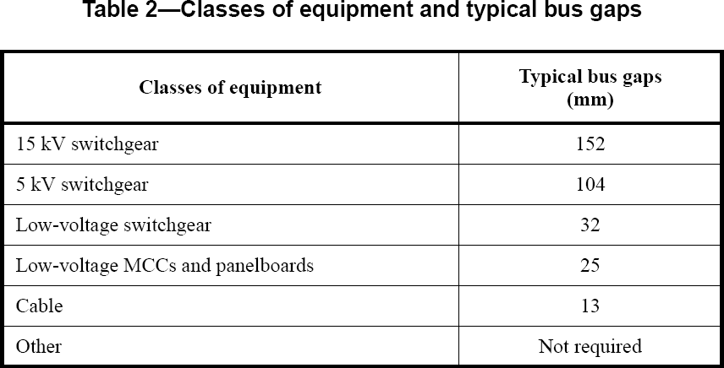

- Select the Working Distances
This process assigns the working distance based upon the class of equipment. Different classes of equipment will have different typical working distances. For example, 15kV switchgear may have a working distance of 910mm, whereas a low voltage MCC may have a working distance of 455mm.

The working distances used in this study have been taken from Table 3 (below) of IEEE 1584.

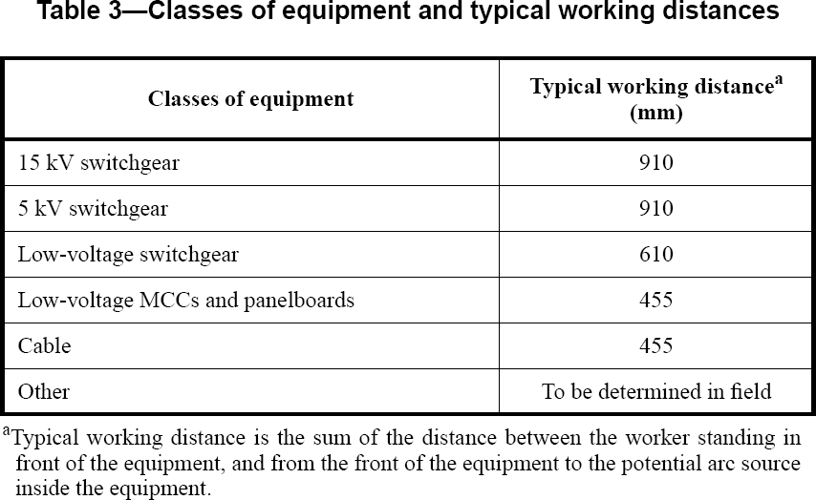

- Determine the Incident Energy for All Equipment
PC5 calculates the incident energy using the methods described in section 3.1.8.1 of IEEE 1584. Note that for cases where the voltage is over 15kV or the conductor gap is outside the range of 13-152mm then the Lee Model is used. The Lee method is described below in the following section. PC5 automatically determines the correct model to use and calculates the result to the standard.

The calculation begins by taking the log10 of the incident energy normalized (En) using the expression below. This equation is based on data normalized for an arc time of 0.2 seconds and a distance from the possible arc point to the person of 610mm.

Log10En = K1+ K2 +1.081Log10Ia + 0.0011G

where:
- En is incident energy (J/cm2) normalized for time and distance
- K1
= –0.792 for open configurations (no enclosure) and
= –0.555 for box configurations (enclosed equipment)
- K2
= 0 for ungrounded and high-resistance grounded systems and
= –0.113 for grounded systems
- G is the gap between conductors (mm) (see Table 4 IEEE 1584).

The value for En is then calculated using:
E = 10Log10En
n

Finally, the incident energy is converted from the normalized value to suit the specific installation being considered:

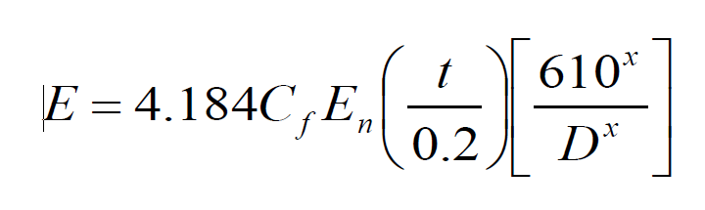
Where:
- E is incident energy (J/cm2)
- C_{f} is a calculation factor
= 1 for voltages above 1kV, and
= 1.5 for voltages at or below 1kV
- E_{n} is incident energy normalized (J/cm2)
- t is arcing time (seconds)
- D is distance from the possible arc point to the person (mm)
- x is the distance exponent from Table 4 of IEEE 1584 shown below.
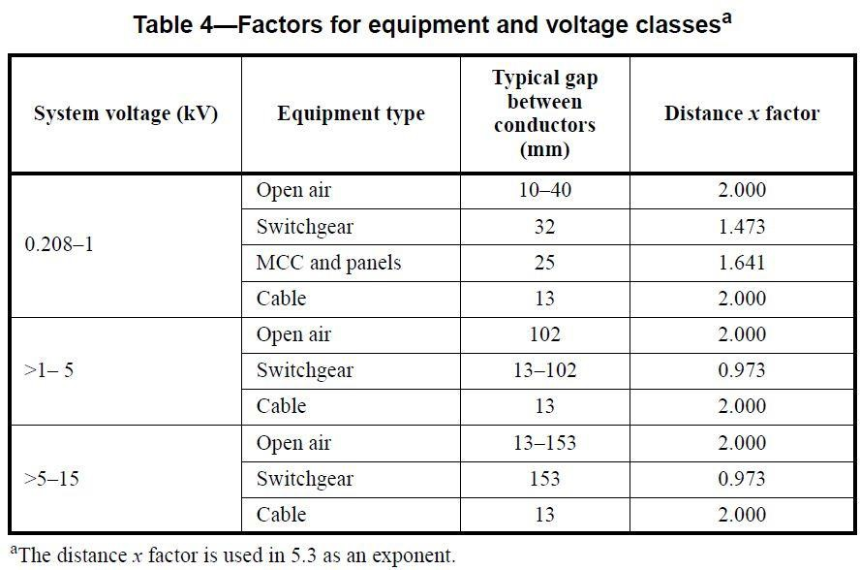

- Determine the Flash Protection Boundary for all Equipment

PC5 calculates the flash protection boundary, which specifies the distance where an electrical worker with exposed skin or different levels of PPE will sustain a second-degree burn. The flash protection boundary is calculated using the following formula.
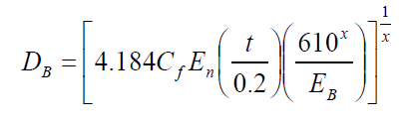

Where:
  - DB is the distance of the boundary from the arcing point (mm)
  - Cf is a calculation factor
= 1 for voltages above 1kV, and
= 1.5 for voltages at or below 1kV
  - En is incident energy normalized
  - EB is incident energy in J/cm2 at the boundary distance
  - t is time (seconds)
  - x is the distance exponent from Table 4 of IEEE 1584
  - Ibf is bolted fault current (kA).

EB can be set at 5.0J/cm2 for bare skin or at a greater value to match the proposed PPE. For a practical example of the 5.0J/cm2 value, a second degree or ‘just curable’ burn, the following example is taken from IEEE 1584 Clause E.2:
If a butane lighter is held 1 cm away from a person’s finger for one second and the finger is in the blue flame, a square centimetre area of the finger will be exposed to about 5.0 J/cm2.

Segregation
Segregation entails removing the personnel from the hazard by placing a physical barrier in between or increasing the distance between the person and the source of the arc flash. Several techniques exist and these will be discussed in the following sections.
Remote Racking & Operation of Circuit Breakers
Racking and operating a circuit breaker manually can expose personnel to significant risk. Much of the risk is associated with the person’s physical proximity to a circuit breaker when its connection or closure to an energized bus is completed. During such procedures the risk of an arc forming between the opposing conductors is at its highest and this, combined with available fault current and increased trip times (e.g. relies on upstream breaker opening) can produce significant incident energy. By permitting the automatic racking of the circuit breaker from a remote location, circuit breaker remote racking replaces the manual racking operation and removes the operating personnel from manual contact with the circuit breaker. Further, when a remote racking system is used in conjunction with a remote switch operator, the user can also operate, trip, and close the circuit breaker from a safe distance. Quite often this location is outside the switchroom allowing personnel to complete operations without entering the arc flash boundary.
Boundaries and Signage
Signage should be installed both outside the switchroom and on switchboards to indicate the arc flash hazard present to personnel. Furthermore, consideration should be given to designating the extent of the flash protection boundary around switchboards by highlighting the zone on the ground. This may be done by painting or applying suitable stickers around the switchboard.
These simple control measures allow personnel to recognize the hazard and apply the appropriate level of protection before entering the zone.
In instances where maintenance is being carried out, testing for dead may be completed using a distance volt stick which will keep the operator further away from the potential arc source until the equipment is proven to be de-energized.
Arc Fault Containment
Switchboards can be constructed to withstand internal arcing-faults by segregating sections of the board and venting each section to release the pressure caused by an arcing-fault. The inclusion of these features on a switchboard may reduce the arc flash hazard to personnel while the switchboard is fully closed, but not while the board is opened under maintenance.
Furthermore, the standard tests listed in AS/NZS 3439.1 only prescribe testing on the load side of outgoing circuits (limited arc-fault) and not the less frequent bus, incomer fault or protection device fault (unlimited arc-fault).
IEEE 1584 does not, at present, recognize any improvement in safety as a result of limited or unlimited arc-fault containment – possibly because the tradition in North America is to construct switchboards without strong arc containment. The IEEE standards committee is currently working to include arc-fault testing as part of the consideration of arc flash hazard. In the meantime, it is left to individual workplaces to interpret the IEEE 1584 arc flash results and to reconcile these with the arc-containment ratings of the switchboards under consideration.
It is unknown if the switchboards installed at the site facility are designed for arc fault containment; however, we have treated them such that the ability of the board to contain the arc flash energy has no bearing when the doors are open, and personnel are working live.
Personal Protective Equipment (PPE) – Incident Energy Analysis Method
In all cases where personnel are working in areas where an electrical hazard exists, they should be provided with and use the correct PPE for the work being performed. PPE should be visually inspected before each use and maintained in a clean, safe and reliable condition.
Protective clothing that is designed for use in a potential arc flash situation is treated to be flame-resistant (FR). The materials used can be treated to withstand different levels of incident energy and are tested to determine an applicable arc rating (cal/cm²).
When using the incident energy analysis method as specified in Annex D of NFPA 70E – 2015 (in the case of this report, PTW calculated values), table H.3(b) from Annex D of NFPA 70E – 2015 is used to determine the required arc rated clothing and PPE.
The PPE requirements should be followed, taking into account specific site or task requirements that may necessitate additional PPE. For further information on arc flash PPE refer to
NFPA 70E - 2015 Clause 130.7.
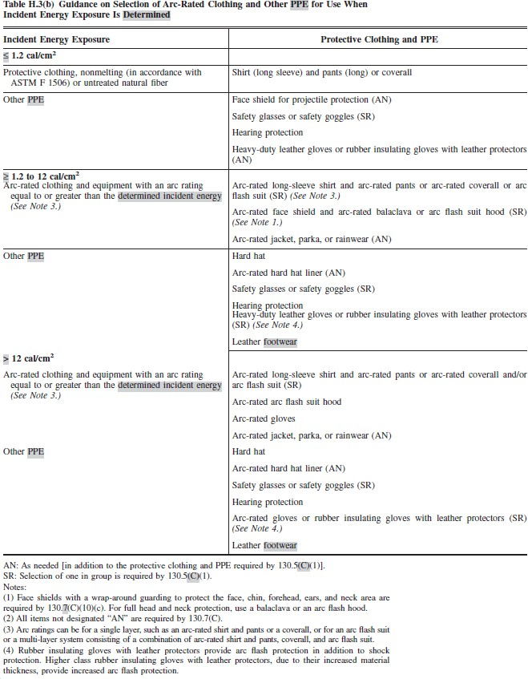

Personal Protective Equipment (PPE) – Arc Flash PPE Categories Method
Arc Flash Hazard Identification table 130.7(C)(15)(A)(a), Arc Flash Hazard PPE Categories table 130.7(C)(15)(A)(b) and Personal Protective Equipment (PPE) table 130.7(C)(16) from
NFPA 70E – 2015 identifies the requirement for PPE while performing specific tasks and may be used as a component of an arc flash risk assessment. It is noted that the results of an incident energy analysis to specify an arc flash PPE category in table 130.7(C)(16) is not permitted.
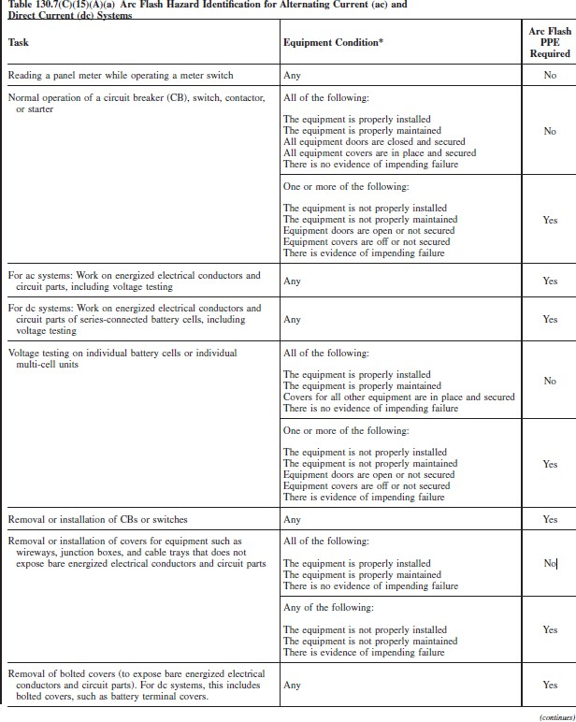

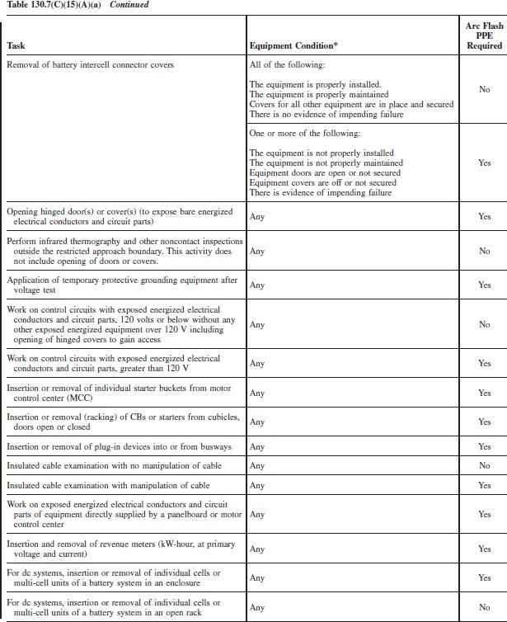

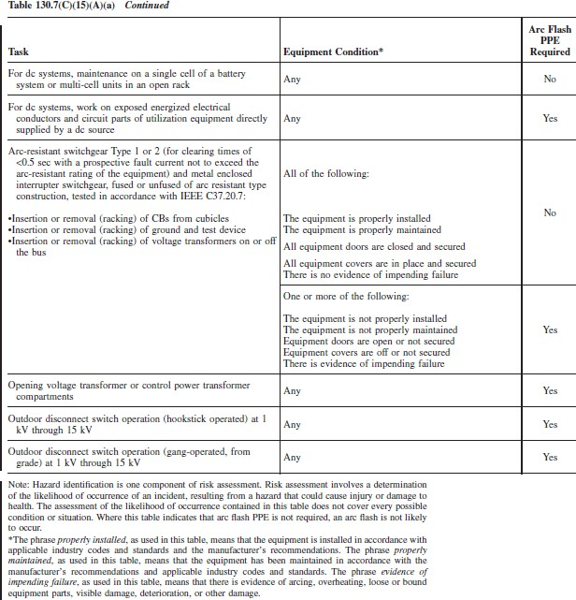

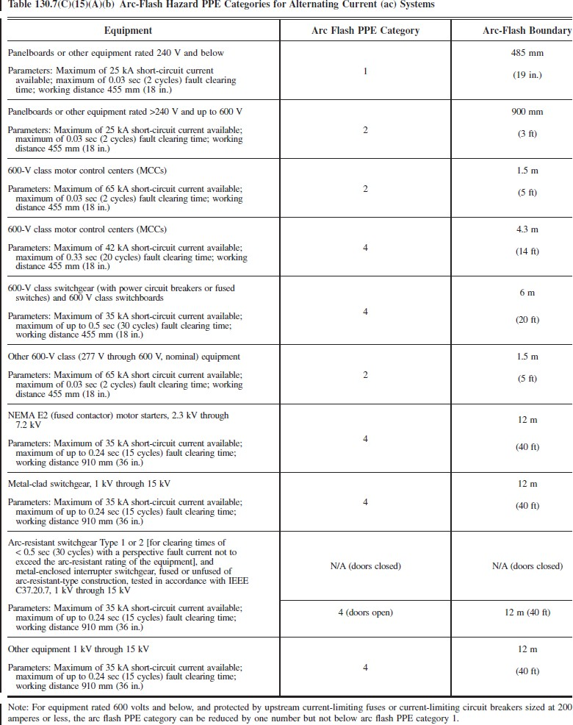

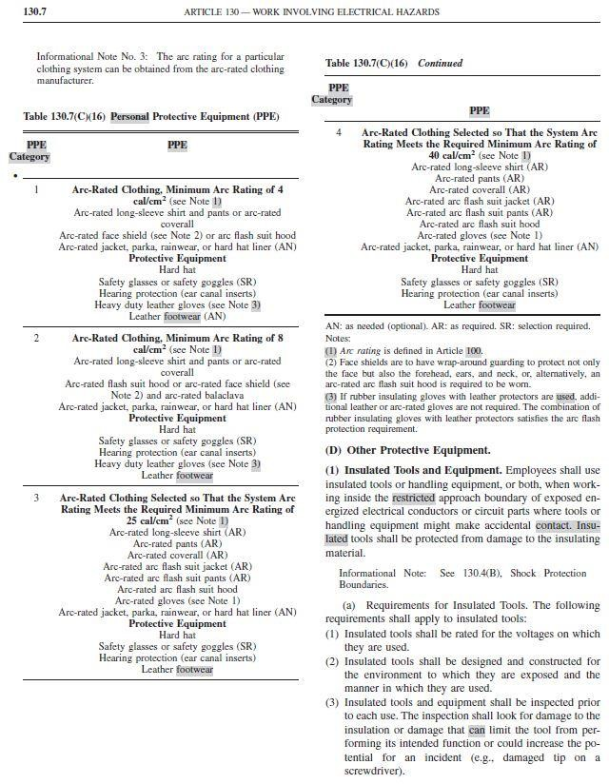

Energy Reduction
Energy reduction aims to reduce the amount of energy produced by the arc. The amount of energy released by an arc increases with the amount of current through the fault and the length of time the fault occurs, albeit in a non-linear relationship. A reduction in the tripping time of protective devices will directly reduce the amount of energy released by an arc. A reduction in prospective fault current may decrease the arc flash energy, provided the protective device tripping time is not increased at the lower current.
Reducing the protective device tripping time will reduce the incident energy produced by an arc fault, however this may also reduce the electrical network’s ability to withstand transient events such as motor starting or switching.
The following sections look at some of the techniques that can be used to reduce the incident energy.
Protective Device “Maintenance Mode”
One method of arc flash risk reduction is to use two sets of protective device settings. While the plant is in normal operation, the protection settings are set to ‘running mode’ or the standard protection settings for the site. When personnel are present in switchrooms or performing maintenance on electrical equipment, the settings are reduced to ‘maintenance mode’ settings which would significantly reduce the tripping time (and if possible, the let through current) of the protective devices, thereby reducing the arc flash hazard. This option would only be useful where protection settings can be modified remotely from the protective devices.
UV Detection
Other methods of reducing the tripping time and fault current on a switchboard include installing UV arc detection in the switchboard bus chamber and/or cubicles. The detectors react on light and are generally available with a 180º or 360º characteristic. In the event of an arcing fault, the detectors generate a fast (less than 1msec) tripping pulse to the circuit breaker(s) supplying the installation. The arcing time is thus reduced to the mechanical opening time of the circuit breaker.
The detectors should be installed in each cubicle/drawer and the bus chamber and should be shielded from normal switching arcs.
Current Limiting Fuses
Another method of reducing the incident energy by reducing trip times is by installing fault current limiting fuses in series with the switchboard protection or using fault current limiters.
A current limiting fuse operates by clearing the fault very quickly when the fault current reaches what is known as the current limiting range. In a current limiting fuse, the fusible link’s typical design has many places where the cross-sectional area has been reduced in size, and the link is usually encapsulated in quartz sand. When a short circuit fault occurs, the reduced cross-sectional areas on the fusible link will heat up quickly and melt, thus opening the fusible link.
A current limiting fuse is like a conventional fuse, except for the quartz sand. The sand changes
the fuse’s behavior. When a normal fuse melts, an arc will bridge the gap that is formed until the gap becomes too wide for the arc to bridge. The energy of an arc flash explosion depends largely on the duration of that arc, so a faster means of interrupting the current will reduce the severity of the arc flash. In a current limiting fuse, the quartz sand absorbs energy and quenches the arc that forms within the fuse. This results in a faster acting fuse that interrupts the current before it can reach its maximum intensity. In many cases, this will dramatically decrease the severity of an arc flash.
High Impedance Earthing
This method of energy limitation is reliant on the arcing fault occurring between a phase and earth. Industry data suggests that the majority of faults that occur in electrical systems are earth faults. Using this statistic and assuming that a suitable protection element to detect an earth fault is present, there is a high probability that the protection element will break the fault before it can become a three-phase fault.
Installing impedance in the earthing system will reduce the amount of fault current available. This in conjunction with an earth fault protection device that is set to operate sufficiently quickly will in turn limit the arc flash incident energy. The limited earth fault current will also reduce the ability of the earth fault to become a three-phase fault, which often results from slow or no earth fault protection.

Appendix G - AS3000/2018 Maximum Demand Calculations

WATER TREATMENT SITE
Maximum Demand Calculation:
Pumps: | 2x30kW 53.3A (Duty/ Standby)
 |  |  | Red | White | Blue |  | NOTES
 | 1st pump (100%) |  | 53.3 | 53.3 | 53.3
 | SUB TOTAL |  | 53.3 | 53.3 | 53.3 |  | Amps
 |  |  | Red | White | Blue |  | NOTES
 | General Power |  | 5.6 | 5.6 | 5.6 |  | As per table C3 AS3000
 | General Lighting |  | 5.6 | 5.6 | 5.6 |  | As per table C3 AS3000
 | General Air conditioning |  | 15 | 15 | 15 |  | As per table C3 AS3000
 | SUB TOTAL |  | 26.2 | 26.2 | 26.2 |  | Amps
 | TOTAL |  | 79.5 | 79.5 | 79.5 |  | Amps
 |  |  | Cable Capacity | Max Demand (+15%) | Acceptable
 | Consumer Mains Cable |  | 363 | 91.4 | YES

Appendix H – Arc Flash stickers
