Theodore WTP Planning Report
  - For Banana Shire Council
BTP1635-02-REP-3

19 December 2023

Theodore WTP Planning Report
For Banana Shire Council

City Water Technology Pty Ltd
ABN 92 052 448 094
26 / 924 Pacific Highway, Gordon, NSW 2072, Australia
T: +61 2 9498 1444
F: +61 2 9498 1666
W: www.citywater.com.au
E: contact@citywater.com.au
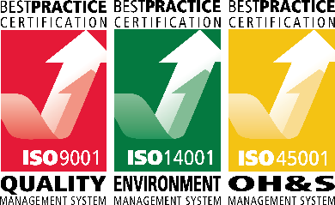
Issue Date | Revision | Issued to | Prepared by | Reviewed by | Comments
18/05/2022 | A | BSC | WT | CS/MMC | Draft
19/07/2022 | 0 | BSC | WT | CS/MMC | First issue
24/10/2022 | 1 | BSC | WT | MMC | Second issue
6/02/2023 | 2 | BSC | WT | MMC | Third issue
19/12/2023 | 3 | BSC | WT | MMC/JM | Fourth issue

Executive Summary
This report outlines the investigations undertaken by CWT on the Theodore WTP with regards to current and future plant capacity, operations and performance. The issues, outcomes and recommendations from the study are summarised below.
Water Quality Issues
A review of the raw water and WTP treated water quality found that:
- Raw water issues include very high turbidity and colour from river flow events, periodic high manganese levels, and taste and odours. Herbicides are known to be present. Algal toxins are a potential risk;
- WTP treated water typically meets both ADWG limits and WTP CCPs, with periodic excursions on treated water turbidity and true colour. The chlorine residual measured after the clear water tanks is highly variable and low residuals may sometimes compromise disinfection. Manganese targets are occasionally exceeded;
- pH and alkalinity levels are mostly within ADWG limits, but the WTP lacks pH control as currently operated;
- Herbicides have been present in treated water, but are within the ADWG recommended levels;
- From modelling of corrosivity potentials, the typical treated water is likely to be only mildly corrosive except under worst case conditions.
Note: For more details on water quality and corrosivity indices refer to Section 3.3 and Section 3.4 respectively.
WTP Flow Rate and Demand Issues
The design flow rate of Theodore WTP is 27 L/s. Due to raw water pump capacity limitations, the WTP normally operates at 15 – 23 L/s, which is sufficient to meet current maximum daily water demands. The planned new raw water pumping station (design capacity of 27 L/s) should provide more consistent flow through the WTP.
The Theodore WTP is expected to be able to meet projected future water supply demand in the Theodore area, including future demand from a proposed new motel development. This may require increasing the WTP operation time from an average of 7 hours to 8 hours. (Refer to Section 2.4 for more details)
WTP Process, Chemical Systems and Operational Issues
A review of the WTP treatment processes and chemical dosing systems found that:
- Most of the plant components are sized to achieve the design flow of 27 L/s. The raw water pumps limit the achievable flow rate, particularly at low river levels.
- Plant control and automation, safety and maintenance issues were also reviewed, with various recommendations identified in Section 6 of this report.
Summary of Future Options
Three broad options for the future of the Theodore WTP have been identified:
- Option 1- Do Nothing
- Option 2 – Refurbish the existing WTP
- Option 3 – Construct a new WTP
From the options listed above, ‘Do Nothing’ is not preferred as it does not address any of the existing issues in the WTP.
Refurbishing the existing WTP to address all the issues listed in Section 6 is feasible. The cost of implementing the recommended process upgrades and automation upgrades are estimated at $2,078,000 and $756,500 respectively.
Another option is to construct a new WTP to service Theodore. The cost of designing and constructing a WTP similar to existing capacity is estimated at $5-6 million.

Contents
Executive Summary 2
1. Introduction and Objectives 10
2. Plant Flow Rates and Water Demand Issues 11
2.1 Annual Raw Water Extraction Allocations 11
2.2 Plant Flow Rates 11
2.2.1 Design Flow Rate 11
2.2.2 Operating Flow Rates and Production Data 11
2.3 WTP Treated Water Production Capacity 12
2.3.1 Flow Rate Variation Through WTP Process 12
2.3.2 Daily Water Production Capacity for Various WTP Flow Rates 13
2.4 Current and Future Water Demand 14
3. Water Quality Issues 16
3.1 River Source and Catchment Land Uses 16
3.2 Water Quality Monitoring Data 16
3.3 WTP Raw and Treated Water Quality 16
3.3.1 Turbidity 16
3.3.2 Colour 17
3.3.3 pH and Alkalinity 18
3.3.4 Iron and Manganese 20
3.3.5 Pesticides and Herbicides 21
3.3.6 Chlorine Residual 22
3.3.7 Aluminium 23
3.3.8 Microbiological Parameters 23
3.3.9 WTP Raw and Treated Water Quality Summary 23
3.4 Water Corrosivity Issues 24
3.4.1 Problems Caused By Corrosive Waters 24
3.4.2 Corrosivity Indices 25
3.4.3 Water Quality Targets for the Prevention of Corrosion 25
3.4.4 Theodore Corrosion Indicators 26
3.5 Treated Water Quality Targets 26
4. WTP Process Description and Capacities 28
4.1 Process Overview 28
4.2 Raw Water Pumps and Plant Inlet 28
4.3 Pre-Filtration Chemical Dosing 30
4.3.1 Chemical Dosing Locations 30
4.3.2 Pre-Coagulation Chlorine Dosing 31
4.3.3 Pre-Coagulation Alkali Dosing 32
4.3.4 Ultrion 44560 Coagulant Dosing 32
4.3.5 Polyacrylamide (LT25) Polymer Dosing 32
4.4 Flash Mixing Tank 32
4.5 Clarifier 34
4.6 Filtration and Backwashing 37
4.6.1 Filter Design and Condition 37
4.6.2 PAC Dosing to Filters 39
4.6.3 Filter Backwashing System 39
4.7 Post-Filtration Chemical Dosing 42
4.7.1 Chemical Dosing Locations 42
4.7.2 Post-Filtration Chlorine Dosing 43
4.7.3 Post-Filtration Lime Dosing 43
4.8 Clear Water Storage 43
4.9 Wastewater System 45
4.10 Plant Components Capacity Summary 47
5. Chemical Dosing Systems 49
5.1 Chemical System Descriptions 49
5.1.1 Ultrion 44560 Coagulant 49
5.1.2 Polyacrylamide (LT25) Polymer 50
5.1.3 Chlorine 51
5.1.4 Lime 54
5.2 Chemical Dosage Rates 54
5.3 Chemical System Capacity Summary 56
6. WTP Issues 57
6.1 Plant Control and Automation Issues 57
6.1.1 General Observations 57
6.1.2 Electrical switchboards 57
6.1.3 Control of Plant Startup and Shutdown 57
6.1.4 Process Impacts of Plant Start-up 57
6.1.5 Filter Backwashing Automation 58
6.1.6 Online Monitoring 58
6.2 Plant Operational and Maintenance Issues 59
6.2.1 Clarifier 59
6.2.2 Filters 59
6.2.3 Clear Water Tank 59
6.2.4 Chemical Dosing System 60
6.2.5 Wastewater System 60
6.2.6 Manganese issues 60
6.2.7 Power Failure Protection 61
6.2.8 Operations during Floods 61
6.2.8.1 Maintenance Tasks 61
6.3 Safety and Environmental Issues 61
6.3.1 Chemical Bunding 62
6.3.2 Manual Handling 62
6.3.3 Contact with Chemicals 62
6.3.4 Chlorine Gas 62
6.3.5 Stairways and Unguarded Platforms 63
6.3.6 Process Water 64
6.3.7 Laboratory and Office Facilities 64
6.3.8 Site effluent 64
7. Summary of Findings and Issues 65
7.1 Findings 65
7.1.1 Water Quality Issues 65
7.1.2 WTP Flow Rate and Demand Issues 65
7.1.3 WTP Process, Chemical Systems and Operational Issues 65
8. WTP Future Options 66
8.1 Do Nothing 66
8.2 Refurbish Existing WTP 66
8.2.1 Process Upgrade Recommendations 67
8.2.2 Automation Upgrade Requirements 70
8.3 New WTP 71
8.3.1 Timing 71
8.4 Summary 72

Figures
Figure 2-1 Plant Flow Rates and Water Production for Theodore WTP from June 2017 to February 2022 11
Figure 2-2 Plant Backwash Volume and Monthly Water Losses for Theodore WTP from June 2017 to February 2022 13
Figure 3-1 Raw and Treated Water Turbidity for Theodore WTP from June 2017 to February 2022 17
Figure 3-2 Raw and Treated Water Colour for Theodore WTP from June 2017 to February 2022 18
Figure 3-3 Raw and Treated Water pH from June 2017 to February 2022 19
Figure 3-4 Raw and Treated Water Alkalinity from June 2017 to February 2022 19
Figure 3-5 Raw and Treated Water Iron for Theodore WTP from June 2017 to February 2022 20
Figure 3-6 Raw and Treated Water Manganese for Theodore WTP from June 2017 to February 2022 20
Figure 3-7 Treated Water Chlorine Residuals from June 2017 to February 2022 23
Figure 4-1 Theodore WTP Treatment Process 28
Figure 4-2 Raw water pumps control panel 29
Figure 4-3 Raw Water Inlet Main at WTP 30
Figure 4-4 Pre-Chlorine and Coagulant Dosing Points 31
Figure 4-5 Polyacrylamide (LT25) Dosing Point 31
Figure 4-6 Flash mixing tank 33
Figure 4-7 Clarifier 34
Figure 4-8 Clarifier desludge valves (automatic and manual) 36
Figure 4-9 Clarifier inner wall showing corrosion 36
Figure 4-10 Clarifier launders 36
Figure 4-11 Motors for clarifier desludge rake and stirring paddle 37
Figure 4-12 Filter tank 39
Figure 4-13 Cabinet housing turbidity meter transmitter (transmitter disconnected for repairs) 40
Figure 4-14 Air blower for filters 40
Figure 4-15 Filter Control Panel 41
Figure 4-16 Backwash Water and Air Inlet Pipework 42
Figure 4-17 Post-Chlorine Dosing Point 43
Figure 4-18 Clear Water Tank and Clear Water Pumps 44
Figure 4-19 Pit on Treated Water Rising Main 45
Figure 4-20 Sludge flow splitting pit showing sluice gates 46
Figure 4-21 Sludge lagoons showing vegetation overgrowth 47
Figure 5-1 Coagulant storage tank 49
Figure 5-2 Coagulant dosing pump 50
Figure 5-3 Polyacrylamide (LT25) storage tanks 51
Figure 5-4 Polyacrylamide (LT25) dosing pump 51
Figure 5-5 Chlorinators 53
Figure 5-6 Coagulant dose (mg/L) vs. Raw water turbidity (NTU) 55
Figure 5-7 Coagulant dose (mg/L) vs. Treated water turbidity (BTU) 55
Figure 6-1 Electrical switchboard 61
Figure 6-2 Platform outside chlorine building 63
Figure 6-3 Stairway behind chlorine building 63

Tables
Table 2-1 Estimated Water Production at Various WTP Flow Rates 13
Table 2-2 Total population at Theodore based on Censes Data (2006-2021) 14
Table 2-3 Theodore WTP Demand Projection 14
Table 3-1 Summary of Pesticide and Herbicide Analysis Results (detectable results listed only) for Raw Water 21
Table 3-2 Summary of Pesticide and Herbicide Analysis Results (detectable) for Treated Water 22
Table 3-3 Summary of Raw and Treated Water Quality Data from Theodore WTP 24
Table 3-4 Typical Target Water Quality Parameters for Corrosion Control 25
Table 3-5 Corrosivity Indices for Theodore Raw and Treated Water 26
Table 3-6 Treated Water Quality Targets & Guideline Values 27
Table 4-1 Raw Water Pumps and Plant Inlet parameters 29
Table 4-2 Flash Mixing Tank parameters 33
Table 4-3 Clarifier (Flocculation and Settling Zones) parameters 34
Table 4-4 Filters parameters 37
Table 4-5 Filter Backwashing parameters 41
Table 4-6 Treated Water System parameters 43
Table 4-7 Wastewater System parameters 45
Table 4-8 Process Components Capacity Summary (based on a design flow rate of 27 L/s) 47
Table 5-1 Ultrion 44560 System parameters 49
Table 5-2 Polyacrylamide System parameters 50
Table 5-3 Chlorine System parameters 52
Table 5-4 Australian Standard Requirements for Chlorine Installations 53
Table 5-5 Lime System parameters 54
Table 5-6 Dose rates of chemicals used at Theodore WTP 55
Table 5-7 Chemical System Maximum Capacities 56
Table 6-1 Online Monitoring Meters Summary 58
Table 8-1 Summary of recommended upgrades for Theodore WTP 67
Table 8-2 Summary of automation upgrade requirements for Theodore WTP 70
Table 8-3: Timeline for Design and Construction of new WTP for Theodore 71

Introduction and Objectives
Banana Shire Council (BSC) engaged City Water Technology to conduct a detailed review of the Theodore water treatment plant (WTP) with regards to plant capacity, operations and performance while addressing planning issues for current and future upgrade requirements. This planning report outlines the findings from the above investigations for the Theodore WTP and sets out options for addressing future upgrade requirements.
The objectives of the review and planning report for the Theodore WTP are to:
- Analyse raw water quality, treated water quality and treated water storage
- Evaluate current and future water demand and WTP production requirements
- Review process performance and capacity, including chemical dosing systems and sludge management
- Review current operational and control issues, considering potential automation options
- Develop performance and capacity upgrade pathways to meet current and future demand, including capital works upgrade program

Plant Flow Rates and Water Demand Issues

Annual Raw Water Extraction Allocations
Theodore WTP's raw inlet feed water is sourced 100% from the Dawson River. The current allocation of river water to the Theodore WTP is 300 ML/yr.

Plant Flow Rates

Design Flow Rate
Based on the original operating manual supplied with the plant, the design flow for the plant is 27 L/s. The operators advise that the plant has only briefly operated at 27 L/s for the purpose of testing the raw water pump. This scenario required operating the two (duty/ standby) raw pumps in a duty/duty arrangement during a period of high river water level.

Operating Flow Rates and Production Data
Daily raw and treated water volumes for the period June 2017 to February 2022 is shown in Figure 2-1, based on plant operation data provided by BSC.
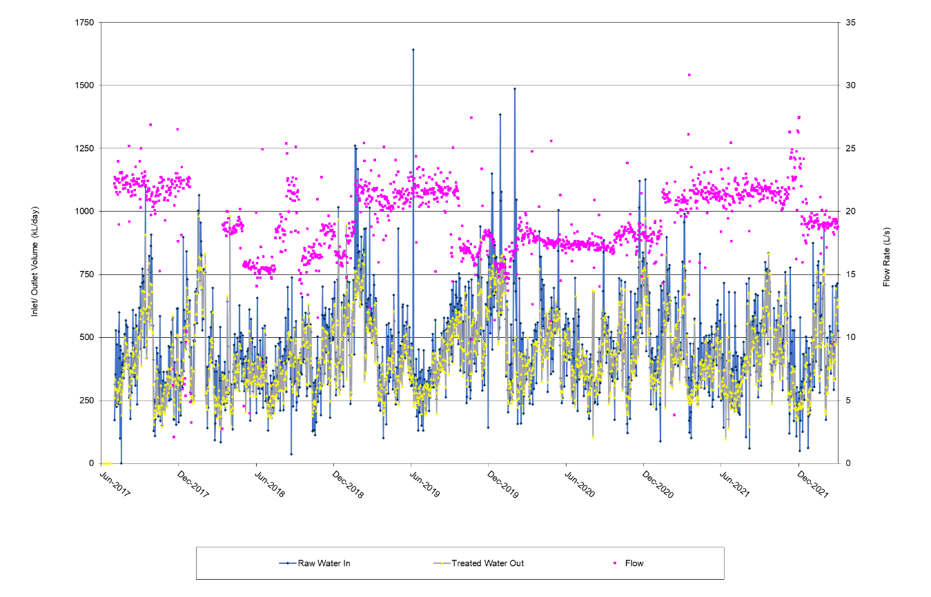
Figure 2-1 Plant Flow Rates and Water Production for Theodore WTP from June 2017 to February 2022
According to Figure 2-1, the plant flow rate has typically operated in the range 15 - 23 L/s (5th and 95th respectively) with an average of 19.3 L/s. The minimum and maximum flow rate recorded was 2 L/s and 31 L/s respectively, but these values may be erroneous due to discrepancy between raw water pump operation duration and WTP operation hours. The maximum flow of 31 L/s was recorded on a day when the WTP was in operation for less than 1 hour, which would have contributed a larger margin of error. It was noted that there was a lack of indication regarding when the raw water pumps were running concurrently or at separate times. The variation in pumping rate is most likely due to changes in the river level, with the very low rates in June 2018 associated with a very low river level and high rates in June 2019 associated with very high river levels. Sudden changes in flow rate are attributed to changeover of raw water pump duties and/ or blockages, or other conditions affecting the pumps. Changes in operation principles, operation team or demand may have also contributed to the yearly change in flow rates.
The reported WTP raw water inlet volume per day varies between 121 kL/day and 1015 kL/day with an average of 460 kL/d. 5th and 95th values are 210 – 776 kL/day respectively. The maximum raw water inlet volume recorded is around 1,642 kL/day.
The plant typically runs for 3 – 12 hours per day (5th and 95th percentile respectively), with an average of 7 hours per day. It is noted that the Theodore WTP has operated for up to 24 hours once a year on average. There is capacity to run the plant for more hours per day to increase daily water production if required. The maximum daily run-time will be limited by the time required for backwashing and maintenance tasks, which must be completed when the plant is off-line.

WTP Treated Water Production Capacity

Flow Rate Variation Through WTP Process
The raw water pump set points controls the raw water inlet flow to the WTP. The measured flow rate will vary throughout the WTP process, according to the following water balance:
- The ‘Plant flow rate’ is measured by the raw water flow meter at the inlet to the plant;
- Flow is removed periodically from the clarifier during desludges;
- Flow is removed periodically from the clear water tank for filter backwashing;
- ‘Consumption’ flow measured after treated water pumps and after backwash water take-off point.
There is currently no recycling of sludge lagoon supernatant and any wastewater flows removed are thus permanently removed from production.
Inflow and outflow volume data was used to calculate the water losses through the process. The ‘water loss’ was calculated as the raw water minus treated water daily volume as a percentage of the raw water inflow, with negative losses attributed to storage within the clear water tank between various days. Water losses, daily raw water flow volumes and recorded backwash flow volumes are shown in Figure 2-2.
From Figure 2-2, the monthly water losses at Theodore WTP had a median value of 7.9% and an average of 8.4%. It was noted that the water volume removed during clarifier desludges were not measured. The filter backwash volumes are recorded manually based on a totaliser reading on this line. Backwash is carried out every Monday, Wednesday, and Friday while the filter outlet turbidity transmitter is sent for repairs. As seen in Figure 2-2, recorded backwash volumes have varied from 45 to 116 kL, and are typically 75 kL. Based on operational data provided, the average volume of water used per backwash from June 2020 to February 2020 was 87 kL, which was 27% higher compared to backwash volume from June 2017 to May 2020. Losses of up to 5 % are reasonable for a typical conventional treatment plant, with higher losses expected during periods of dirty raw water due to increased desludge and backwashing. The water loss at the Theodore WTP is considered high with water losses trending higher in the past 12 months with an average of 9.3%. The water losses can potentially be reduced by optimisations to the clarifier desludge and filter backwash processes. It was also noted that the existing backwash flowmeter is a pulse type flowmeter which are not as accurate as magnetic flowmeters.

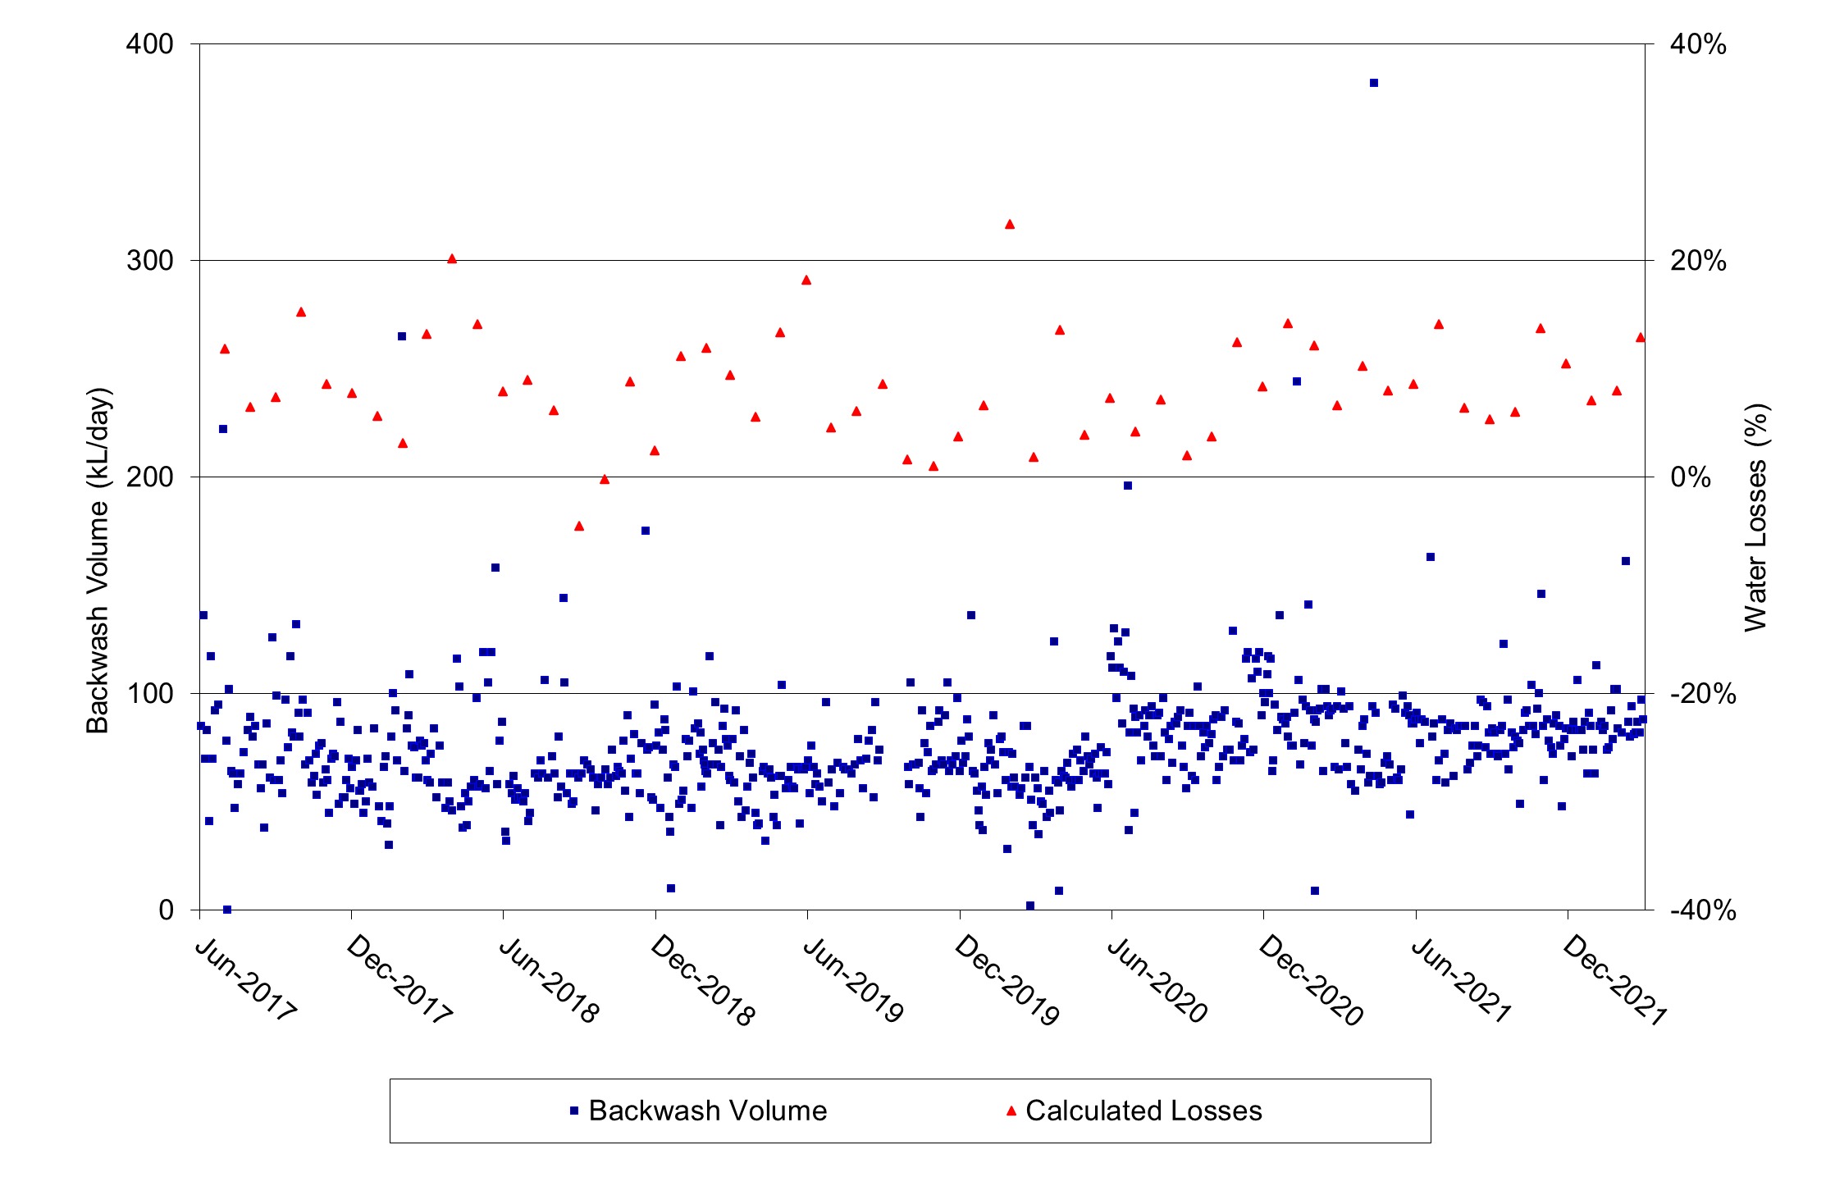
Figure 2-2 Plant Backwash Volume and Monthly Water Losses for Theodore WTP from June 2017 to February 2022

Daily Water Production Capacity for Various WTP Flow Rates
Table 2-1 summarises the potential maximum daily water output for various WTP inlet flows. Calculations are based on up to 20 hours WTP operation per day and process water losses of 5-10% and a worst case of 20%.
Table 2-1 Estimated Water Production at Various WTP Flow Rates
WTP Inlet Flow Rate (L/s) | Estimated Treated Water Output (kL/d) with 20 h/day Operation
 | 5% Water Loss | 10% Water Loss | 20% Water Loss
15 | 1,030 | 970 | 860
18 | 1,230 | 1,170 | 1,040
20 | 1,370 | 1,300 | 1,150
23 | 1,570 | 1,490 | 1320
25 | 1,710 | 1,620 | 1,440
27 | 1,850 | 1,750 | 1,560

From Table 2-1, the current average plant flow rate of 20 L/s can produce 1,300 to 1,400 kL/d in 20 hours operation with 5-10% water losses. The potential maximum flow rate of 27 L/s can produce 1,600 to 1,800 kL/d. The lowest recorded flow rate of around 15 L/s would only produce 950 – 1,050 kL/d.

Current and Future Water Demand
Demand for water produced at Theodore WTP includes the town demands and supply to trucks filling at the WTP standpipe.
From Table 2-1, the historical maximum treated water demand of around 1,300 kL/ day can be met by plant flows of 19 L/s with 20 hours operation per day.
Table 2-2 shows the total population at Theodore based on census data from the Australian Bureau of Statistics. Based on the trend, the projected future population at Theodore for the next 10 years is expected to remain similar or with marginal increase.
Table 2-2 Total population at Theodore based on Censes Data (2006-2021)
Year | Population
2006 | 444
2011 | 452
2016 | 438
2021 | 451

Based on the Theodore Water Supply Planning Report (EngineersPlus, 2022) the population in Theodore is expected to decrease marginally in the next 10 years. It was understood that there has been a development approval for a motel which is expected to increase the water demand by a maximum of 20%.
Table 2-3 shows the water supply demand for Theodore based on 3 scenarios:
- Existing – demand based on existing population
- Future – projected demand including proposed motel development
- Ultimate – projected demand based on all land parcels within the water supply area being fully developed.
Table 2-3 Theodore WTP Demand Projection
Parameter | Unit | Value |  |  | Flow/E.P.  (L/EP/day)
 |  | Existing | Future | Ultimate
Equivalent Population (EP) |  | 527 | 637 | 1371 |  | -
Average Day Demand, ADD | kL/day | 285 | 344 | 740 |  | 541
Mean Day Maximum Month Demand, MDMM (1.5 x ADD) | kL/day | 428 | 516 | 1,110 |  | 811
Maximum Day, MD (2.25 x ADD) | kL/day | 641 | 774 | 1,665 |  | 1217
Note:
Data based on the Theodore Water Supply Planning Report (EngineersPlus, 2022) provided by Council.
Current annual allocation from Dawson River is 685 kL/day.
Average Day (AD) Demand is equal to the total consumption recorded for the year divided by the number of days within the year. The average day demand for Theodore is 285 kL. The AD demand per EP has been calculated by analysing the annual water usage for Theodore by the population.
Mean Day Maximum Month (MDMM) Demand is the average demand expected to be experienced over the maximum month and does not necessarily need to be a calendar month.
Maximum Day (MD) Demand is the demand expected to occur for one day every year and which is calculated as the Average Day Demand x Maximum Day Factor.
Permanent water restrictions may reduce the impact of population growth on water demands, although the effect of potential water restrictions has not yet been quantified.
The current operating conditions at Theodore WTP (average flow rate of 19.3 L/s and operating time of 7 hours) can produce 390 – 460 kL/d of treated water. Based on Table 2-3, this is sufficient to meet existing demands. In order to meet the ‘future’ demand as defined above, the average flow rate through the plant will need to be increased to about 23 L/s, or alternatively the operating hours of the plant will need to be increased to 8 hours. Thus, if the current WTP design flow can be maintained under all conditions, the existing WTP is expected to be able to meet moderate demand increases from future development.
The current water allocation of 300 ML/y corresponds with a plant flow rate of 27 L/s, operating time of 8.5 hours per day and treated water production of 660-780 kL/d (assuming 5-20% water losses). Based on Table 2-3, this allocation is sufficient to service the existing and ‘future’ demand projections.

Water Quality Issues

River Source and Catchment Land Uses
Theodore WTP draws water from the Dawson River, which also feeds the Moura and Baralaba WTPs. Theodore is many kilometres upstream of the Moura and Baralaba draw-off points. The Theodore WTP raw water draw-off is about 1 km upstream of the Theodore weir. There are four weirs upstream of the Theodore raw water draw-off point. The upstream weirs are used for irrigation water removal.
The Theodore region has a large amount of cotton, sorghum and beef farming. Irrigated crops are required to have catch ponds to take runoff from the irrigated area (to have zero runoff back to the river), however it is expected that this regulation may not always be adhered to and/or catch dams may overflow in times of heavy rains. The water-borne protozoan parasites Giardia and Cryptosporidium may be present in the faeces of cattle and other livestock. Because of the surrounding agricultural areas, the raw water is likely to contain some of these protozoan parasites and may also contain pesticides/ herbicides.
High raw water manganese levels are reported to occur when land in the catchment is cleared, and sediments wash into the river.
The WTP raw water pumps are located in the Theodore Water Pump Station, which also houses several other much larger irrigation pumps. The water draw-off point is around 1 km upstream from the Theodore weir. The river depth at the Theodore weir is around 8.5 to 11 m.

Water Quality Monitoring Data
Raw water quality is monitored daily at the WTP. Raw water quality data for the period between 2017 to 2021 were reviewed and discussed below for each relevant water quality parameter.

WTP Raw and Treated Water Quality

Turbidity
Raw and treated water turbidity trends, based on WTP log sheet data, are shown in Figure 3-1. Treated water turbidity is analysed from samples taken from the treated water sample tap in the WTP laboratory. It is noted that this sample comes from a point after post-chlorine dosing to the filtered water.
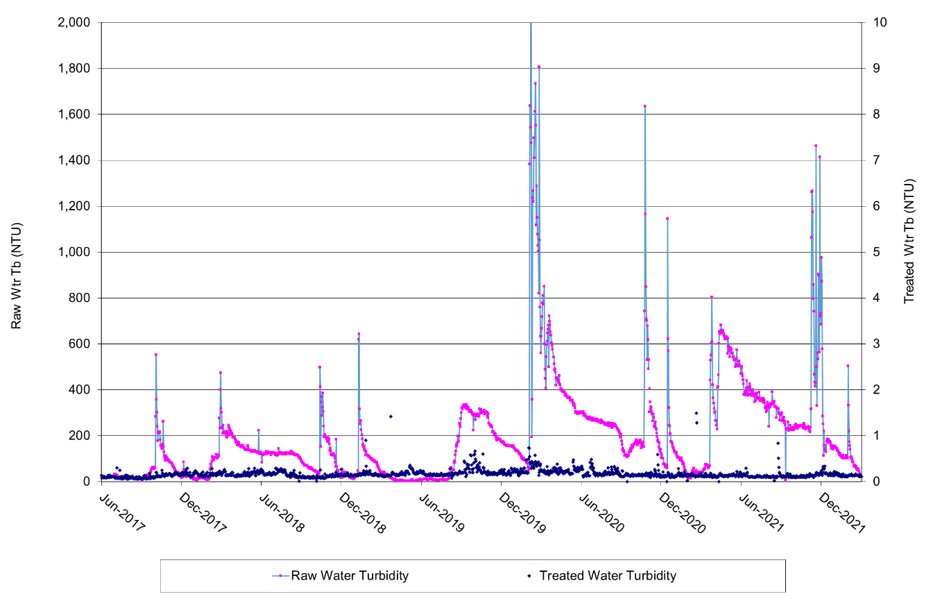
Figure 3-1 Raw and Treated Water Turbidity for Theodore WTP from June 2017 to February 2022
As seen in Figure 3-1, raw water turbidity varies seasonally with turbidity peaks seen in November-January of most years associated with river flow conditions. The maximum recorded turbidity is 3212 NTU and there have been several peaks over 1000 NTU during river flood conditions. Raw water turbidity is generally lower and more stable during the winter months. It is noted that the significant and sometimes rapid changes in turbidity will require the operator to be vigilant in re-optimising the coagulant dose.
Treated water turbidity is typically around 0.17 NTU, with a maximum value of 1.49 NTU. Over the period analysed, the treated water turbidity was < 0.5 NTU 99% of the time, indicating the Theodore WTP was operating well according to the results of the samples taken. High treated water turbidity in the filtered water is likely to be associated with poor coagulation and/or poor filter performance and turbidity. A target of < 0.2 NTU should be targeted to minimise potential pathogen breakthrough. Disinfection is likely to be compromised at turbidity > 1 NTU.
An online turbidity meter was connected to the filtered water sample line, drawing water from the filter outlet manifold before post-filtration chlorine is dosed. This turbidimeter has reportedly been disconnected and sent back to the supplier for repairs. Filtered water turbidity is reportedly currently being measured manually by operators daily. As such, the possibility of turbidity spikes following backwashing could not be reviewed. The filtered water turbidity is understood to follow similar trends to the final water, as expected.

Colour
Raw and treated water true colour levels, based on WTP log sheet data, are shown in Figure 3-2. The measurement of ‘true colour’ requires the filtration of the sample to remove turbidity before colour analysis. This filtration step has been performed since mid-2005, when a suitable filtration flask was obtained for the WTP laboratory.
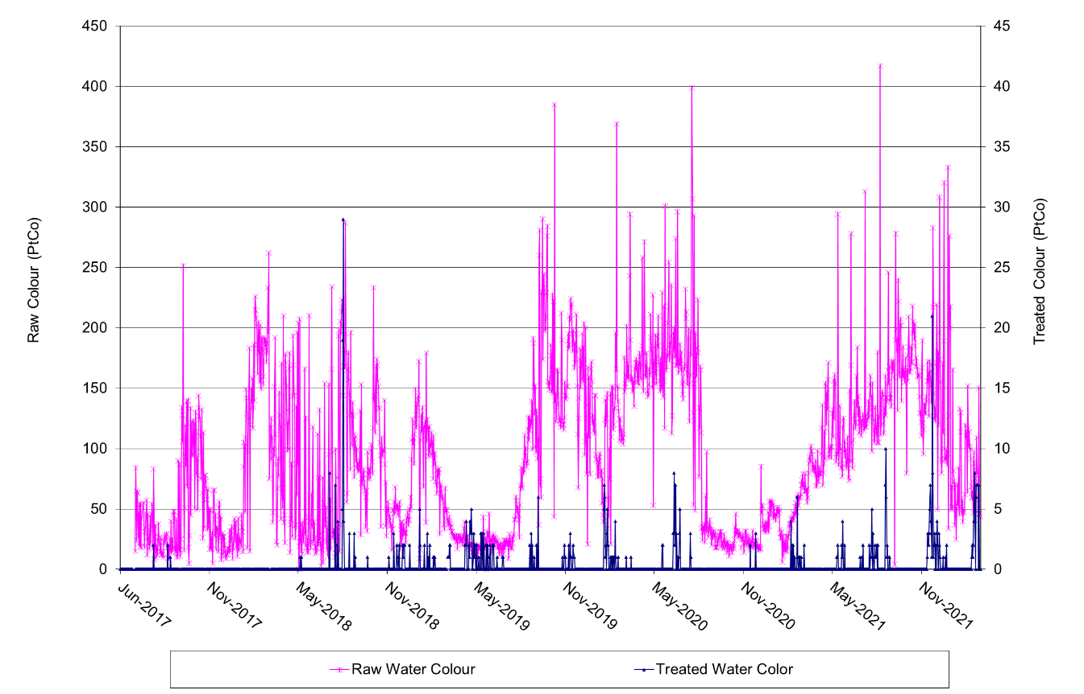
Figure 3-2 Raw and Treated Water Colour for Theodore WTP from June 2017 to February 2022
Raw water true colour measurements have ranged between 3 and 417 Pt-Co, with 5th and 95th percentile values of 16 and 203 Pt-Co respectively.
Treated water colour has typically been < 2 Pt-Co, although there have been occasional spikes up > 5 Pt-Co. The treated water colour results indicates that the WTP generally operating efficiently, however there may be scope for coagulation to be further optimised.

pH and Alkalinity
Raw and treated water pH levels, based on available WTP log sheet data, are shown in Figure 3-3.
From Figure 3-3, the raw water pH is relatively stable, with 5th and 95th percentile values of 6.9 and 7.7 respectively.
The treated water pH has been maintained between 6.7 and 7.4. The average treated water pH was about 7.0, well within the treated water CCP target pH range of 6.5 – 8.5. It was noted that pH above 7.5 can lead to ineffective chlorine disinfection. The lowest recorded treated water pH of 6.2 probably occurred due to instrument error, as the treated water pH was relatively stable between 6.8 and 7.4 since the switch to Ultrion 44560 coagulant.
Alkalinity levels, based on available WTP log sheet data, are shown in Figure 3-4.
Raw water alkalinity has ranged between 50 and 82 mg/L. Treated water alkalinity has ranged from 44 to 78 mg/L.
Figure 3-3 and Figure 3-4 indicated that the treated water pH and alkalinity follows the raw water pH and alkalinity trends very closely. This is expected as there is only coagulant dosing at Theodore WTP and no chemical dosing for pH control currently.

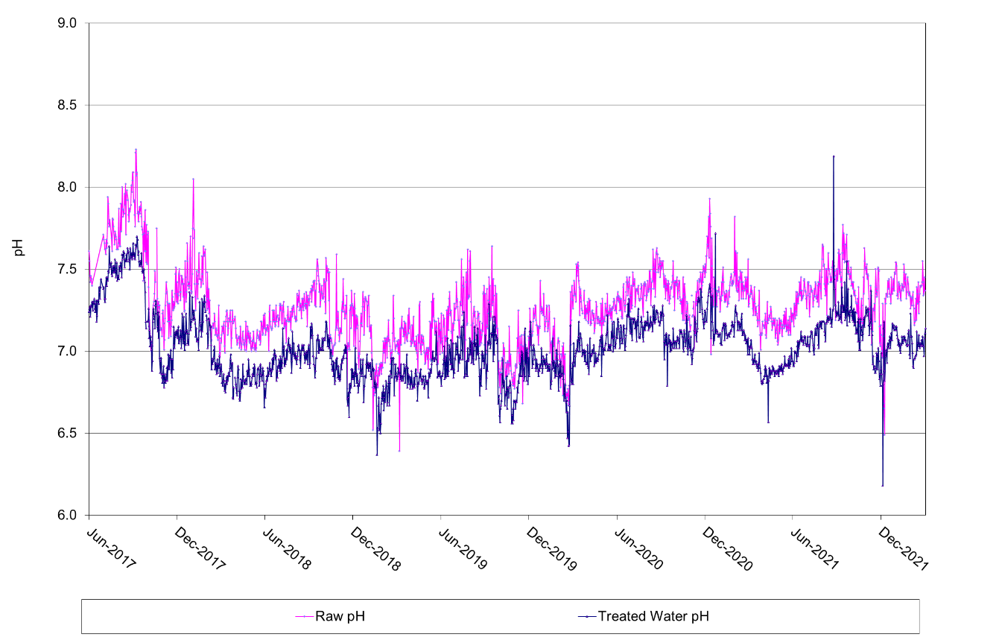
Figure 3-3 Raw and Treated Water pH from June 2017 to February 2022

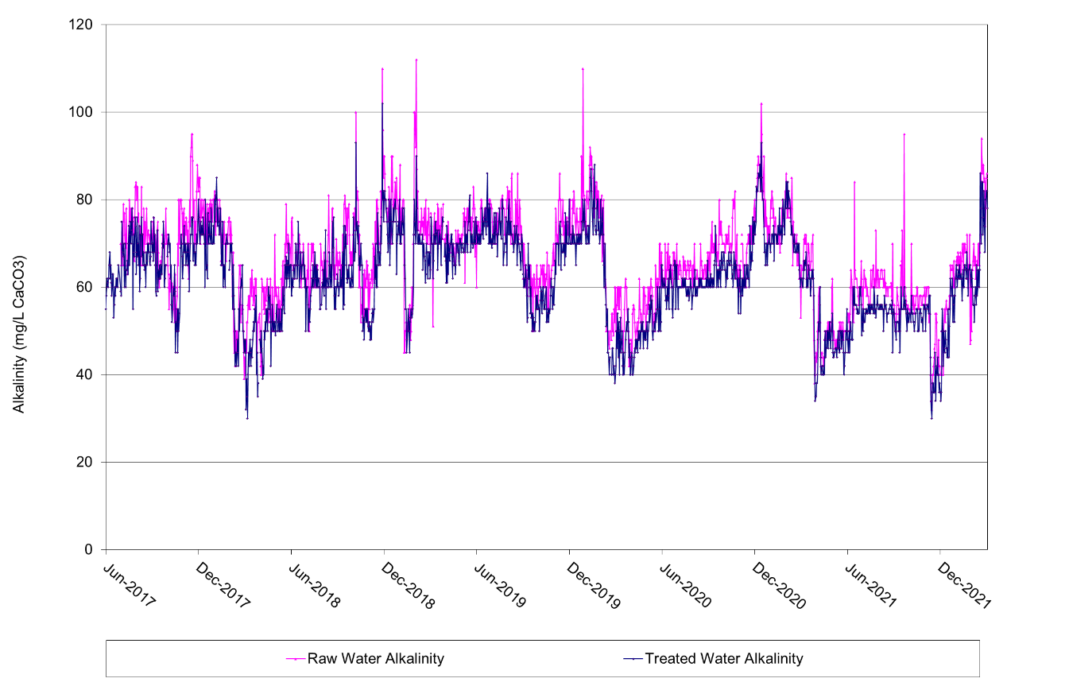
Figure 3-4 Raw and Treated Water Alkalinity from June 2017 to February 2022

Iron and Manganese
Raw and treated water iron levels, based on WTP log sheet data, are shown in Figure 3-5
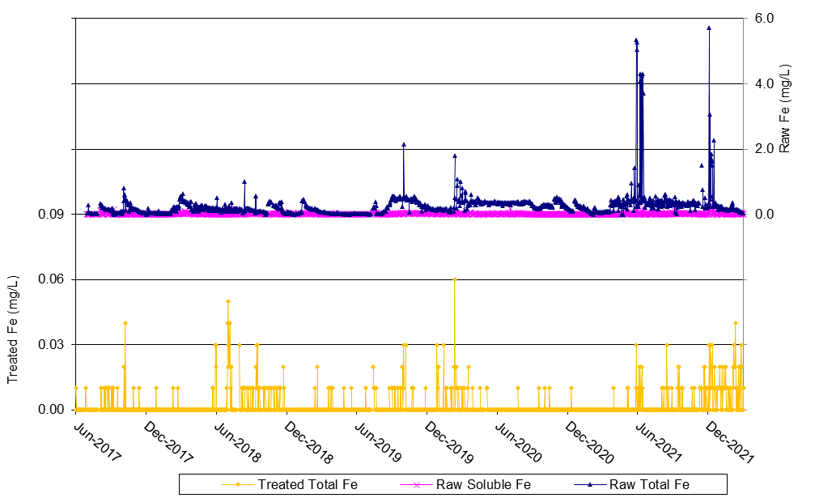
Figure 3-5 Raw and Treated Water Iron for Theodore WTP from June 2017 to February 2022

Raw and treated water manganese levels, based on WTP log sheet data, are shown in Figure 3-6.
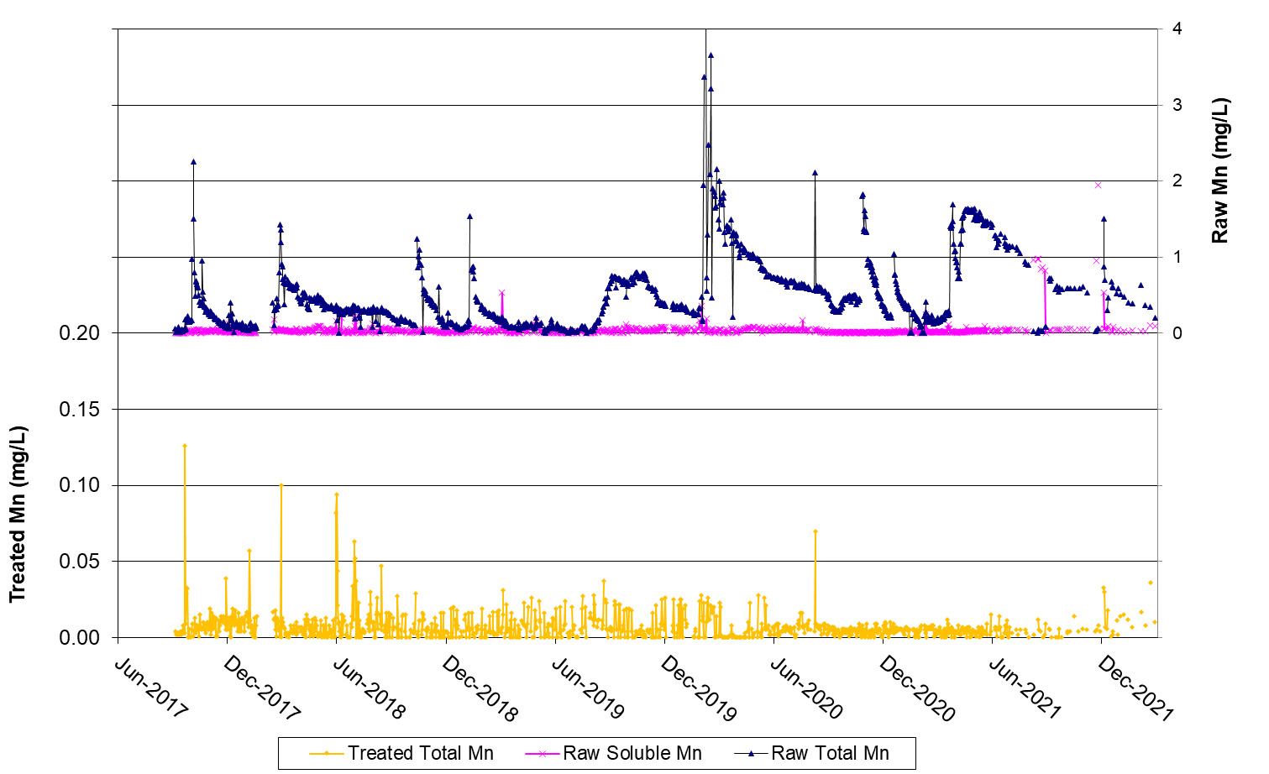
Figure 3-6 Raw and Treated Water Manganese for Theodore WTP from June 2017 to February 2022
From Figure 3-5, the raw water iron content at Theodore is generally low and range between 0.02 mg/L and 0.51 mg/L (5th and 95th respectively), with several instances of > 2 mg/L recorded. From Figure 3-6, manganese is present in the raw water at Theodore at relatively high levels, with several instances of total manganese > 1 mg/L. The iron and manganese are mostly present in the particulate form, probably associated with sediments either washed into the river or resuspended by turbulent flow. Raw water-soluble manganese levels have generally been < 0.08 mg/L, with a period of elevated levels in late 2021.
Treated water total iron levels are very low with a 95th percentile value of o.o1 mg/L and a maximum of 0.06 mg/L. Treated water total manganese levels are generally low with a 95th percentile value of 0.02 mg/L. However, several instances where total manganese levels > 0.05 mg/L were detected which corresponded with higher raw total manganese levels.
Based on the 2011 Australian Drinking Water Guidelines, the aesthetic guideline for iron was set at ≤ 0.3 mg/L, while for manganese the aesthetic guideline is ≤ 0.1 mg/L (100 μg/L) and health guideline of ≤ 0.5 mg/L. However, it has been found that significant numbers of dirty water complaints are usually received when treated water manganese concentrations exceed 0.02 mg/L and targets as low as 0.01 mg/L have been set in some WTPs with manganese problems. Manganese can also accumulate in the reticulation system to emerge from taps later causing more complaints.

Pesticides and Herbicides
The data available on raw water pesticide and herbicide were analysed, and herbicides and pesticides with detectable levels are shown in Table 3-1. A number of herbicides and pesticides were found to be present.
Table 3-1 Summary of Pesticide and Herbicide Analysis Results (detectable results listed only) for Raw Water
Parameter | Units | 16/12/2020
Herbicide  Diuron | µg/L | 0.02
Herbicide  Hexazinone | µg/L | 0.06
Herbicide  Tebuthiuron | µg/L | 0.74
Pesticide  Atrazine, 2-hydroxy | µg/L | 0.02
Pesticide  2-Nitro-m-xylene | µg/L | 107
Pesticide  Decachlorobiphenyl | µg/L | 128
Pesticide  Dibromobiphenyl | µg/L | 104
Pesticide  Pyrene-d10 | µg/L | 100
Pesticide  Triphenyl phosphate | µg/L | 131

Treated water herbicide and pesticide were analysed and the herbicides and pesticides with detectable levels were summarised in Table 3-2.
Table 3-2 Summary of Pesticide and Herbicide Analysis Results (detectable) for Treated Water
Parameter | Units | 12/12/2018 | 16/09/2020 | 16/12/2020 | 14/04/2021 | 09/06/2021 | ADWG limit
Herbicide  Hexazinone | µg/L | 0.12 | 0.02 | 0.04 | 0.01 | <0.10 | ≤0.4
Herbicide  Metolachlor | µg/L | <0.10 | 0.01 | <0.01 | 0.05 | <0.10 | ≤0.3
Herbicide  Tebuthiuron | µg/L | 0.84 | 0.66 | 0.7 | 0.48 | 0.54
Herbicide  Dalapon (2,2-DPA) | µg/L | 1.5 | 1.1 | 0.7 | 1 | 0.4
Pesticide  Atrazine, 2-hydroxy | µg/L | 0.02 | <0.02 | 0.02 | <0.02 | <0.02 | ≤0.02
Pesticide  2-Nitro-m-xylene | µg/L | 70 | 73 | 94 | 72 | 82
Pesticide  Decachlorobiphenyl | µg/L | 133 | 105 | 125 | 118 | 119
Pesticide  Dibromobiphenyl | µg/L | 92 | 94 | 103 | 100 | 112
Pesticide  Pyrene-d10 | µg/L | 109 | 97 | 100 | 99 | 115
Pesticide  Triphenyl phosphate | µg/L | 125 | 86 | 133 | 125 | 134

From Table 3-2, Hexazinone, Metolachlor and Atrazine were detected but were within the acceptable ADWG limits. However, several other herbicides and pesticides were detected but their limits are not published in the ADWG.
The presence of herbicides in the treated water is not desirable. Previously, the WTP process included PAC dosing, which may adsorb some chemicals. However, the current arrangement may not effectively remove such organic contaminants. Ideally the operation and/ or design of the WTP treatment system should be improved with the aim of effectively removing pesticides and herbicides from the water. PAC dosing or ozone/ BAC are commonly employed treatment systems.
Pesticides and herbicides should continue to be monitored regularly in the raw water and these contaminants should be considered in any incident management procedures developed for raw water contamination events.

Chlorine Residual
Treated water chlorine residual levels, based on available WTP log sheet data, are shown in Figure 3-7.
From Figure 3-7, chlorine residuals have ranged between 0.08 and 3.6 mg/L, with 5th and 95th percentile values at 0.8 and 2.1 mg/L respectively. The average chlorine residual is at 1.5 mg/L. There has been quite significant variation in day-to-day values. On days where the chlorine residual was significantly lower than the CCP target value, there may be a risk of ineffective disinfection.

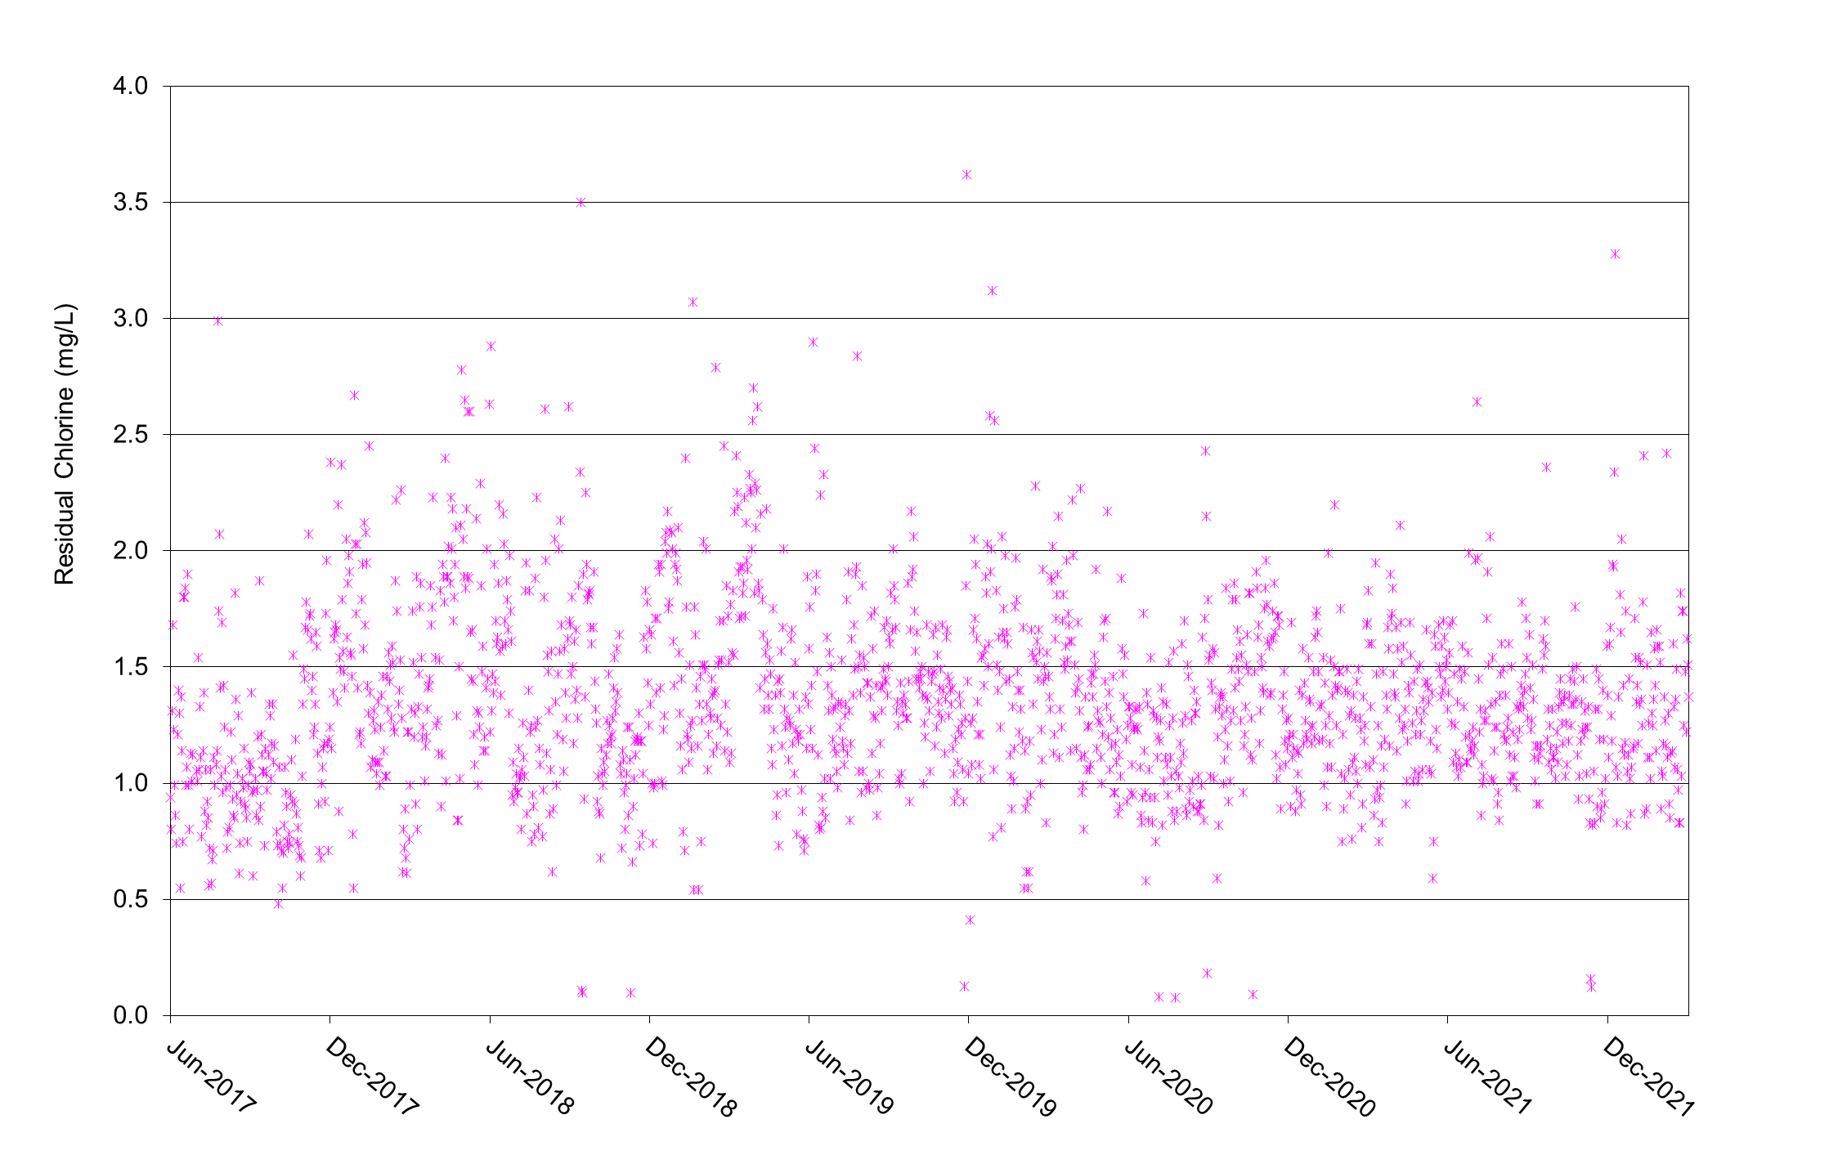
Figure 3-7 Treated Water Chlorine Residuals from June 2017 to February 2022

Aluminium
External laboratory data indicates that total aluminium levels are typically between 0.03 to 0.008 mg/L.

Microbiological Parameters
Total coliforms and E. Coli were tested monthly for treated water samples between June 2017 to Jan 2022.
From the data provided, total coliforms and E. Coli were generally below detectable limits. Only the sample in January 2020 showed detectable levels of coliforms, which may be attributed to an inadequate disinfection from the chlorine system or contamination of the test sample during sampling.
Coliforms and E.Coli should continue to be monitored regularly and any further detections should be followed up urgently to identify and address any issues leading to inadequate disinfection.
Due to the agricultural land uses in the dam catchment, it is suggested that the raw and treated water could be analysed for Cryptosporidium and Giardia on occasion to check background levels of these pathogens, particularly after heavy rain.

WTP Raw and Treated Water Quality Summary
The range and typical values for significant water quality parameters in the WTP raw and treated waters are summarised in Table 3-3.
Table 3-3 Summary of Raw and Treated Water Quality Data from Theodore WTP
Parameter | Units |  | Count | Min | 5%-ile | Mean | 95%-ile | Max
Raw Water Quality
pH |  |  | 1702 | 6.4 | 6.9 | 7.3 | 7.7 | 8.2
Turbidity |  | NTU | 1697 | 2 | 8 | 206 | 620 | 3212
Alkalinity |  | mg/L CaCO3 | 1690 | 32 | 49 | 66 | 82 | 112
Apparent Colour |  | Pt-Co | 1697 | 47 | 103 | 1722 | 4479 | 22631
True Colour |  | Pt-Co | 1697 | 0 | 16 | 94 | 203 | 417
Conductivity @ 25°C |  | uS/cm | 1687 | 22 | 149 | 246 | 347 | 640
Soluble Iron |  | mg/L | 1429 | 0.00 | 0.00 | 0.02 | 0.04 | 5.52
Total Iron |  | mg/L | 1403 | 0.00 | 0.02 | 0.27 | 0.51 | 5.73
Soluble Manganese |  | mg/L | 1120 | 0.00 | 0.00 | 0.04 | 0.08 | 1.94
Total Manganese |  | mg/L | 1113 | 0.00 | 0.05 | 0.51 | 1.51 | 4.07
Treated Water Quality
pH |  |  | 1730 | 6.2 | 6.8 | 7.0 | 7.4 | 8.2
Turbidity |  | NTU | 1728 | 0.01 | 0.09 | 0.17 | 0.30 | 1.49
Alkalinity |  | mg/L CaCO3 | 1727 | 30 | 44 | 62 | 78 | 102
True Colour |  | Pt-co | 1725 | 0.0 | 0.0 | 0.3 | 2.0 | 29.0
Free Chlorine - Onsite |  | mg/L | 1730 | 0.1 | 0.8 | 1.5 | 2.1 | 3.6
Total Iron |  | (mg/L) | 1482 | 0.000 | 0.000 | 0.002 | 0.010 | 0.060
Total Manganese (Treated) |  | (mg/L) | 1124 | 0.000 | 0.000 | 0.007 | 0.021 | 0.126

Water Corrosivity Issues

Problems Caused By Corrosive Waters
Waters may be potentially corrosive due to various combinations of parameters such as low pH, low alkalinity, or low hardness. Problems commonly experienced in a water supply because of aggressive water include:
- reduced disinfection efficiency at elevated pH levels;
- pitting corrosion, high copper levels and blue water in copper pipes within buildings;
- elevated iron levels associated with iron or steel pipes;
- meringue dezincification of brass fittings at pHs of 8.5 or higher;
- high pH values throughout the reticulation due to the dissolution of various compounds from concrete and cement within the system.
These problems can lead to increased health risk to consumers and deterioration of service pipes and fittings in water supply schemes.
Water quality is considered the main contributing factor to corrosion of infrastructure in water supply systems. Other factors contributing to corrosion may include micro-organisms on pipe walls; reticulation design and layout; materials used; and water use characteristics.

Corrosivity Indices
Indices which reflect the corrosion potential or “aggressiveness” of water can be modelled using water quality data. These indices are useful in estimating the likely corrosion potential of waters, although they do not necessarily apply to all types of waters. They include:
- the Calcium Carbonate Precipitation Potential (CCPP)
- the Langelier Index
The CCPP and Langelier Index are indicators of whether a water is likely to be aggressive or scale forming. Negative values indicate that waters are likely to be corrosive while positive values indicate the water is likely to form calcium carbonate scale.
If the CCPP is zero, then the water is saturated in terms of calcium carbonate. If the CCPP is positive then the water is over-saturated and likely to precipitate a film, predominantly of CaCO₃, onto pipes and other water supply infrastructure in contact with the water. If the CCPP is negative, then the water is under-saturated and is likely to be corrosive. Various studies have shown CCPP to be an accurate indicator of corrosiveness of concrete and cement linings.
The Langelier Index (LI) has also been found to be an accurate indicator of water scaling, and hence corrosivity under most circumstances. It is the difference between the saturated pH and the water's actual pH and is therefore on a logarithmic scale. A negative value indicates that the water is likely to be corrosive and a positive value shows it to be over-saturated and therefore likely to be scale forming.

Water Quality Targets for the Prevention of Corrosion
The water quality targets outlined in Table 3-4 are generally recommended to minimise potential corrosivity in treated waters, based on industry experience.
Table 3-4 Typical Target Water Quality Parameters for Corrosion Control
Parameter | Units | Target | Guideline Range
pH |  | 7.8 to 8 | 7.6 to 8.2
Alkalinity | mg/L as CaCO3 | 45 to 55 | > 40
Ca Hardness | mg/L as CaCO3 | > 40 | > 40
CCPP | mg/L | - 3 | - 6 to 0
Langelier Index | pH units | - 0.3 | - 0.6 to 0

The pH of the water should be above 7.6 for waters leaving the WTP but should not exceed 8.3 as dezincification can occur at pH of around 8.5 and above. At pH above 7.5, the effectiveness of chlorine disinfection is reduced.
A free chlorine residual of around 0.2 mg/L in the extremities of the reticulation system is usually recommended to minimise the possibility of microbiologically-induced corrosion.

Theodore Corrosion Indicators
Corrosivity indices were modelled for Theodore WTP raw and treated water using proprietary software. The data used as input to calculations and the calculated indices are listed in Table 3-5.
Table 3-5 Corrosivity Indices for Theodore Raw and Treated Water
Parameter | Units | Raw water Typical | Treated Water Typical | Treated Water Worst Case
Temperature | º C | 23 | 23 | 23
TDS | mg/L | 165 | 130 | 87
Alkalinity | mg/L as CaCO₃ | 66 | 62 | 30
Calcium hardness | mg/L as CaCO₃ | 76 | 55 | 34
pH | - | 7.3 | 7.0 | 6.2
Chloride | mg/L | 27 | 27 | 44
Sulphate | mg/L | 3.5 | 3.3 | 4.0
CCPP | mg/L | - 10.0 | - 21.6 | - 70.4
LI | - | - 0.7 | - 1.2 | - 2.5

The results of the modelling for the raw water show that it is likely to be corrosive. It is noted that corrosion has occurred on steel fittings on the raw water pumps offtake. The results for the typical treated water show that the water is outside the recommended range for CCPP and LI, and therefore may be corrosive.
The worst case treated water quality is very likely to be corrosive, however it is noted that this type of quality would occur rarely and for short periods of time. The use of Ultrion 44560 instead of alum had also decreased the risk of very low treated water pH and alkalinity occurring.
No particular corrosion problems have been reported within the Theodore water reticulation system.

Treated Water Quality Targets
The treated water quality target levels recommended in the Australian Drinking Water Quality Guidelines (NHMRC, 2011) are shown in Table 3-6, with common targets based on industry experience and other water treatment plants around Australia and the current targets used at the Theodore WTP based on DWQMP provided by BSC.
Table 3-6 Treated Water Quality Targets & Guideline Values
Parameter | Units | ADWG |  | Common Industry Treated Water Targets | Current Theodore Treated Water Target
 |  | Health | Aesthetic
Turbidity | NTU | <1 | 5 | < 0.1 | < 0.15
Colour | HU |  | 15 | ≤ 5 | ≤ 5
pH |  |  | 6.5 – 8.5 | 7.5 – 8.3 | 7.5-7.6
Chlorine | mg/L | 5 |  | Depends on system | 1.0 – 1.5
Total Aluminium | mg/L | 0.2 |  | ≤ 0.2 | -
Total Manganese | mg/L | 0.5 | 0.1 | ≤ 0.05 | -
Total Iron | mg/L |  | 0.3 | ≤ 0.3 | -
Total Alkalinity | mg/L as CaCO₃ |  |  | ≥ 40 | -
Total Dissolved Solids (TDS) | mg/L |  | < 600 | < 500 | -
CCPP |  |  |  | -1 to -5 | -
Total Trihalomethanes | mg/L | 0.25 |  | ≤ 0.15 | -

The targets adopted at the WTP are reasonable compared to the ADWG and industry values. It is noted from the analysis of water quality above that the targets are not always met.

WTP Process Description and Capacities

Process Overview
Theodore WTP is a conventional treatment process, comprising the following main unit processes:
- Coagulation
- Flocculation
- Settling
- Filtration
- Disinfection
- pH adjustment
A diagram of the plant process is shown in Figure 4-1. Note that PAC is not currently dosed.

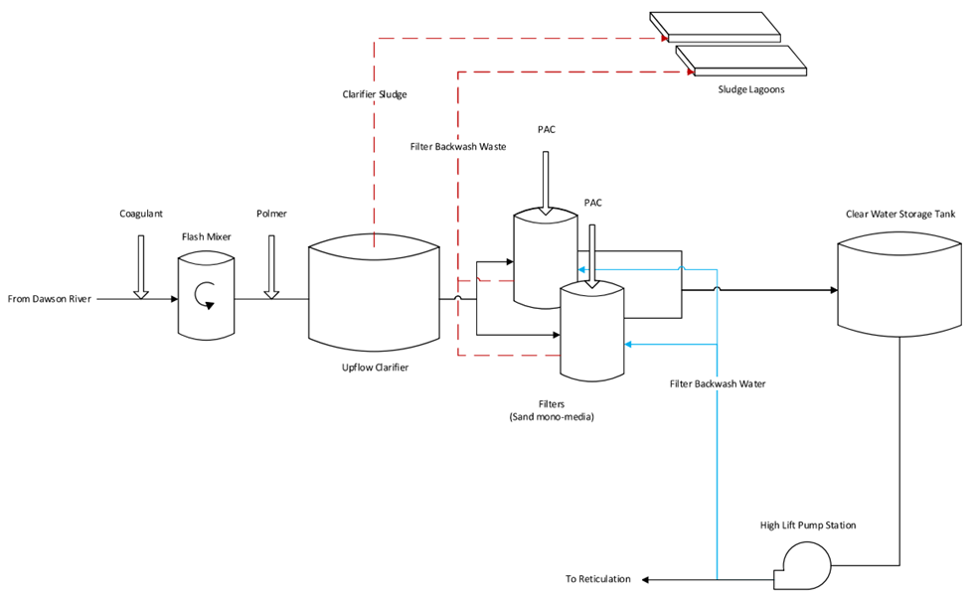
Figure 4-1 Theodore WTP Treatment Process

Raw Water Pumps and Plant Inlet
Raw water is drawn from the Dawson River in the Theodore Weir impoundment, around 1km upstream of the weir.
The raw water pumps are mounted in the Theodore Water Irrigation Pump Station on the right bank of the river. There are 5 pumps in the pump station, 3 run by Theodore Water for irrigation purposes and 2 run by BSC for WTP inlet feed. The raw water pumps are powered and controlled from the raw water pump switchboard in the Theodore Water Irrigation pump station.
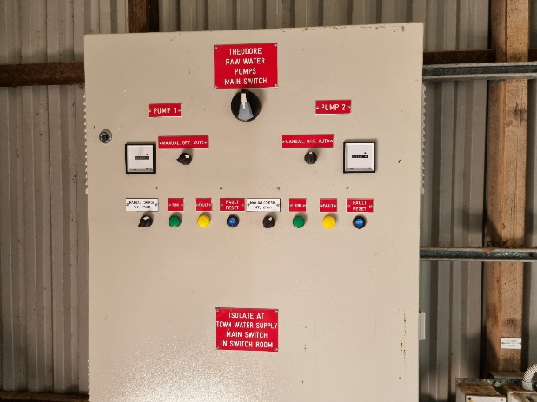
Figure 4-2 Raw water pumps control panel

Table 4-1 Raw Water Pumps and Plant Inlet parameters
Component | Parameter (Units) | Design Criteria | Comments
Dawson River Pumps | Intake type | Floating draw-off
 | No. and Capacity each (L/s) | 2 (duty/ standby) x approx 19 L/s | Noted that pumps have no speed adjustment capability
 | Pumping elevation to WTP | Approx 12 m | Weir crest 133.82 AHD, Plant inlet TWL 146.1 AHD (from Council’s data)
Plant Inlet | Max hydraulic capacity | 27 L/s assumed | Designed for 27 L/s as per old manual
The raw water pumps are two (duty/standby) centrifugal pumps, each rated at 27 L/s according to the original plant operating manual. The pumps are the original pumps installed with the WTP in 1987. Currently the pumps have a capacity of 19 L/s with one pump in operation, and 22L/s with both pumps in operation.
The main parameters of the raw water pumps and plant inlet are given in Table 4-1.
During a CWT site visit, it was noted that the raw water pump control panel at the pump station was refurbished and working as intended. It was also noted that, due to the 2011 floods the HL pumps were reconditioned. The raw water pumps are in good operating condition. According to operators, BSC has allocated budget for a new raw water pump station which is in the design stage.
Based on the SCADA system, the raw water pumps are controlled by the level sensor in the clear water storage tank. Operators reported that there was a communication issue between WTP and the raw water pump station. This required operators to reset the control intermittently.
The pumps take water from a floating draw-off in the river, designed to rise and fall with the river and to avoid drawing in the sediments near the bottom of the river. It has been noted that the foot valves were pulled out and checked about 2 years ago. The defective foot valves have been replaced for better operation. It was noted that the draw-off point can be extended further out into the centre of the river when the river level is low. It is recommended that a river height transducer be installed for improved monitoring of river water level. A genset should also be provided at the raw water pump station in case of power outages in the area.
The inlet main at the WTP before the Flash Mixing Tank contains a non-return valve, the raw water sample point (for sample to the laboratory), the raw water Magflow meter, dosing points for pre-chlorine and coagulants (Figure 4-3) and a manual isolation valve. A flowmeter transmitter is located in the WTP laboratory, and flow is continuously monitored and recorded in the SCADA system.

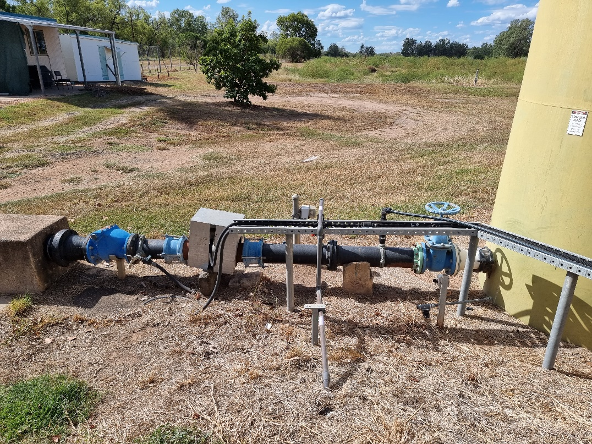
Chemical Dosing Points
Raw Water Sample Point
Flow Meter
Non Return Valve
FLASH MIXER
Figure 4-3 Raw Water Inlet Main at WTP

Pre-Filtration Chemical Dosing

Chemical Dosing Locations
The chemicals currently dosed for pre-treatment and coagulation are:
- Ultrion 44560 coagulant dosed into the main at the plant inlet;
- Polyacrylamide, product name Magnafloc LT25 polymer dosed into the pipe between the flash mixer and the clarifier.
The dosing points for these chemicals are shown in Figure 4-4 and Figure 4-5.

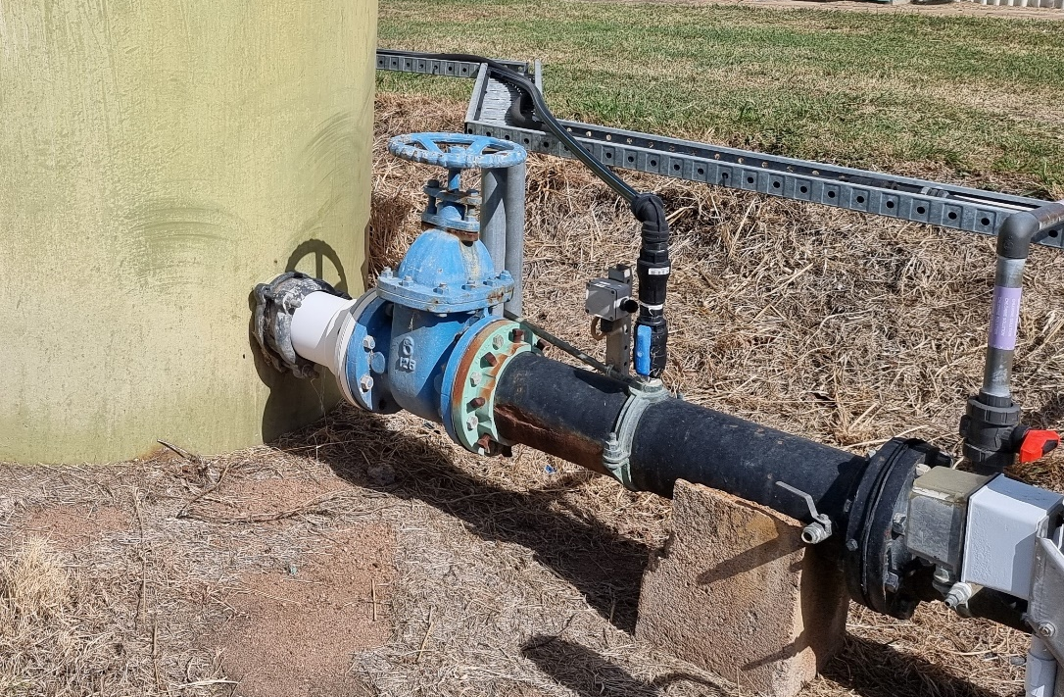
Chlorine Dosing Point (not used)
Ultrion 44560 Dosing Point
FLASH MIXER
Direction of Water Flow
Figure 4-4 Pre-Chlorine and Coagulant Dosing Points

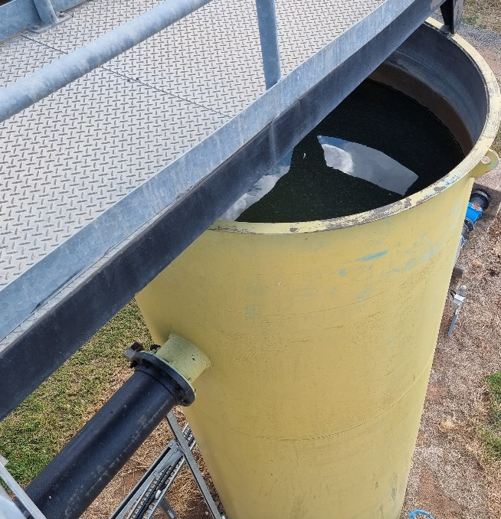
LT25 Dosing Point
FLASH MIXER
Figure 4-5 Polyacrylamide (LT25) Dosing Point

Pre-Coagulation Chlorine Dosing
During the site visit, it was noted that pre-chlorine is not currently used at the WTP and avoided due to potential of producing THMs.
Based on the WTP original operating manual, the pre-coagulation chlorine dosing was not included in the original plant design but has been added to the process subsequently.
Pre-coagulation chlorination (‘pre-chlorine’) is generally used to oxidise soluble metals and organic compounds (including taste and odour compounds). Chlorine dosing can also assist by enhancing the coagulation process. It is understood that pre-chlorine is dosed mainly for oxidation of taste and odour compounds at Theodore WTP.
One of the risks with pre-coagulation chlorination is that there is more chance that chlorine will react with the high levels of organic substances in the water to produce undesirable by-products such as trihalomethanes (THMs). If blue-green algal cells are present, chlorination may also lyse the cells, potentially releasing any algal toxins into the water.

Pre-Coagulation Alkali Dosing
Pre-coagulation alkali dosing was in the original design of the WTP but is not currently used.
This dosing was beneficial for maintaining a suitable pH and alkalinity for coagulation, when alum was used as the main coagulant. However, Ultrion 44560 consumes less alkalinity than alum, therefore pre-lime is not required.
If required, there is potential capacity to dose pre-coagulation lime (‘pre-lime’) as there are two lime batching/dosing tanks (currently used as duty/ standby for post-lime). Dosing pre-lime would require the installation of dosing lines and dosing pump(s).

Ultrion 44560 Coagulant Dosing
Ultrion 44560 is currently used as the main coagulant (to replace Nalco coagulant DVS C001, alum and polyDADMAC). Ultrion 44560 is understood to be a polymerised aluminium chemical product, of the type often called aluminium chlorohydrate (ACH), although the actual chemical composition of the product is protected by Nalco as proprietary information. Such products can be effective at lower doses than alum and generally consume less, or none, alkalinity, therefore reducing the need for pre-coagulation alkali dosing.

Polyacrylamide (LT25) Polymer Dosing
The polyacrylamide, Ciba product Magnafloc LT25, is dosed as a flocculation aid at the pipe carrying water between the flash mixer and the clarifier. Magnafloc LT25 is a non-ionic polyacrylamide. It is understood that the polyacrylamide product LT25 has also been dosed as a polymer in the past.
Anionic or nonionic polyacrylamides (also known as polyelectrolytes) are used as flocculation aids to assist in binding particles together during coagulation and flocculation. These long-chain polymers influence the bonding between floc particles and help to form larger and/or denser floc.
The dosing location after the flash mixer allows contact time and mixing of the coagulant chemicals before contact with the polyacrylamide. Flocculation aid polymers are best dosed downstream of the primary coagulant dosing point, allowing a suitable contact time for the coagulant, as well as adequate mixing and initial floc development before the polymer is added.

Flash Mixing Tank
The flash mixing tank comes directly after coagulant dosing and essentially provides mixing and chemical contact time for formation of flocs. The main parameters for the flash mixing tank are given in Table 4-2.
During the site visit, CWT noted that the coating of the flash mixing tank was in poor condition and may require repainting. However, no leaks were observed, and the level sensor was in good operating condition.
It is noted that only hydraulic mixing is provided to blend the coagulants into the water. This type of low G mixing is suitable for high TOC & turbidity raw water for sweep floc coagulation (G value is not important). However, for charge neutralization (low TOC& turbidity water) better mixing will be required. Poor mixing can typically lead to overdosing of coagulant and high aluminium levels in the treated water. Based on available results, coagulation mixing is currently sufficient. Mechanical or inline static mixers could be employed to optimise coagulant mixing with the raw water. However, this introduces additional headloss on the capacity of the raw water pumps and can affect the throughput of the WTP.
The maximum capacity of the flash mixer is taken to be the design flow rate of 27 L/s, although plant trials would be recommended to test this rate (or higher rates) to prove that adequate mixing and detention time can be provided at the new rate.
Table 4-2 Flash Mixing Tank parameters
Component | Parameter (Units) | Design Criteria | Comments
Flash Mixing Tank | Dimensions: diameter, depth (m), volume (m³) | 1.8 m, 5 m, approx 12 kL | From original operating manual
 | Detention time | 7 min at 27 L/s  8.5 min at 22 L/s | Time for 27 L/s from original operating manual
 | Flash mixing | Hydraulic only

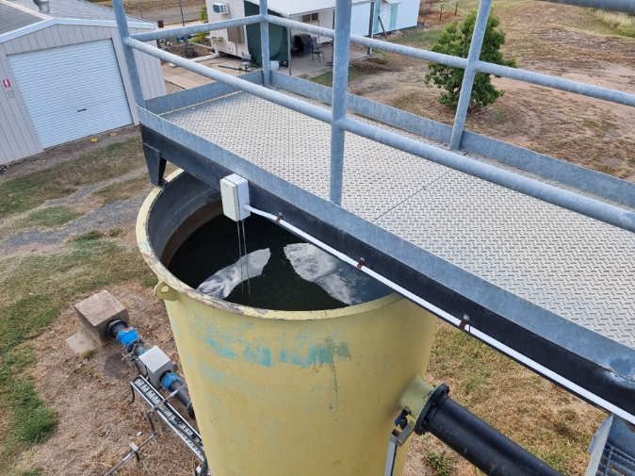
Figure 4-6 Flash mixing tank

Clarifier

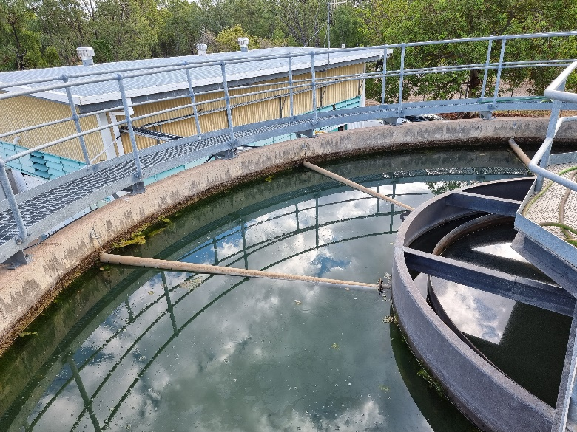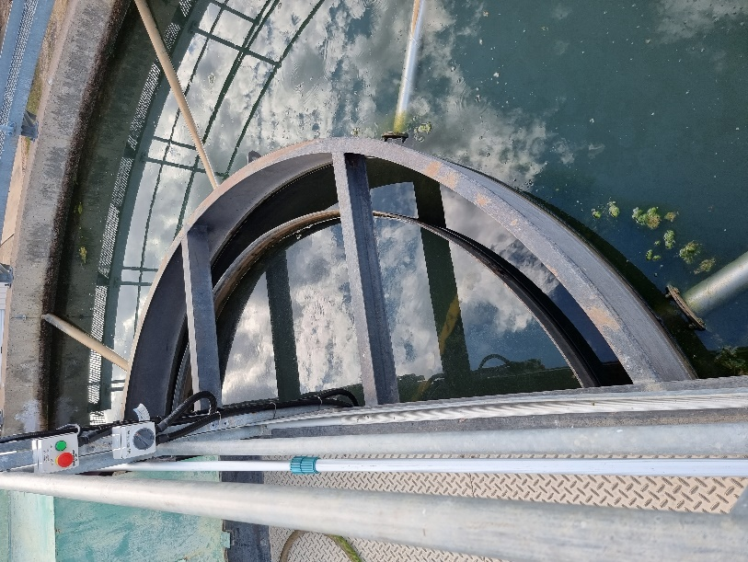
Figure 4-7 Clarifier
The clarifier is a solids contact upflow design. It was originally designed to treat a flow of 27 L/s. Inflow into the clarifier is into the central flocculation zone, where mechanical mixing (with a stirring paddle) assists in the formation and development of floc particles. The water then flows under the skirt and upwards in the outer settling zone, where floc settle out and clarified supernatant is collected in the radial arms and flows on to the filters.
There is a sludge rake in the settling zone of the clarifier which operates when the plant is on to scrape the sludge to the centre of the conical floor. Settled sludge is periodically removed from the bottom cone of the clarifier by operation of the automatic desludge valve.
The main parameters for the clarifier are given in Table 4-3.
Table 4-3 Clarifier (Flocculation and Settling Zones) parameters
Component | Parameter (Units) | Design Criteria | Comments
Flocculation | Type | Flocculation occurs in central flocculation zone of clarifier
 | Dimensions: depth (m), volume (m³) | 4.5, 24.6 m³ | From original operating manual
 | Flocculation time | 15 min at 27 L/s  18 min at 22 L/s | Time for 27 L/s from original operating manual
 | Flocculation mixing | Stirring paddle (1:6 speed turndown)
Clarification | Clarifier type | Upflow sludge blanket clarifier
 | Dimensions: diameter, depth (m) | Internal diameter 10 m, 4.5m deep
 | Settling zone surface area (m²) | 66 m²
 | Surface rating (m/h) | 1.47 m/h at 27 L/s  1.20 m/h at 22 L/s | Rate for 27 L/s from original operating manual
 | Sludge scraping | Sludge rake, 3 m/min rake tip speed
 | Sludge drawoff system | Automatic desludge from bottom of clarifier cone
 | Tank drainage facilities | Manual sludge bleed/ scour line
 | Typical sludge removal frequency, duration (sec), volume | Frequency 10 min, duration 1 min, volume not measured | Desludge on and off times are operator adjusted at filter control panel

The design flocculation time of 15 minutes (at 27 L/s) is reasonable based on the expected warm water temperatures and additional floc formation time available in the flash mixer. However, some conditions may require longer flocculation times. Jar testing trials could be carried out to look at the minimum flocculation time required to form suitable floc, if required.
The design settling surface rating of 1.47 m/h (at 27 L/s) is considered to be a reasonable rate for an upflow clarifier. Higher surface ratings may be achievable for warm water with high turbidity; however, plant trials would be recommended to prove that adequate settling could be achieved if higher rates were applied.
The clarifier is understood to run well at flow rates of 15-23 L/s. Thus, the maximum capacity of the clarifier is taken to be the design flow rate of 27 L/s, noting that performance at this flow rate could be further confirmed over a longer period of stable operation.
During the site visit, CWT noted that the sludge wasting valve was smaller than other similarly sized clarifiers (50 mm instead of 100 mm). The operator was also required to manually operate the scour valve weekly to ensure no build-up of sludge in the clarifier.
It was also noted that the inner wall of the clarifier (Figure 4-9) showed signs of corrosion and may need to be repaired to maintain operational lifespan. The launders (Figure 4-10) were above the water level and need to be adjusted to below the water level for better clarifier performance. The driving units (including motor, gear, chain) for the clarifier desludge rake and stirring paddles were also found to be in poor condition.
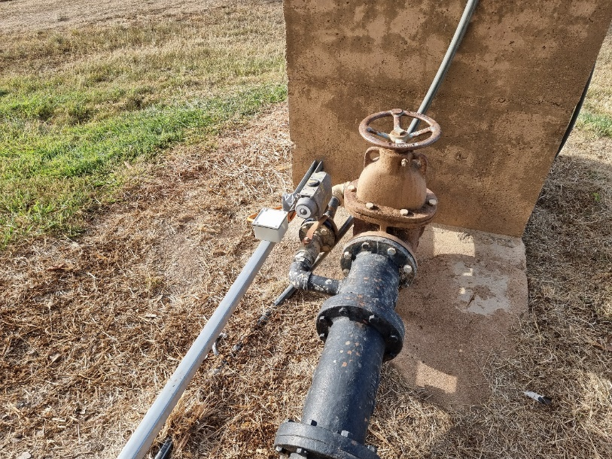
Manual scour valve
Automatic desludge valve
Figure 4-8 Clarifier desludge valves (automatic and manual)

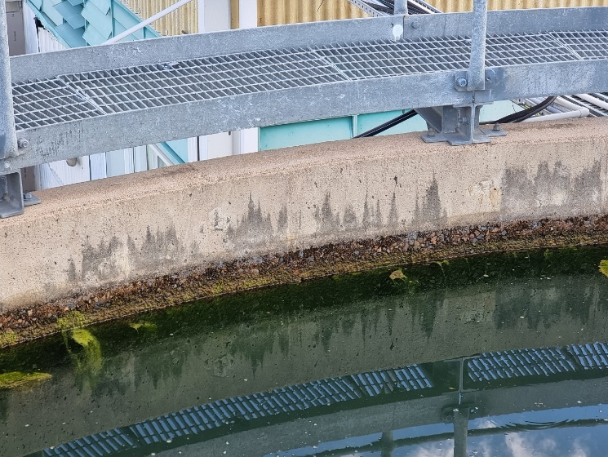
Figure 4-9 Clarifier inner wall showing corrosion

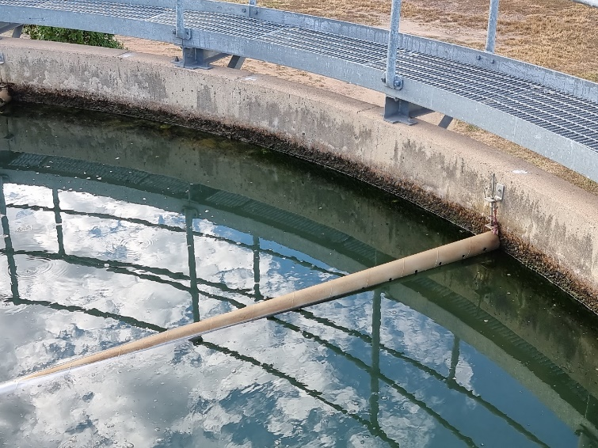
Figure 4-10 Clarifier launders

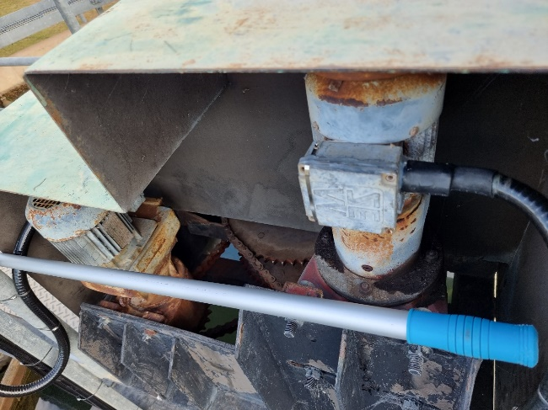
Figure 4-11 Motors for clarifier desludge rake and stirring paddle

Filtration and Backwashing

Filter Design and Condition
The two filters are located in cylindrical tanks next to the clarifier. The filters are designed to treat a flow of 27 L/s, according to the original operating manual. The filters contain sand media of effective size 0.5 to 0.6 mm.
The main parameters for the filters are given in Table 4-4.
Table 4-4 Filters parameters
Component | Parameter (Units) | Design Criteria |  | Comments
Filter Beds | Maximum flowrate for filtration stage (L/s) | 27 |  | Based on original manual
 | Type | Sand mono-media
 | Number of filters | 2
 | Filter vessel: diameter, height (m) | 2.58 m, 5 m |  | Based on original manual
 | Area per Filter (m²) | 5.3 m²
 | Total Filter Area (m²) | 10.6 m²
 | Filtration Rate (m/h): |  |  | Filters are usually backwashed while plant is off, so not common to have only one filter on line
 | Both filters operating | 9.2 (at 27 L/s flow rate)
 | One filter off-line | 18.4 (at 27 L/s flow rate)
Filter Media | Filter sand: size (mm), U.C., depth (mm) | 0.5 – 0.6 mm, 1.4 – 1.7, Depth not known |  | From original manual.
 | Coarse sand and gravel | Size (mm)  0.5 – 1  2 – 3  3 – 5  5 – 12  12 - 20 | Depth (mm)  900  100  75  75  100
 | Underdrains | PVC header and laterals cast into concrete. Plastic nozzles |  | From original manual
 | Available Headloss (m) | At least 2.5 m |  | Headloss displayed on chart recorder in laboratory

It is understood that the filter media was replaced in 2013. However, there was insufficient information to determine the depth of the media in its original condition. More detailed investigation into the media depth may be required to determine if the any media had been lost in the backwash and if the filter needs to be topped up.
Based on the filtration rates in Table 4-4, a typical filtration rate of 9.2 m/h is in the higher range for sand media filters. A filtration rate of 7.5 m/h is considered ideal, and this is achieved with a plant flow rate of 22 L/s. However, if only one filter was on-line when the plant was running, the resulting filtration rate (18.4 m/h for 27 L/s) would be excessive for the filter design. Based on this, it would appear that the WTP was designed to have both filters on-line at all times when running. It was noted during the site visit that the operators will shut down the plant in order to perform backwash on both filters instead of diverting the full plant flow through one filter. For the WTP to run while backwashing takes place, the media will need to be changed to a dual media configuration which is compatible with higher filtration rates. This may also require raising the launder height.
Based on available data, the filters appear to operate adequately at the current flow rates of 15 – 23 L/s. The maximum capacity of the filters is taken to be the design flow rate of 27 L/s, although performance at this flow rate could be confirmed over a longer period of stable operation.
During the site visit, CWT noted that both the internal and exterior coating on the filter tanks were in poor condition and require refurbishment.
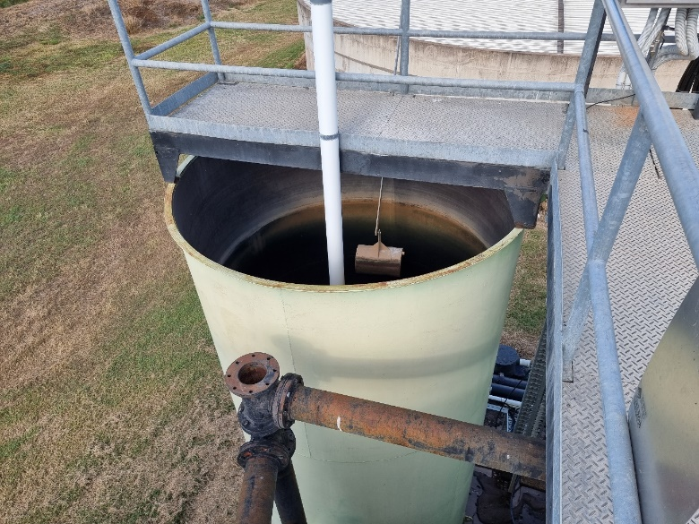
Figure 4-12 Filter tank

PAC Dosing to Filters
During the site visit, it was noted that PAC is not currently used at the WTP.
Based on the WTP operating manual, PAC was dosed manually into the filters, added to the clean filter bed after each backwash. The PAC is mixed with water in a bucket and then poured down the PVC tube to the surface of the media. Either a hose or turbulence from the filter inflow is used to distribute the PAC over the filter surface.
The general purpose of PAC dosing is to adsorb organic compounds, such as taste and odour compounds and algal toxins. There are different types of PAC product, each good for adsorbing certain compounds.
In many water treatment processes, PAC is dosed to the raw water and settled out in the clarifier, providing a reasonably long contact time and removing most of the additional solids before the filtration stage. Dosing PAC once at the start of the filtration run gives the PAC a long contact time, although the adsorption of the PAC dosed may be exhausted before the end of the filter run and doses must be limited to significantly lower doses than could be applied to the raw water. There is also a risk that the uncoagulated PAC fines may overload or pass through the filters. The compounds adsorbed onto the PAC would generally be removed with the carbon particles as part of the waste backwash water.

Filter Backwashing System
The purpose of backwashing is to remove the floc and other solids from the filter media at the end of a filter run. Air scour is often used before water washing to loosen the floc from the media grains. The air scour and water washing rates should be carefully designed and controlled to provide adequate washing without disturbing the media bed or washing filter media into the wastewater collection troughs.
Backwashing of the filters is conducted manually by operators 3 times per week (on Monday, Wednesday and Friday). This was done because the turbidity transmitter (Figure 4-13) was disconnected and sent for repairs. CWT noted that operators were tasked with testing the turbidity of the filter outlet manually during this period until the transmitter is reinstalled. The filters are usually run 12-16 hours between backwashes. As the backwash sequence can only be initiated manually, filtered water turbidity and differential pressure across the media are not currently accounted for in the backwash sequence.
The backwashing sequence includes an air scour phase followed by a water wash phase. Air scour is provided by an air blower (Figure 4-14), located in a small shed on the outside wall of the main chemical building. It was noted that a new air blower was installed at the WTP. Backwash water flow and pressure is provided by the (dual purpose) clear water pumps. The filter inlet, outlet and backwashing valves are hydraulically controlled, and a tap inside the filter control cabinet needs to be manually turned on before operating the valves to provide fluid to the controls. The valves must then be operated individually to configure the filter for each backwashing phase.
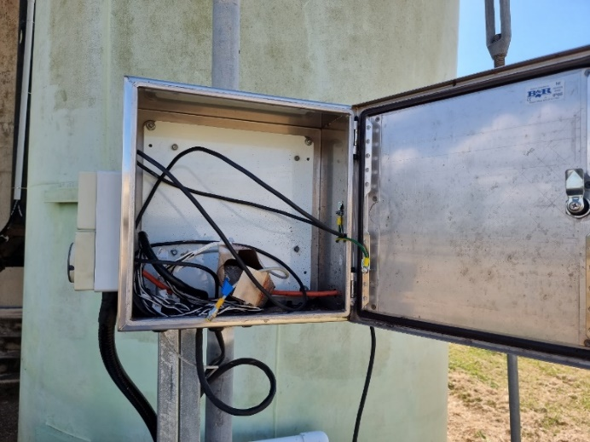
Figure 4-13 Cabinet housing turbidity meter transmitter (transmitter disconnected for repairs)

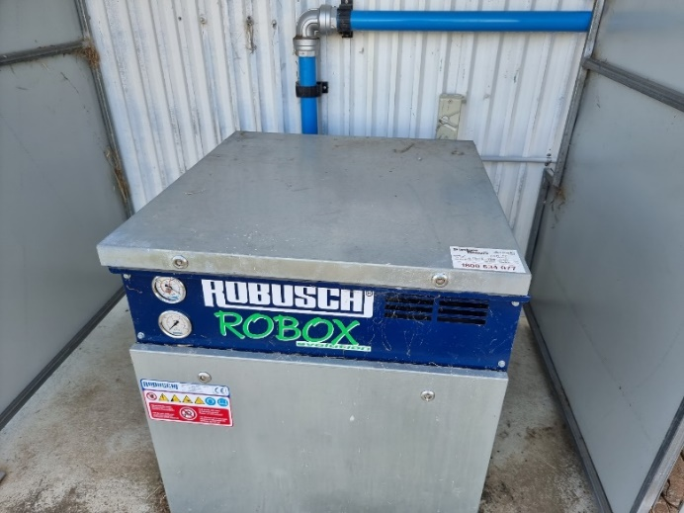
Figure 4-14 Air blower for filters

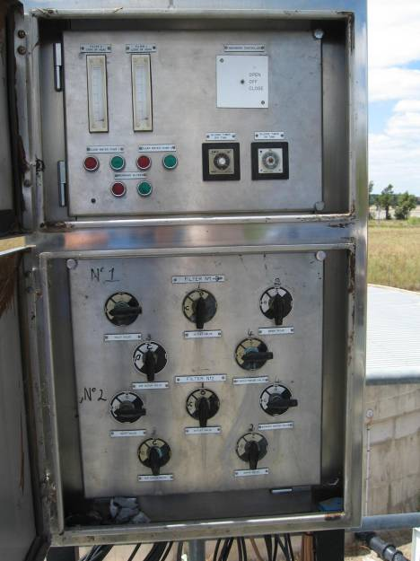
Figure 4-15 Filter Control Panel
The backwash water is drawn off from the treated water main downstream of the clear water pumps. The clear water pumps normally operate in response to level signals in the elevated town reservoir. If they are operating automatically at the time of backwashing, the operator need only open the backwash inlet valve for the water wash phase. If the clear water pumps are off when the backwash is being performed, the automatic controls can be overridden to start the pumps from the filter control panel, however the operator must remember to turn the pumps back to automatic control when the backwash is finished because, with the controls overridden, the pumps will not stop when the high level in the reservoir is reached. Reservoir overflows have reportedly occurred because of operator error in forgetting to return the pumps to automatic control.
An automated backwash system (with the capacity to allow manual backwashing when required) would reduce the operator time spent on this task and reduce the likelihood of operational mistakes. VSDs can be installed on the backwash pumps to enable ramping up and backwashing at different rates as required.
Filter backwashing component capacities and settings are outlined in Table 4-5.
Table 4-5 Filter Backwashing parameters
Component | Parameter (Units) | Design Criteria | Comments
Backwashing Parameters | Backwash control | Manual operation of valves and pumps | Backwashing can only be done manually.
 | Backwash phases | Procedure (manually controlled):  - Air scour (typically 2 min)  - Water wash (typically 10 min or until clean) | Filter valves are hydraulically operated from local control panel.
 | Backwash triggers | Manual backwash performed when:  - Filtered water turbidity > 0.6 NTU  - Headloss > 2.5 m  - Run time > 1 week
 | Backwash frequency (hours) | Filters are normally backwashed once per week | The two filters are normally washed on the same day
 | Air scour rate (m/h, L/s) | 42 m/h | From original manual
 | Air scour blower: capacity (m³/min) | 3.4 m³/min | From original manual
 | Water scour rate (m/h, L/s) | 24 – 42 m/h
 | Backwash pumps capacity | 35 – 62 L/s

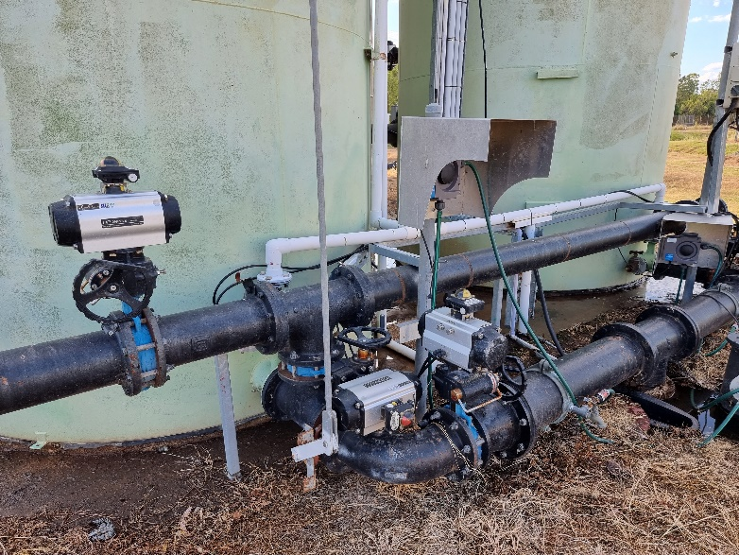
Figure 4-16 Backwash Water and Air Inlet Pipework

Post-Filtration Chemical Dosing

Chemical Dosing Locations
The chemicals dosed after filtration are:
- Post-filtration chlorine (for disinfection)
Chlorine is dosed into the filtered water pipe at the inlet to the clear water tank. The dosing point is shown in Figure 4-17.

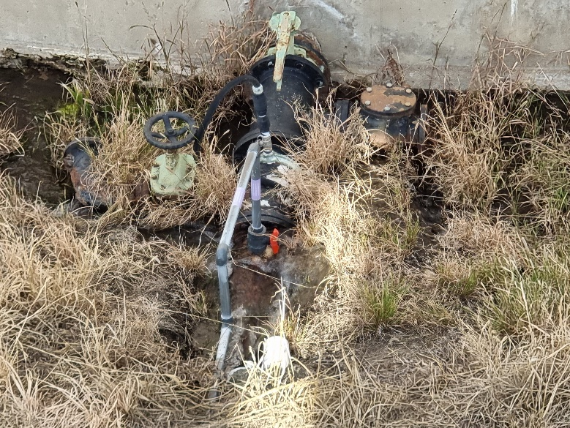
CLEAR WATER TANK
Post-Lime Dosing Point (Not used)
Post-Chlorine Dosing Point
Figure 4-17 Post-Chlorine Dosing Point

Post-Filtration Chlorine Dosing
Post-filtration chlorine (‘post-chlorine’) is dosed for the purpose of disinfection, to contribute a residual chlorine concentration to the water leaving the plant to prevent recontamination prior to consumption, and to prevent microbial growth in the reticulation pipes.
The post-chlorine dose is manually adjusted to meet the final water chlorine residual target.

Post-Filtration Lime Dosing
During the site visit, it was noted that post-lime is not currently used at the WTP.
Based on the WTP operating manual, post-filtration lime (‘post-lime’) was dosed to correct the pH of the water after coagulation and filtration to a level suitable for release into the distribution system. Soda ash was originally used as the alkali for both pre-coagulation and post-filtration dosing and was reportedly replaced by alkali lime in 1996. According to the original operating manual, the dosing pump was adjusted up or down based on the measured pH in relation to the pH target.

Clear Water Storage
The final treated water is stored in the clear water tank, from where it is pumped to the elevated town reservoir by the clear water pumps. A standpipe connected to the treated water rising main, located just outside the WTP site, is used to fill water trucks.
The main parameters of the clear water system are shown in Table 4-6.
Table 4-6 Treated Water System parameters
Component | Parameter (Units) | Design Criteria | Comments
Clear Water Storage Tank | Type | Round, concrete tank
 | Diameter, depth (m) | 20.6, 3 m deep
 | Total Capacity (ML) | 1.0 | Based on data sheet supplied by operator
 | Detention time | 10.3 hours at 27 L/s  14.6 hours at 19 L/s | Assuming no short circuiting
Clear Water Pumps (also used for backwashing) | No. and Capacity each (L/s) | 2 (duty/ standby),  Capacity:  - 20 – 25 L/s filling to elevated town reservoir (against 38 m head)  - 40 L/s when backwashing filters at WTP | Discharge from the clear water pumps is throttled to reduce flowrate to the network. Pumps currently operate 5-6 times per day.  Full capacity of the clear water pumps is utilized during a backwash cycle.
Elevated Town Reservoir | Capacity (ML) | 0.227 | Based on data sheet supplied by operator

The detention time in the clear water tank is extensive if the full 1 ML volume is used. However, it was noted that the inlet and outlet to the clear water tank are close together and not separated by a baffle, thus short circuiting is likely to occur, and the full contact time of the tank may not be used. Adequate contact time in the clear water tank is critical as water is pumped out of this tank directly into the distribution system. Ideally a baffle arrangement should be installed to ensure that the water does not short circuit through the clear water tank. Another potential solution is to extend the suction line of the high lift pump to ensure the intake point is away from the filtered water inlet pipe. However, this may require the clear water tank to be drained down. This will also increase the suction head of the high lift pumps and will need to be accounted for in the design of the new high lift and backwash pumps.
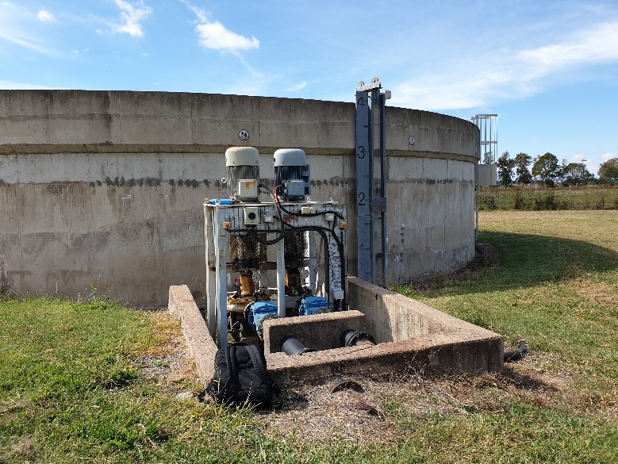
Figure 4-18 Clear Water Tank and Clear Water Pumps
The clear water pumps are centrifugal pumps which pump water through the town system and into the elevated reservoir in town, and also supply flow and pressure for backwashing the filters. The capacity of the clear water pumps was reported to be 28 to 35 L/s when filling the elevated town reservoir. The capacity will vary due to changing pressures within the town distribution system and varying levels in the reservoir.
Components on the treated water rising main after the clear water pumps (located where the main passes through an access pit) including the tee for backwash water supply, the treated water Magflow meter, a non-return valve and an isolation valve are shown in Figure 4-19. The treated water flow meter is continuously monitored and recorded on the SCADA system.
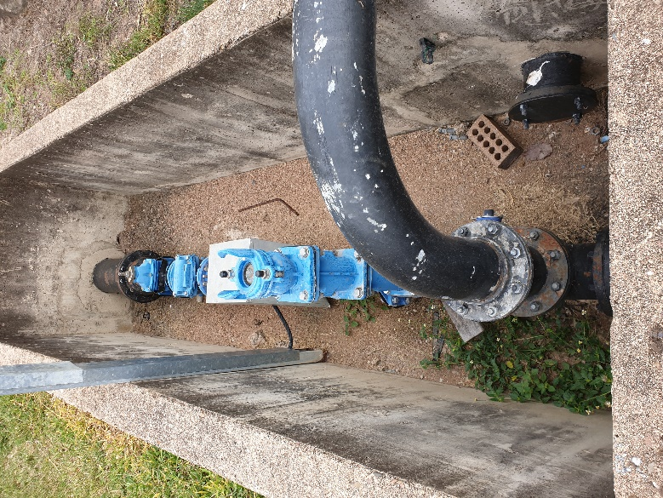
Water Flow
Figure 4-19 Pit on Treated Water Rising Main
The elevated town reservoir reportedly holds around 230 kL of water. The water flows to the elevated town reservoir through the reticulation when the WTP clear water pumps are on, and back-feeds out of the reservoir into the system when the clear water pumps are off.

Wastewater System
The main parameters of the wastewater system are summarised in Table 4-7.
Table 4-7 Wastewater System parameters
Component | Parameter (Units) | Design Criteria | Comments
Sludge Lagoons | No. of, dimensions | 2 lagoons, each 70 m x 52 m | Dimensions based on original operating manual
 | Typical maximum fill level | 700 mm sludge depth | Based on original operating manual
 | Sludge capacity (m³) | 2,550 m³ each (assuming 700 mm depth) | Lagoons appear to be adequate for current sludge production as operators report that suitable drying is achieved
 | Supernatant collection | Originally used supernatant collection weirs with adjustable stopboards. However, weirs have been blocked off – i.e. currently no supernatant removal | Major water discharge is by evaporation
 | Underdrains | Underdrains located under sand layer; underdrain isolation valves are located at discharge points on fence line | Underdrainage discharges into paddock next door to WTP. Underdrains usually closed while lagoon being filled.
Supernatant Recycling | Facilities | No facility for recycling supernatant from lagoons

Waste clarifier sludge and filter backwash water is normally directed into one of the two sludge lagoons via a flow splitting pit. During the site visit, it was observed that the chain connecting to the stopboards is rusted and broken (Figure 4-20). This will need to be repaired so that operators do not need to enter the pit to manually open/close the gates.
As noted above, the supernatant collection weirs have been blocked off and there is no other supernatant removal facility in the lagoons. Evaporation appears to adequately remove water from the lagoons to dewater the sludge. Volume of the dried sludge in the lagoon should be estimated, dug out and transferred to landfill.
The lagoons are fitted with underdrains, which can be opened or closed as required. The isolation valves for the underdrains are on the outlet of the discharge pipes, on the WTP fence line. When opened, the underdrains discharge the subnatant into the neighbouring paddock, with the permission of the landowner. According to operators, the underdrains are kept closed at all times and the sludge lagoons are dried out through evaporation. The lagoons reportedly have plenty of capacity for the wastewater levels produced and effective drying, even with no removal of subnatant.
The disposal of subnatant into the neighbouring paddock is not currently in use, but may become an environmental issue if required to be used in the future. Therefore, a method of collection or disposal of the subnatant may be considered by Council in the future.
It was noted that there was an overgrowth of vegetation on the sludge lagoons, which will need to be removed to maintain evaporation rates.
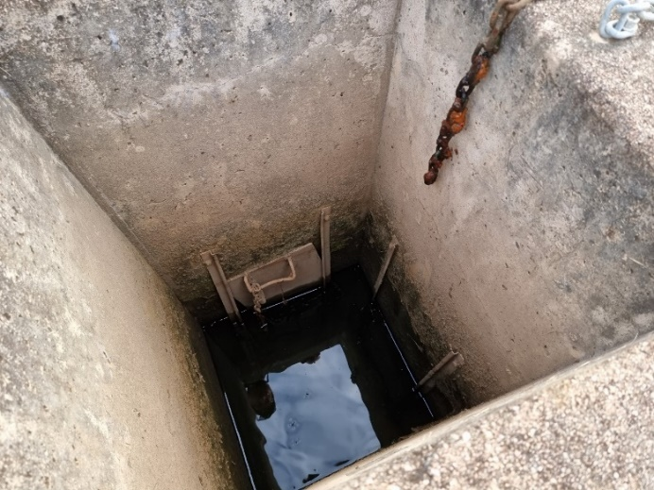
Figure 4-20 Sludge flow splitting pit showing sluice gates

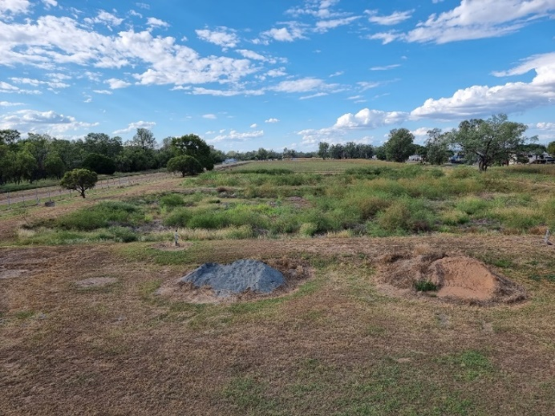
Figure 4-21 Sludge lagoons showing vegetation overgrowth

Plant Components Capacity Summary
The current capacities of the main WTP unit processes were estimated, based on the review of components in each unit process. A summary is shown in Table 4-8, along with notes on the main capacity-limiting factor for each unit process, and options which could be undertaken to increase the capacity of that unit process, if required.
Chemical system capacities are addressed in Chapter 5.
Table 4-8 Process Components Capacity Summary (based on a design flow rate of 27 L/s)
Component | Main Limiting Factor(s) | Estimated Maximum Capacity | Options to Increase Capacity (if required)
Raw Water Pumps | Pump condition/ capacity, river level | 22 L/s | Refurbish/ upgrade pumps, add more pumps  Funding for new pump station reportedly allocated by BSC
Plant Inlet and Flash Mixer | Hydraulic design | 27 L/s | Upgrade design
Clarifier | Flocculation time, surface loading rate | 27 L/s | Increase surface loading rating, add another clarifier
Filters | Filtration rate | 27 L/s (through both filters) | Add more filters
Clear water tank | Detention time | 27 L/s | Prevent short circuiting
Clear Water Pumps | Pump capacity | 20 - 25 L/s (pumping to elevated town reservoir) | Dedicated backwash pump(s)  Upgrade to pumps with VSD
Sludge Lagoons | Lagoon volume and drying time required | Not limited for current operations | Supernatant for site irrigation
From Table 4-8, it appears that the capacity of the raw water pumps and clear water pumps are currently the most limiting factors for the overall plant capacity. The raw water pumps flow rates will be limited when the river is at low level.
The current flow rates are sufficient for existing demand (as defined in Section 2.4). In order to meet future demand, the WTP may be required to increase the average flow rate or increase the operation time. The planned new raw water pump station with a design flow rate of 27 L/s should provide more consistent flow rates required to meet future demand.

Chemical Dosing Systems

Chemical System Descriptions

Ultrion 44560 Coagulant
Ultrion 44560 is currently used as the main coagulant at Theodore WTP. Ultrion 44560 is delivered in IBCs and is transferred using a transfer pump into the coagulant solution tank for dosing. Dosing is achieved with a single dosing pump.
The main details for the Ultrion 44560 dosing system are given in Table 5-1.
Table 5-1 Ultrion 44560 System parameters
Component | Parameter (Units) | Design Criteria | Comments
Ultrion 44560 | Chemical product and Strength (%) | Ultrion 44560 | Chemical composition is proprietary information
 | Batching system | Dosed undiluted | Product density is 1260 g/L
 | Storage space | 1 x 1000 L IBC stored in chemical shed
 | Dosing tank size | 1.35 m diameter, 1.5 m depth
 | Dosing pumps: No. of, Capacity (L/h) | 1 x 20.4 L/h

There are 2 coagulant storage tanks available, but only one is in use. There is no level sensor or level switches on the storage tank. There is only one Ultrion 44560 dosing pump. This dosing pump is flow paced and the dosing rate needs to be set manually via a dial on the pump. It was noted that carrier water was provided for coagulant dosing.
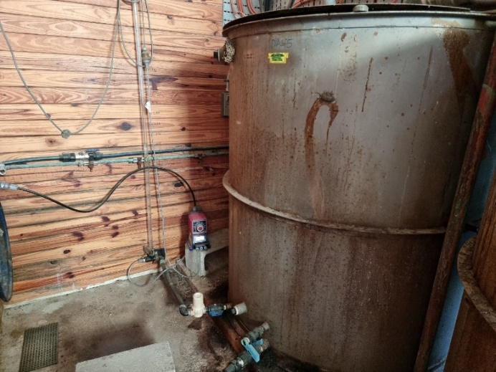
Figure 5-1 Coagulant storage tank
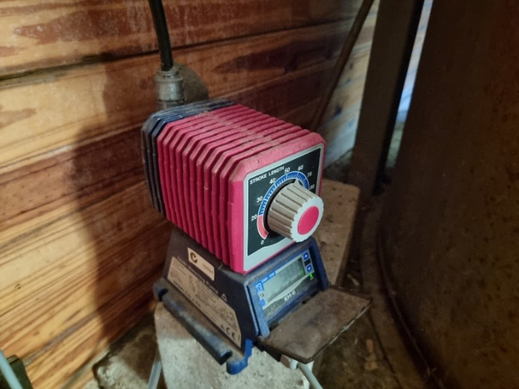
Figure 5-2 Coagulant dosing pump

Polyacrylamide (LT25) Polymer
The polyacrylamide LT25 is supplied as a powder and batched manually. The powder is loaded slowly into the tank while the mixer is running. The main details for the polyacrylamide makeup and dosing system are given in Table 5-2.
Table 5-2 Polyacrylamide System parameters
Component | Parameter (Units) | Design Criteria | Comments
Polyacrylamide System | Chemical product and Strength (%) | Magnafloc LT25, supplied as powder | Density 750 g/L
 | Storage space (bags) | Up to 10 bags stored in chemical dosing shed.
 | Batching system | Manual loading into feed hopper
 | Batching concentration (g/L) | 1.28 g/L | 640 g of powder into 500 L
 | Dosing tank size | 0.8 m diameter x 1.2 m depth
 | Dosing pumps: No. of, Capacity (L/h) | 1x 26.5 L/h | Capacity per pump nameplate. Dosing pump model is US Filter Encore 100

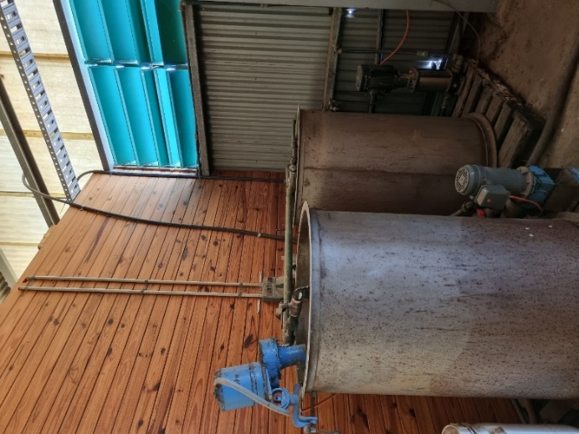
Figure 5-3 Polyacrylamide (LT25) storage tanks

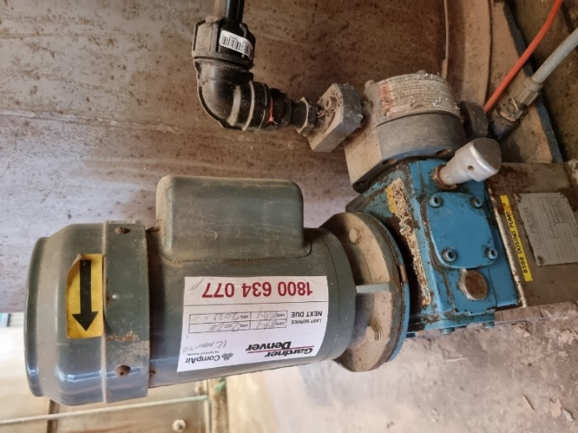
Figure 5-4 Polyacrylamide (LT25) dosing pump
There are 2 LT25 storage tanks available, but only one is in use. There is no level sensor or level switches on the storage tank. There is only one LT25 dosing pump (no standby). The dose rate of LT25 is adjusted manually at the dosing pump. It was noted that carrier water was not provided for LT25 dosing.

Chlorine
The chlorine room is a separate room in the chemical dosing shed, accessed from the outside of the shed. The chlorine room houses up to six cylinders (two on-line cylinders plus standby cylinders) and the pre-chlorine and post-chlorine chlorinators. It was noted during the site visit that the pre-chlorine line was not connected to the chlorinators, and the pre-chlorine chlorinator was isolated.
The chlorine booster pump is housed inside the chemical dosing shed, next to the polyacrylamide batching tank.
The main details for the pre- and post-chlorine dosing systems are given in Table 5-3.
Table 5-3 Chlorine System parameters
Component | Parameter (Units) | Design Criteria | Comments
Chlorine System | Chemical product | Chlorine gas (70 kg cylinders)
 | Chlorine room capacity (cylinders) | 4 to 6 x 70 kg cylinders | 2 duty (1 x pre and 1 x post), remaining cylinders unconnected standbys
 | Ejectors: No. of, Type, Capacity (g/h) | 2 (1 x pre and 1 x post dosing), S10k Rotameters, capacity of 1000 g/h | Ejector capacity based on rotameter scales. * Note that design maximum gas discharge rate from a 70 kg cylinder is:  - 1200 g/h at 15 deg C  - 700 g/h at 10 deg C  Thus, pre-chlorine likely to be limited to approx. 1200 g/h in winter
 | Booster water pumps: No. of, Capacity (L/s) | 1 common to both pre and post dosing. Type Grundfos CR-5. Capacity of 5.8 m³/h | No installed standby
 | Load cells capacity | 2 load cells | Connected to the Wizard 4000 digital weight indicator
 | Service water supply | Supplied from clear water tank
 | Chlorine leak detector: Type | Acutec 35 | Hydra-sentinel automatic chlorine shutdown system

It was noted that the chlorine system has been upgraded with 2 load cells connected to the Wizard 4000 digital weight indicator and a vacuum regulator with internal auto changeover system. If one chlorine cylinder is emptied, the vacuum regulator will switch over to the full cylinder. A Hydra-Sentinel automatic chlorine shutdown system was also installed to automatically isolate the chlorine cylinders if any leak is detected.
The continued dosing of post-chlorine is critical for disinfection of the final water. It was noted that an ATI Q46 analyser was installed to measure the free chlorine concentration and pH of the treated water. It was also noted that only one chlorine booster pump is available.
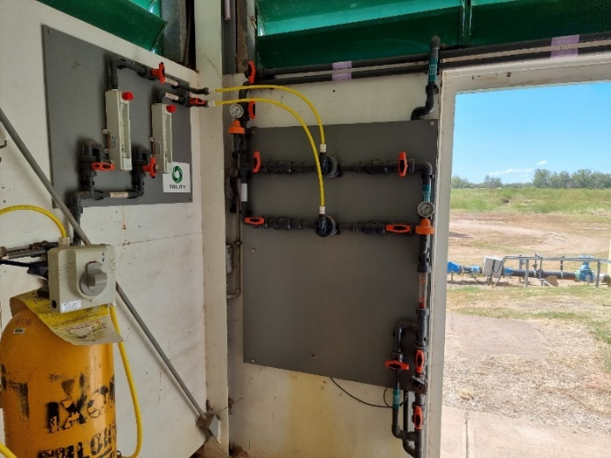
Figure 5-5 Chlorinators
The design of the chlorine systems and the chlorine room is compared to some of the requirements of the Australian Standard for chlorine installations (AS/NZS 2927: 2019) in Table 5-4.
Table 5-4 Australian Standard Requirements for Chlorine Installations
Clause | Reqts Met? | Comments
Cladding or lining of any indoor installation shall be non-combustible. (Clause 6.5.1) | N | Fibro panelling may not be suitable (potentially combustible)
Where kept with other dangerous goods, chlorine storage area shall be clearly delineated and marked with signs (Clause 6.5.1) | Y | Chlorine sign displayed outside door, visible when door open
Personnel doors shall open outwards and be fitted with devices to hold the door open (Clause 6.5.2) | Y | Door opens outwards and latch supplied
A sign, indicating that the door is to be kept open whenever personnel are inside, shall be fitted outside the door and shall be visible when the door is open (Clause63.5.2) | Y | Adequate signage
Natural ventilation required for areas where 2000 kg or less of chlorine is stored.  Natural ventilation requires at least 0.1 m² of vents for each m length of wall, in opposite walls (Clause 6.5.3.4) | Y | Adequate ventilation near floor level on opposite walls to provide cross-draught
Leak detectors shall be installed in chlorination rooms or where chlorine is connected for use. Leak detectors shall be tested at least weekly (Clause 7.8.1) | Y | Leak detector installed. Leak detector is tested weekly with sufficient recorded documentation.
Wind direction indicators shall be installed where chlorine containers are connected for use (Clause 7.8.4) | N | No wind direction equipment

From Table 5-4, wind direction indicators (e.g., wind sock) is recommended in order to comply with Australian Standard requirements.

Lime
Lime dosing system is available onsite, but lime is not currently dosed as part of the water treatment process at Theodore WTP.
The main details for the lime makeup and dosing system are given in Table 5-5.
Table 5-5 Lime System parameters
Component | Parameter (Units) | Design Criteria | Comments
Lime System | Chemical product and strength (%) | Hydrated lime. Various suppliers. Varying purity | Poor quality lime implicated in pump and line blockages
 | Makeup and dosing system components | Bag unloading chute.  Solution mixing tank.  Dosing pump | Manual loading into tank
 | Number of makeup systems | 2 solution tanks | Can be used as duty/standby
 | Storage capacity | 1-2 pallets of lime in 20 kg bags
 | Bag unloading arrangement | Bags manually unloaded into solution tank | Dust extraction system available
 | Batching concentration (g/L) | Approx 23.5 g/L (2.35%) | 2 x 20 kg bags (40 kg) lime per 1700 L tank
 | Solution tank capacity (L) | Approx 1700 L | Per original manual. Note that operators gave tank capacity as 1700 L and other data as 1840 L
 | Dosing pumps: No. of, Capacity (L/h) | None
 | Dose adjustment method | Change pump stroke rate
 | Service water supply | Supplied from treated water rising main

Based on previous operational information, lime is batched manually into a standard concentration dosing solution. This requires manual lifting and unloading of bags into 2 storage tanks available. The dosing solution is delivered to the dosing point by a single metering pump.
The lime system was set up to automatically flush the pump and dosing line with service water both periodically during operation (with operator-adjustable duration and frequency) and on plant shutdown (with operator-adjustable duration).

Chemical Dosage Rates
Table 5-6 shows the dose rates of the chemicals currently used at Theodore WTP based on operational data provided.
Table 5-6 Dose rates of chemicals used at Theodore WTP
Chemical | Dose rate (mg/L)
Ultrion 44560 coagulant | 9.8 – 19.8
Polyacryamide (LT25) polymer | 0.05
Post-chlorine disinfection | 4.5 – 5.3 (g/h)

As requested by Council, an assessment was performed on coagulant dose vs. raw water and treated water turbidity. Results are provided in the figures below.
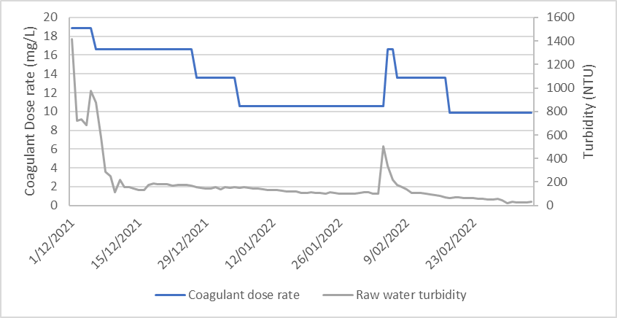
Figure 5-6 Coagulant dose (mg/L) vs. Raw water turbidity (NTU)
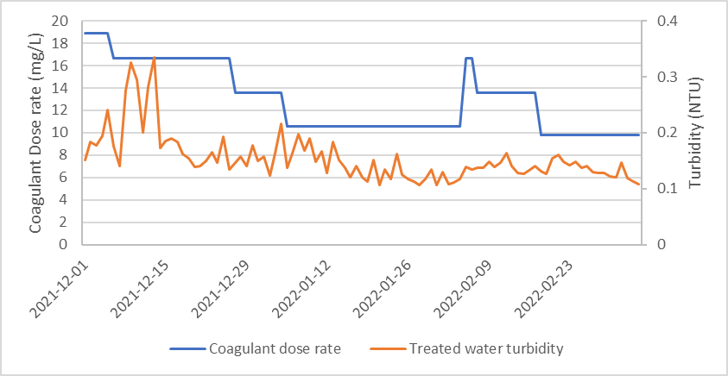
Figure 5-7 Coagulant dose (mg/L) vs. Treated water turbidity (BTU)
There was correlation between the recorded coagulant dose and raw water turbidity during the assessment period (late 2021 to early 2022). As noted in the Section 5.1.1, the coagulant dose pump is flow paced and the dosing rate is set manually by the operator. Based on Figure 5-6, operators responded to changes in raw water turbidity by varying the coagulant dose during the assessment period. Treated water turbidity did not have significant variation or graphical correlation to the coagulant dose during the assessment period.
- Chlorine dose rate vs. chlorine residual measurement was also compared, as requested by Council. The analysis was not conclusive, as the chlorinator rate is recorded as “g/hr or mg/L” in the operational data; these are different units and the values recorded ranged between 0.2 – 5.5 (between 30-06-2017 to 07-03-2022). For majority of data points (except 24-09-2021 onwards), the free chlorine residual measured in the treated water exceeded the value of the chlorinator dose (if assumed the data was reported in mg/L). This should be the other way around.
- Magnafloc dose was not recorded or was nil during the assessment period, according to the operational data.

Chemical System Capacity Summary
The current maximum capacities of the chemical systems in mg/L for various plant flows were calculated, based on the review in Section 5.1, and are shown in Table 5-7. This represents the maximum dosage rates of each chemical based on chemical dosage pump capacities at current dosing solution concentrations. The options for increasing the capacity of each system are also listed.
Table 5-7 Chemical System Maximum Capacities
Chemical | Dosing Pump Capacity (L/h) | Dosing Solution Concentration (g/L) | Calculated dose capacity (mg/L)  @ 25 L/s | Calculated dose capacity (mg/L)  @ 27 L/s | Batch Tank Volume (L) | Options to Increase Capacity (if required)
Ultrion 44560 | 20.4 | 1260 | 285 | 265 | 2000 | Larger pump
Polyacrylamide (LT25) | 26.5 | 1.28 | 0.38 | 0.35 | 600 | Stronger solution, larger pump
Pre-chlorine  (not used currently) | 1000 g/h | N/A | 11 | 10 | 70 kg | Recently upgraded
Post-chlorine | 1000 g/h | N/A | 11 | 10 | 70 kg | Recently upgraded
Post-lime  (not used currently) | 0 | N/A | N/A | N/A | 1700 | Stronger solution, larger pump

Comparing Table 5-6 and Table 5-7, it is shown that:
- The Ultrion 44560 coagulant dosing system is sufficient for current dosage requirements and has plenty of capacity to handle future plant capacity increases if required.
- The polyacrylamide polymer dosing system is sufficient for current dosage requirements and has plenty of capacity to handle future plant capacity increases if required.
- The post-chlorine dosing system has been upgraded and is sufficient for current dosage requirements and has some capacity to handle future plant capacity increases if required.

WTP Issues

Plant Control and Automation Issues

General Observations
In general, the existing process at Theodore WTP is relatively simple, but requires more operator input than automated systems. It was noted that the operations and control system at Theodore WTP has a low level of automation, with no automatic chemical dosing adjustment and a fully manual backwashing procedure.
Improvements to the automation of the treatment process would help with:
- consistently meeting regulatory requirements
- improving process performance and reliability
- saving cost chemicals, energy, and labour

Electrical switchboards
An electrical audit at Theodore WTP had found water pooling in the cable corridor of the main switchboard and heavy corrosion around the electrical equipment. It was understood that the existing switchboard at the Theodore WTP has reached end of life and is not compliant with current safety standards. It is recommended that the electrical switchboard be replaced to maintain reliable performance and compliance with current safety standards.

Control of Plant Startup and Shutdown
The plant is automatically started and stopped based on water demand via the following control loops:
- High Lift Pump Control: The elevated town reservoir level signal is used to generate a start/stop signal to the WTP high lift (treated water) pumps via the SCADA. The start/stop signals can be set on the SCADA system;
- Raw Water Pump Control: The WTP clear water tank level signal is used to generate a starts/stop signal to the raw water pumps via telemetry;
- Chemical Dosing Systems Control: A level switch installed in the flash mixing tank is used to generate a start/stop signal to the WTP chemical dosing systems. The chemical dosing systems start when the operating water level is reached in the flash mixer/ clarifier.
It is noted that all valves on the flow path through the WTP remain open when the plant is off. The filter inlet and outlet valves are manually operated only.
Operators explained that there was a communication issue between WTP and the raw water pump station. This required operators to notice the raw water pumps not starting up and resetting the control system intermittently.

Process Impacts of Plant Start-up
It is noted that the clarifier and chemical dosing systems generally run more smoothly with continuous rather than start/stop operation. Flow changes due to plant start-up may disturb settling in clarifiers and over/under dosing of chemicals due to delays in the start-up or shutdown of the chemical dosing system.
It is noted that start-ups can have an impact in limiting further optimisation of the treatment process in future, the number of start-ups per day could be reduced by:
- altering the start and stop levels in the clear water tank and elevated reservoir;
- fitting VSDs to the raw water pumps.

Filter Backwashing Automation
As discussed in Section 4.6.3, the backwashing system can be improved to make operation easier and reduce the chance of operator error by:
Upgrading control of filter valves and provision for an automated backwash sequence
Installing dedicated backwash pump(s)
Installing magnetic flowmeters on the backwash water line
Installing VSD on backwash pumps to allow for ramping up and backwashing at different rates as required.

Online Monitoring
The existing and planned online monitoring facilities for the WTP are summarised in Table 6-1.
Table 6-1 Online Monitoring Meters Summary
Parameter | Sensor | Sampling location | Comments
Turbidity | HACH | From filtered water sample line (drawing from tapping in common filter outlet pipe) | Logged to SCADA. High turbidity alarm set to 2 NTU.  Transmitter sent for repairs; manual testing required until transmitter reinstalled.
pH | ATI Q46 | Treated water rising mains | Logged to SCADA
Chlorine Residual | ATI Q46 | Treated water rising mains | Logged to SCADA
Raw Water Flow | ABB Magflow meter | Raw water main (under metal cover) | Logged to SCADA (through chart recorder)
Treated Water Flow | ABB Magflow meter | Treated water rising mains | Logged to SCADA (through chart recorder)
Clear Water Tank Level | ‘Platypus’ pressure sensor plus Hi/ Lo level float switches | Clear water tank | Level sensor logged to SCADA.  Hi/ Lo float switches trigger alarms on SCADA
Elevated (Town) Reservoir Level | ‘Platypus’ pressure sensor plus Hi/ Lo level float switches | Reservoir | Level sensor logged to SCADA.  Hi/ Lo float switches trigger alarms on SCADA
Filter Headloss | N/A | N/A

From Table 6-1, flow rates, filtered water turbidity, critical tank levels and treated water parameters are monitored by on-line instruments. Most of these signals are connected to the SCADA system and thus are understood to be able to be trended. It is recommended that differential pressure sensors, dedicated backwash pumps and backwash line magnetic flowmeter be installed to provide better control, optimised system for operation of the backwash cycle and reduced water losses.

Plant Operational and Maintenance Issues

Clarifier
During the site visit, it was noted that the launders on the clarifier were above the surface of the water. The launders need to be adjusted so the outlet holes of the launders are below the surface of the water.
According to operators, operators need to estimate the sludge level in the clarifier and perform manual desludges weekly. The sludge level will need to be monitored closely or it may cause a build-up of sludge in the clarifier and lead to the sludge rake getting stalled or carry over of flocs into the launders. It is recommended a sludge judge be provided for operators to measure and record the sludge level in the clarifier daily.
During periods when the clarifier needs to be offline for repairs or refurbishment, the WTP will need to be shut down. To mitigate this risk on water security, it is recommended that a duplicate clarifier be installed. This allows the WTP to operate as normal when one of the clarifiers is taken offline.
Another method to provide water security while the clarifier is offline is to find and integrate alternative raw water sources (eg, bore water) into the WTP. However, this will require further investigation into alternate water sources and treatment requirements.

Filters
During the site visit, the turbidity transmitter on the filter outlets was sent for repairs and has not been reinstalled. This has required operators to manually sample and test the turbidity of the filtered water. This could potentially lead to filter breakthrough and the WTP not meeting treated water targets. The filters are currently manually backwashed 3 times a week (Monday, Wednesday and Friday) by operators. It is understood that the turbidity transmitter has been received and reinstalled after the site visit. It is recommended that differential pressure sensors be installed on the filter tanks to measure the head loss through the filter beds as an indication of media saturation. This also provides a layer of redundancy to the filtered water turbidity sensor for determining filter breakthrough.
It was noted that the current filter operation does not allow for filter-to-waste operation when the filtered water turbidity exceeds operational target. This could potentially compromise the treated water quality in the clear water storage. It is recommended that a filter-to-waste system is installed to improve filtered water quality. This will require installation of a new automatic filter-to-waste valve and new pipeline directing filtered water outlet from the filters to the sludge lagoons.
It was noted that the filters were refurbished in 2013. It is recommended that a condition assessment of the filter be conducted to inform the performance and remaining life of the filter and media.

Clear Water Tank
It was noted that Theodore WTP has only one clear water tank. If the clear water tank requires maintenance, the WTP will need to be shut down for an extended time. This may lead to water security issues. It is recommended that a second (smaller) clear water tank be installed so that the WTP can operate normally while the main clear water tank is unavailable. The smaller tank to be sized based on low demand period.
BG&E was commissioned to perform a condition assessment of the roof of the clear water tank. The assessment reported several defects in the roof structure including corrosion on fixing, connections, gutter and steel beams, as well as concrete spalls. The report recommended remediation of the corroding sections and further assessment to determine the nature and extent of the spalling.

Chemical Dosing System
The chemical dosing pumps starts when the WTP starts, with the dosage rate manually adjusted by operators on the dosing pumps. The chemical dosing system can be upgraded to a flow paced dosing system using existing flowmeters for more optimised operation.
It was noted than there is only one pump available for the dosing of each chemical. With the current system, operation of the WTP would be severely impacted if any of the chemical dosing pumps went offline. It is recommended that a standby dosing pump is installed for each chemical dosing system to reduce the risk of plant downtime due to equipment failure and to allow for maintenance to be carried out without affecting the operation of the WTP.

Wastewater System
During the site visit, CWT noted that the chains connected to the stopboards at the flow splitting pit into the sludge lagoons were rusted and broken. This will require operators to enter the pit to manually open/close the gates when switching between sludge lagoons. It is recommended that the chains and stopboards be refurbished to reduce the risk for operators when operating the stopboards.
It was also noted that both the sludge lagoons had an overgrowth of vegetation (Figure 4-21). This can reduce the evaporation rate of the sludge. It is recommended that the vegetation overgrowth be cleared out as soon as possible to improve the performance of the sludge lagoons. It is also recommended to investigate alternative sludge dewatering options.

Manganese issues
Based on operational data, the plant currently operates well with respects to the removal of incoming manganese. However, consideration should be given to the installation of a potassium permanganate dosing system to ensure the WTP has a manganese removal step.
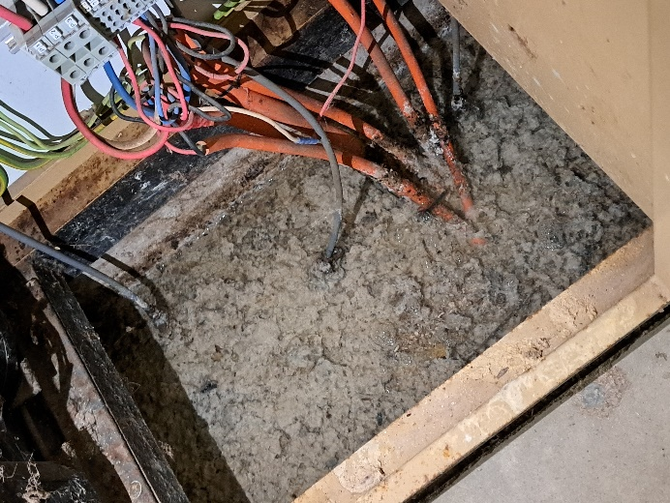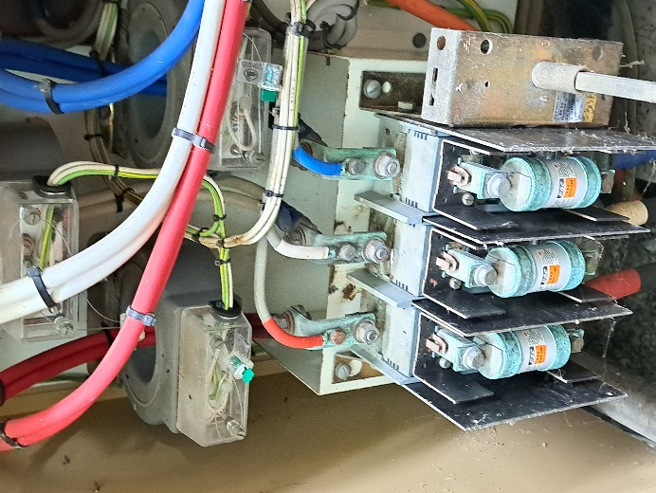
Figure 6-1 Electrical switchboard
It is understood that the site laboratory is in the same building as the main switchboard. It is suspected that regular water sample testing and chemical usage in the laboratory may have led to increased deterioration of the main switchboard. It is recommended that a separate building be made available to house the site laboratory.

Power Failure Protection
It is noted that there is an onsite emergency diesel generator. The generator can be used to power the plant when there is a local power failure at the WTP. Power supply is still required to run the raw water pumps.
The generator is housed in a shed behind the plant building. Diesel fuel for the generator is obtained from the Council construction crew. It was noted during the site visit that the changeover switch is not working. BSC indicated that changeover switch will be fixed within the month as a separate package of works.

Operations during Floods
Significantly large floods have negatively impacted the operation of the WTP and water security in the region in the past. It is recommended that further investigation into all WTP assets, their elevation and operability in flood waters to gain an understanding of the works required to enable the WTP to continue to operate during flood conditions.

Maintenance Tasks
Day-to-day operation and maintenance duties are understood to be carried out by staff based in Theodore with support from Taroom. Other activities are organised by Council management representatives as required. It is understood that Council have staffing issues.
The introduction of full process automation to the WTP is expected to reduce the manual operation hours required and allow operators to carry out their tasks more efficiently.

Safety and Environmental Issues
The following safety and environmental issues were noted during CWT’s site visit; however this is not intended to be a full and exhaustive OH&S audit.

Chemical Bunding
From Figure 5-1 and Figure 5-3, it is noted that none of the chemical solution tanks in the chemical shed is separately bunded. Also, none of the chemical dosing pumps is within a bund. Chemical spills would tend to leak into the pipe trenches in the floor of the chemical shed. Chemical spills on the shed floor would be a health hazard. And it is likely that large spills would find their way outside the shed and potentially enter the environment.
It was noted that a spill kit containing equipment for cleaning up and isolating chemical spills is provided at the plant. Based on WTP drawings, chemical spills would flow into the WTP septic system. All chemical storage and batching/ dosing tanks and all chemical dosing pumps should be bunded to prevent the spillage of chemicals. Bunds should be built to conform with standards on design and materials.

Manual Handling
Manual handling issues identified on the plant include:
- Manual handling of PAC and dosing procedure requiring buckets to be carried up the stairs to the filters (if used).
It is noted that a new electric hoist and an electric trolley was installed in the chemical preparation room in 2018 for lifting and transporting of pallets or chemical bags. This helps to lift the bags more quickly and easily onto the loading platform, as well as transporting the bags across the platform to the unloading areas.
It is recommended that, if PAC is to be dosed in the future, a PAC dosing system comprising of batching tanks and dosing pump(s) be installed to reduce the risk of manually handling and dosing of PAC.

Contact with Chemicals
As chemicals are batched manually, there is some potential for the operators to come in contact with the chemicals used such as polymer powders or lime and PAC if used again in the future.
It is noted that a dust extractor is provided for the lime unloading system. Dust masks and other PPE should be worn when handling PAC and polymer powder.
Any upgrades of the chemical systems should consider ways to further minimise the risk of operator contact with chemicals.

Chlorine Gas
During the site visit, it was also noted that there is no wind direction indicator near the chlorine building. It is recommended that a windsock be installed to comply with OHS guidelines.
During the site visit, it was noted that the SCBA cabinet outside the chlorine building was found to be empty and not weatherproof. Operators indicated that the SCBA unit is currently placed in the WTP laboratory next to the chlorine building. It is recommended that a waterproof SCBA cabinet be provided to house the SCBA unit.
A hazardous chemical audit report by Trility noted that there were exposed timber sections in the chlorine building. The report noted that no carbon filter was available in the chlorine building. Trility’s report also noted that safety signage was inadequate, including ‘Danger’, ‘Chlorine’, ‘Restricted Area’ and ‘HazChem’ signs.

Stairways and Unguarded Platforms
There are a number of stairways and platforms which may not conform to modern safety standards. These include:
- The chemical unloading platform – permanent railing or chain arrangement required where chemicals are unloaded;
- Stair-ladder for chemical loading platform – may be too steep;
- Stair-ladder to filters/ clarifier – may be too steep;
- Lockable cages on stair-ladder to filters/ clarifier and on clear water tank – Design may allow cage door to fall on hand/ head.
- Platform outside chlorine building – permanent railing or chain arrangement required.
These installations should be checked against relevant standards. Improvements to increase safety on the above issues of concern should be progressed as soon as possible.

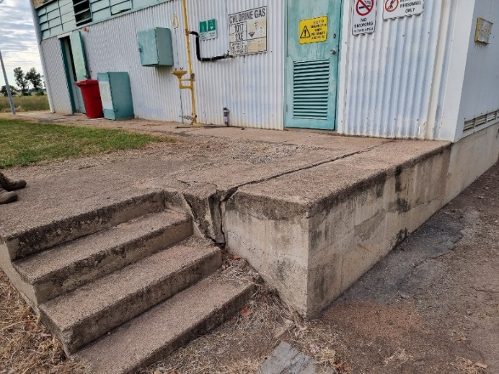
Figure 6-2 Platform outside chlorine building
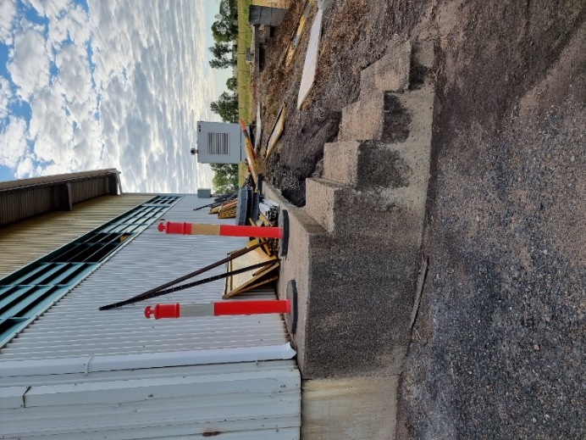
Figure 6-3 Stairway behind chlorine building

Process Water
During the site visit, CWT noted that no RPZ valve was installed on the process water line. The process water line is a draw off from the outlet line of the clear water tank. This may result in back pressure or back-siphoning of the process stream into the process water line leading to contamination of the process water. It is recommended that a RPZ be installed in the process water line to mitigate the risk of process water contamination.

Laboratory and Office Facilities
The laboratory area provided at the WTP is small and rudimentary but appears to serve the purpose as a place for daily water testing and jar testing. It is noted that the room is not air-conditioned, which may be a concern for operator comfort and for the storage of reagents and instruments.
The office hut also contains a small kitchen area for lunch preparation. The level of security for computers and other equipment stored in the office may potentially be a concern because of the remoteness of the site and the insecure louver windows on the hut.
It is noted that a security fence has been erected around the plant area. The plant gates should be locked when the site is unattended.
The laboratory, office and lunch facilities could be improved to provide better operator comfort and security.

Site effluent
Site effluent is currently being disposed of in old septic tanks/ trenches. It is understood that the existing system is approaching it’s the end of its lifespan and BSC has been considering potential options for site effluent disposal. An option may be installing a rising main connecting to the towns sewerage system. However, this rising main will need to cross a water main and irrigation channel. Further investigation is required to assess the options for site effluent disposal.

Summary of Findings and Issues

Findings

Water Quality Issues
A review of the raw water and WTP treated water quality found that:
- Raw water issues include very high turbidity and colour from river flow events, periodic high manganese levels and taste and odours. Herbicides are known to be present. Algal toxins are a potential risk;
- WTP treated water typically meets both ADWG limits and WTP CCPs, with periodic excursions on treated water turbidity and true colour. The chlorine residual measured after the clear water tanks is highly variable and low residuals may sometimes compromise disinfection. Manganese targets are occasionally exceeded;
- pH and alkalinity levels are mostly within ADWG limits, but the WTP lacks pH control as currently operated. This risk can be mitigated by reinstating post-lime chemical dosing;
- Herbicides have been present in treated water, but are within the ADWG recommended levels;
- From modelling of corrosivity potentials, the typical treated water is likely to be only mildly corrosive except under worst case conditions.
Note: For more details on water quality and corrosivity indices refer to Section 3.3 and Section 3.4 respectively.

WTP Flow Rate and Demand Issues
The design flow rate of Theodore WTP is 27 L/s. Due to raw water pump capacity limitations, the WTP normally operates at 15 – 23 L/s, which is sufficient to meet current maximum daily water demands. The planned new raw water pumping station (design capacity of 27 L/s) should provide more consistent flow through the WTP.
Adequate process performance was reported at 27 L/s, although further extended trials could be undertaken to confirm performance under various conditions.
The Theodore WTP is expected to be able to meet projected future water supply demand in the Theodore area, including future demand from a proposed new motel development. This may require increasing the WTP operation time from an average of 7 hours to 8 hours. (Refer to Section 2.4 for more details)

WTP Process, Chemical Systems and Operational Issues
A review of the WTP treatment processes and chemical dosing systems found that:
- Most of the plant components are sized to achieve the design flow of 27 L/s. The raw water pumps limit the achievable flow rate, particularly at low river levels.
- Plant control and automation, safety and maintenance issues were also reviewed, with various recommendations identified in Section 6 of this report.

WTP Future Options
Three broad options for the future of the Theodore WTP have been identified:
- Option 1- Do Nothing
- Option 2 – Refurbish the existing WTP
- Option 3 – Construct a new WTP
These options are outlined and discussed in the subsequent sections.

Do Nothing
The first option – do nothing – is to continue with the current operation of the existing WTP. No capital costs are adopted in this option.
By selecting this option, BSC would be accepting the operational, WHS risks of the existing WTP as well as any unidentified or unanticipated risk. The main overarching risks associated with continued operation of the WTP are:
- Risk of turbidity breakthrough/water quality risk
- Risk of failure due to ageing infrastructure
- WHS risks to operators within plant

Refurbish Existing WTP
Refurbishment of the existing WTP would involve keeping the main components of the WTP but upgrading them for continued and improved operation.

Process Upgrade Recommendations
The recommended process upgrades are summarised in Table 8-1. An estimated cost for each upgrade is included and estimated with an accuracy of ±30%.
Table 8-1 Summary of recommended upgrades for Theodore WTP
Plant Area Description | Recommendation | Effort | Impact | Cost
Complete immediately
Raw water | Upgrade raw water pumps to achieve design flow of 27 L/s (it is understood this upgrade has already been approved) | High | High | No cost
Raw water | Install VSD on raw water pumps to reduce start-up/ shutdown frequency (it is understood that the raw water pump station design is ongoing) | High | High | No cost
Raw water | Install online turbidity meter to monitor raw water turbidity level | High | High | $12,500
Filters | Install differential pressure sensors to monitor filter bed headloss | High | High | Refer to Table 8-2 below
Backwash system | Install dedicated backwash pump(s) with VSD to reduce risk of operator error | High | High | Refer to Table 8-2 below
Coagulant Dosing System | Install level sensor/switch in storage tanks | Low | Medium | $4,000
Polymer Dosing System | Install level sensor/switch in storage tanks | Low | Medium | $4,000
Chlorine Building | Update safety signage and install windsock. | Low | Medium | Minor
Clear Water Tank | Install second clear water tank | Medium | Medium | $700,000
Clear Water Pumps | Install new dry mount submersible clear water pumps with VSD | High | Medium | $10,000
Process water | Install RPZ valve | Medium | High | $1,500
SCADA | Currently only few SCADA pages available.  Controls need to be upgraded. | High | High | $200,000
Electrical Switchboards | Replace switchboard | Medium | High
Complete within 12 months
Flash mixer | Install mechanical or inline static mixer | Medium | Medium | $3,000
Flocculators and Clarifier | Installing second clarifier for redundancy (structure and mechanical equipment) | High | High | $500,000
Backwash system | Install magnetic flowmeter on backwash line | High | Low | $10,000
Filters | Condition assessment of filters | Medium | High | $25,000
Clear Water Tank | Install a baffle between inlet and outlet pipes to prevent short circuiting of treated water allowing for better residence time | Low | Low | $50,000
Coagulant Dosing System | Install new coagulant dosing pump skid equipped with duty/standby dosing pumps, calibration tube, strainer, pressure loading vales, etc | Medium | Medium | $50,000
Polymer Dosing System | Install standby pump | Medium | Low | $8,000
Polymer Dosing System | Install carrier water line for dosing | High | High | $5,000
Polymer Dosing System | Install automatic polymer batching system | Low | Low | $10,000
Elevated town reservoir | Install visual indicator of water level in reservoir. | Low | Low | $3,000
Site laboratory | Upgrade site laboratory | Medium | Medium | $50,000
Complete within 24 months
Flash mixer | Repaint flash mixing tank coating | High | Medium | $10,000
Clarifier | Refurbish mechanical parts (motors) for mixer and rake in poor condition | High | High | $20,000
Clarifier | Repair corrosion of clarifier interior wall | High | Medium | $10,0000
Filters | Repaint coating on filter tanks | High | Medium | $20,000
Clear Water Tank | Repair roof structure defects | High | Medium | $50,000
Coagulant Dosing System | Install bunding | High | High | $1,000
Polymer Dosing System | Install bunding | High | High | $1,000
Other Chemical Dosing Systems | PAC dosing system | High | High | $120,000
Other Chemical Dosing Systems | KMnO₄ dosing system | High | High | $80,000
Site effluent disposal | Investigate options for site effluent disposal (septic tank or connection to town sewerage system) | Low | Medium | $10,000
Sludge | Investigate alternative sludge dewatering options | Low | Low | $20,000
Total cost |  |  |  | $2,078,000

Automation Upgrade Requirements
Error! Reference source not found. Table 8-2 summarises the automation upgrade requirements for Theodore WTP.
Table 8-2 Summary of automation upgrade requirements for Theodore WTP
System | Upgrade requirement | Cost
PLC and SCADA | PLC and RTU units.  Upgrade SCADA pages. | $250,000
Electrical Switchboard | Mains Switch, Power meter, Power distribution section.  Ethernet switch for PLC/SCADA communications.  Soft starters for clear water pumps and backwash pumps, DOL Starters for all other motors.  Interposing relays for all starters.  Auto/Off/Manual switches and Run/Fault Lamps for all motors.
Raw water pumps | New RTU to connect to SCADA system | $12,000
Clarifier | Clarified water turbidity meter | $12,500
Clarifier | Installation of automated valve to main sludge/scour line, and connection to SCADA.  Connect sludge rake and stirring paddle to SCADA | $350,000
Filters | Installation of new ultrasonic level sensors on filters.  Replacement of valves to allow SCADA control.  Installation of dedicated backwash pumps.  SCADA connections to dedicated backwash pumps, blower and associated valves.
Filter and backwash system | Differential pressure sensors (one for each of the 2 filters) | $40,000
Ultrion 44560 Coagulant System | New automatic dosing system with duty/standby pumps and flow pacing control | $50,000
Polyacrylamide (LT25) Polymer System | New automatic batching and dosing system with duty/standby pumps and flow pacing control | $30,000
Clear Water Pumps | New RTU to connect to SCADA system | $12,000
Total Cost |  | $756,500

New WTP
Replacement of the WTP would require a brand new WTP, at the existing site, or on a new site. The new WTP would require the following treatment process. The process is assumed based on continued use of the existing raw water supply:
- Flash mixing
- Clarification
- Filtration
  - Media filtration
  - Backwash system, including pumps and blowers
- Chlorine disinfection
- Chemical Dosing Systems
  - Coagulant
  - Polymer
  - Lime (pH correction)
  - PAC (optional)
- Treated water storage
- Sludge Handling System
The cost for a similar sized conventional water treatment plant with sludge lagoons is estimated at $5-6 million. It is understood the existing raw water pump station is in the process of being upgraded, and could be used to supply raw water to the new WTP.

Timing
The design and construction of a new WTP on a brownfield site would take at least 18 months allowing for the following activities with approximate durations shown.
Table 8-3: Timeline for Design and Construction of new WTP for Theodore
Stage | Duration*
Options Assessment | 4 weeks
Concept Design | 4-8 weeks
Technical Specification | 8-12 weeks
Tender period, review & award | 12-16 weeks
Design & Construct | 52 weeks +
*Timeline is based on minimal review periods for review and approval from Council and staff.
The timeline for the construction of a WTP on a new greenfield site would require additional time for items such as:
- Site selection
- Land purchase
- Site preparation
  - Groundwork e.g. levelling, cut and fill
  - Service connections
- Connection of raw and treated water distribution
Each item could add several weeks or months to the timeline.

Summary
From the options listed above, ‘Do Nothing’ is not preferred as it does not address any of the existing issues in the WTP.
Refurbishing the existing WTP to address all the issues listed in Section 6 is feasible. The recommended process upgrades and automation upgrades are listed in Section 8.2.1 and Section 8.2.2 respectively. The cost of these upgrades are estimated at $2,078,000 and $756,500 respectively.
Another option is to construct a new WTP to service Theodore. The cost of designing and constructing a WTP similar to existing capacity is estimated at $5-6 million.

