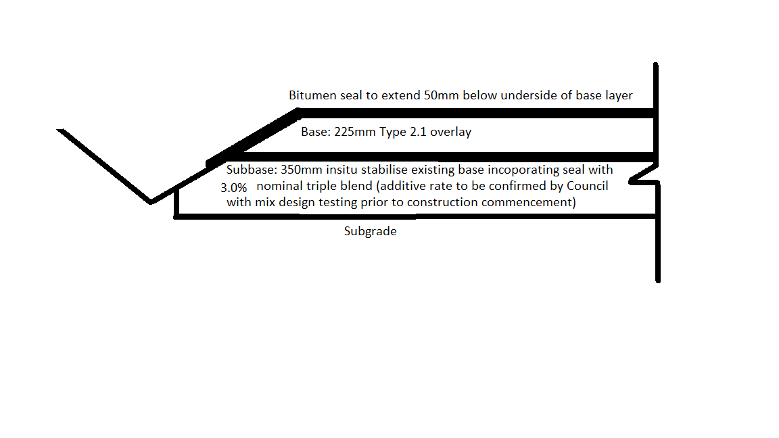

**Pavement Design Amendment**

The following is noted regarding the pavement design amendment.

* Subgrade stabilization will not be undertaken with excavation of existing base material.
* Pavement design is revised to in-situ stabilize existing pavement base material to a depth of 350mm with 3.0% triple blend nominal (Council to confirm triple blend additive rate via mix design testing), existing seal to be incorporated. This layer will form the subbase.
* Base layer to consist of a 225mm Type 2.1 overlay.
* Bitumen seal to extend 50mm below underside of base layer.
* Amended tender schedule ***‘Shepherdsons Road Rehabilitation 2024-2025 - Pricing Schedule - Version C - Appendix D’*** attached.