Question: Item 3.02 "Detailed excavation to meet required profile and remove spoil from site (Provisional Sum), has a quantity and unit of 538.2m3 respectively. Can you please confirm whether this item is a Provisional Quantity Item (as the quantity would suggest)? Or a Provisional Sum item (as the wording would suggest)?

Response: Provisional Quantity

Question: Item 5.11 "Supply and Install, Design Validation Soil Nails complete in accordance with Project Drawings. Including grouting, centralisers, nuts bearing washers, and other ancillary items" has a unit of 48. Can you please confirm whether the unit for this item should be m?

Response: Confirmed - Units should be m. Typo in BOQ now revised

Question: Item 5.12 "Acceptance Testing - Anchors". Can you please confirm whether the unit for this item should be each?

Response: Confirmed - Units should be each. Typo in BOQ now revised

Question: DWG #ARO0388-C03 shows a typical Soil Nail Detail being Dywidag High Strength GEW Plus Threadbar (min yield of 670kN), this however conflicts with the detail, which shows a self-drilling bit on the end, something that is not typical on this bar type.

Response: Previously answered - Self drilling anchors are not required. This was an error. It is expected that the drilling and installation of soil nails will be completed in two separate processes

Question: Details also show an HDPE Tube .6m embedded from the face, however on DWG #ARO0388-C05 under the Header 10. SOIL NAILS, note 9 states, “Soil Nails shall be double corrosion protected”. This conflicts with the detail as a DCP per Spec is usually shrouded in a HDPE pipe with heat shrink end cap and dual grout lines for inner and outer grouting

Response: The contractor is to allow for Standard corrosion protection (SCP) - per detail.

Question: The same detail shows ‘Washer Plate or Titan Angle Adapter Plate as required’. Are Council wanting a hollow bar instead for this item, given the detail and comments?

Response: The contractor is to allow for Washer plate - per detail. Hollow bars are not required

Question: Can you please confirm the type of bar required?

Response: Refer to previous response (inclusive of Item 9)

Question: Is HDPE sheathing is required full length, or for the 600mm at face?

Response: 600mm at face - per detail

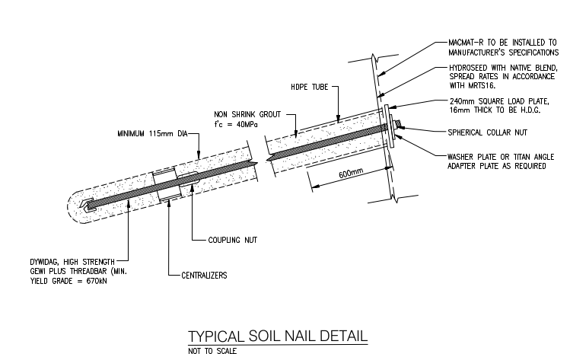

Question: Hole dia. to ensure that the HDPE and hole dia. are correct.

Response: min 115mm dia. hole - per detail

Question: Drawing No. ARO0388-C03 shows hidden lines indicating approximately 3m-long anchors in addition to the 12m anchors used for pinning the Macmat R. These shorter anchors are not clearly referenced in the BOQ, and no additional details have been provided. Could you please confirm whether these 3m anchors are included in the project scope?

Response: The lines shown depict the anchors required to hold down the MAC-MAT R. The Contractor is to allow for the following :

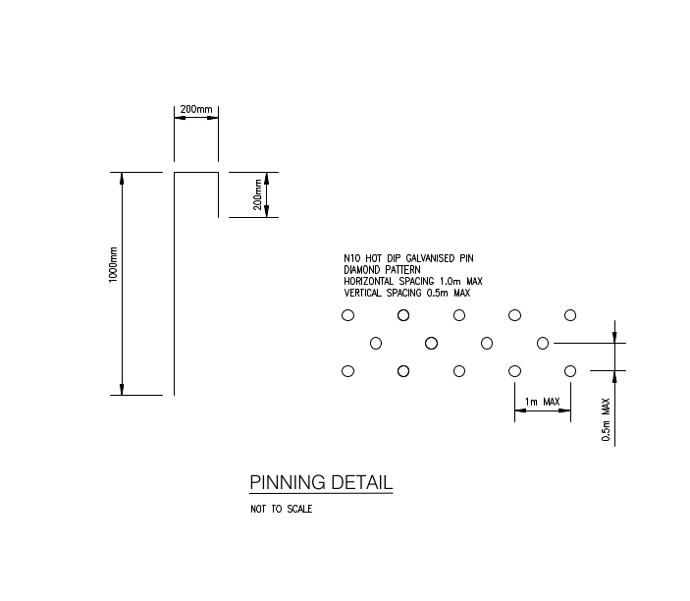

Question: We note that the standard length of Dywidag bars is 11.80 metres. Could the Council please advise whether this length meets the design requirements, or if couplers are needed to extend the bars to the full specified 12m length?

Response: 11.80m - is acceptable

Question: We have been advised by the supplier that 28mm diameter Gewi Plus bars are not available in the country. Would it be acceptable to substitute with an equivalent 32mm standard-grade Gewi bar in lieu of the specified threadbar?

Response: 32mm Standard Grade GEWI bar would be acceptable

Question: Please confirm the expected Practical Completion date requirements for these works?

Response: 31/10/2025

Question: Form of Security?

Response: Retention Moneys