ENVIRONMENTAL DESKTOP & SITE ASSESSMENT

Complete this form prior to developing an environmental management plan (EMP) and site-specific environmental induction for construction projects.
The form consists of two parts, Part 1 - Desktop environmental assessment, and Part 2 – On site environmental assessment. Replace writing in italics with your own text.
Be aware of the full scope of works. Clarify uncertainties before undertaking the assessment.
The aim of the assessment is to identify environmental aspects associated with a project and ensure legislative obligations are met. Mitigation measures are then incorporated into the EMP, and approvals gained if required.
Become familiar with Queensland Globe (Q Globe) identification layers before you start and use the Help Section and Tutorial Videos. Please contact an Environmental Sustainability Advisor (ESA) for further assistance.

Desktop environmental assessment
Project title / no. | Kellys Road – Flood Damage BanSC.0056
Desktop assessor(s) | Samantha O’Brien | Desktop assessment date | 20/03/2025

Scope of work
Description of works
Stabilise eroding banks of Don River, reestablish road pavement on Kellys Road approx CH 470-530

Associated documents
Design (to be updated when final design completed)

Location
Identify | Details | Source
Lot on plan | 10RN1393 | Queensland Geocoder  Q Globe ‘Search’, ‘Land parcels’ layer
Latitude and longitude | 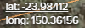 | Q Globe (bottom left of screen, relates to curser point)
Road name and Chainage | Kellys Road  Approx CH 470-530 | KIM
Land tenure/ easements/ reserve | Some works in Road parcel  Some works in Private parcel labelled as grazing/cropping and water channel | Q Globe ‘Land parcels’, ‘Land parcel tenure’, ‘Lease and reserve parcel’ layer

Water
Element/aspect | Details | Requirement/source
Watercourses and waterbodies inside and within 50m of the site boundary | Don River – Major Perennial | Q Globe ‘Watercourse’ and ‘Watercourse (defined by Water Act 2000)’
Removal of vegetation from, excavating or placing fill into a watercourse, lake or spring | Assume that all trees within project extents will be removed. | Department of Regional Development, Manufacturing and Water’s riverine protection permit requirements  Contact an ESA to check if project meets exemption requirements
Wetland trigger area | NA | Q Globe ‘Wetland protection area’, ‘Trigger area’  Contact an ESA if works within 200m of a wetland

Cultural heritage and native title
Task | Details | Requirement/source
Has cultural heritage and native title been considered as a part of this project | If yes, list reference and brief details  If no, provide reasoning why assessment was not undertaken | Follow cultural heritage and native title procedures and assessment

Sensitive receptors – dust, noise and vibration, light
Identify | Details | Requirement/source
Sensitive receptors for dust | Shed? approx 100m from site | Q Globe ‘Land use’
Sensitive receptors – sensitive land uses for noise and vibration | Shed? approx 100m from site. | Q Globe ‘Land use’
Sensitive receptors – critical facilities, infrastructure and utilities for noise and vibration | Telstra Assets recorded in the search area.  No Ergon assets in search area. | Check Before You Dig Australia (BYDA, previously called Dial Before You Dig) (registered infrastructure services/pipelines).  Identify services not shown on the BYDA e.g., some pipelines, fibre optics lines, water mains, sewers (some of these are on KIM).  Q Globe ‘Land parcels’ and ‘Petroleum pipeline licence centrelines (ppl)’

Contaminated land
Identify | Details | Source
Asbestos containing materials | Site is not in a water or sewer retic area. | Where the site is in a sewered and/or reticulated water area, check KIM for the presence of asbestos (AC) pipes and pits.
Contaminated Land Register (CLR) / Environmental Management Register (EMR) | Note if site is on the CLR/EMR and will interact with the notifiable activity/contaminated land | Contact an ESA to check if the site relates to the CLR/EMR.  Note that this information is confidential, and you will only be told relevant details needed for safe and environmentally sound operations.

Flora and fauna
Element | Details | Requirement/source
Regulated vegetation | Saved to file.  Category B  Category X | Department of Resources Vegetation map or property report (save to file).  Use the Vegetation Management Report if there is a lot on plan number (not road reserves) or use the Regulated Vegetation Management Map if only have coordinates (for roads).
Vegetation clearing / Exempt clearing | Exempt under Land Act 1994 | Department of Resources General guide to the vegetation management clearing codes and Exempt clearing work
Significant regional ecosystems / protected areas | Saved to file.  QGlobe - Category A or B containing of concern regional ecosystems | Environmental Reports online tool – Regional ecosystems report (save to file)
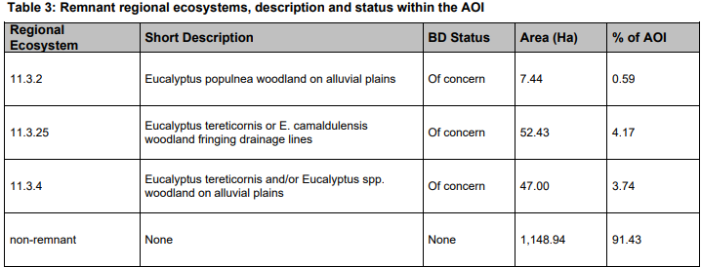
Protected plants and animals (EVNT list) | Saved to file.  Solanaceae Solanum dissectum - Endangered | Department of Environment and Science WildNet database – Request a species list for plants and animals, all native, specified point to a distance of 5 km.  A high-risk species management program may be required where special least concern, endangered, threatened or near threatened species/animal breeding places are on the list and identified during a site visit.  Consider if the project is significant enough to trigger federal referral under the Environmental Protection and Biodiversity Conservation Act 1999.
Protected plants trigger area | Saved to file.  Not in protected plants trigger area. | Department of Environment and Science Protected plants flora survey trigger map  Save copy of Protected Plants map (map valid for up to 12 months).  Contact an ESA if project is in a trigger area
Waterway barrier works | Don River – Major (Purple) | Q Globe ‘QLD waterways for waterway barrier works’  Department of Agriculture and Fisheries What is a waterway barrier work? and Accepted development requirements for operational work that is constructing or raising waterway barrier works (2018)  Permit notification or development application may be required

Biosecurity
Identify | Details | Source
Expected weed / pest species | No weeds recorded in the area of interest. | Environmental Reports online tool – Weed list report (save to file)  Review or print DAF fact sheets for Prohibited invasive plants and Restricted invasive plants for site visit

Sourcing of construction materials
Identify | Details | Requirement/source
Water take | Detail if water will be taken for the project from a natural source.  List which watercourse  Details of permit | Water sourcing will be conducted in accordance with the Department of Regional Development, Manufacturing and Water’s Exemption requirements for constructing authorities for the take of water without a water entitlement (OSW/2020/5467)
Quarry materials | Detail non-commercial sources of construction material i.e., borrow pits and quarries | The Forestry Quarry Management Plan (DES-EM-06-001) is to be followed where extraction is from an Endorsed Quarry Area under sales permits

Maps and plans
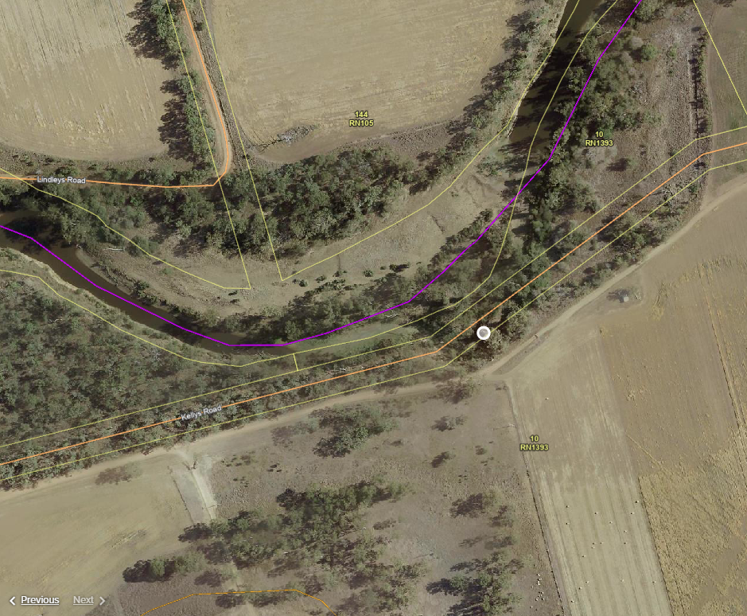

On site environmental assessment
Project title / no. | Kellys Road – Flood Damage BanSC.0056
Site assessor(s) | Jason Turner | Site visit date | 04.04.2025
Take photos of all elements (e.g., animal breeding places, invasive weeds, habitat trees, waste and erosion) for evidence and potential inclusion in the EMP. These issues are required for documentation and contract requirements.
Provide link to photos:

Flora and fauna
Identify | Details | Purpose/follow up
Animal breeding places | Detail any evidence of bowers, burrows, caves, hollows, or nests within project boundary | ESAs are to be consulted where works are likely to interact with actual or potential animal breeding place(s).  Suitably qualified and experienced person (licenced spotter/catcher) to be engaged if tampering with breeding places (damage, destroy, mark, move or dig up).  A high-risk species management program may be required where special least concern, endangered, threatened or near threatened species/animal breeding places are on the list and identified during a site visit. EMP update required.  Refer to the Animal Breeding Places and Species Management Program Procedure.
Habitat trees | Habitat trees identified as part of the site inspection are to be recorded | Discuss with project team to retain explore possibilities of modification to project to retain habitat trees.  Exclusion barriers (mesh) to be erected around vegetation that is to be retained. Vehicles are not to be parked under driplines of vegetation that is to be retained
Protected plants (EVNT) | Use the species list to determine if threatened plants are present | If threatened plants (EVNT classification) are present, a flora survey will be required as per Nature Conservation Act 1992 requirements. Contact an ESA for assistance.  Mapped high risk trigger areas will already require a flora survey and clearing permit.

Biosecurity
Identify | Details | Source, purpose/follow up
Evidence of prohibited or restricted weeds or pests | List found prohibited or restricted invasive plants, or pests | Contact Land Protection Officers for management advice prior to commencing works.

Erosion and sedimentation
Identify | Details | Source, purpose/follow up
Erosion areas | Note areas subject to erosion for both permanent and temporary erosion and sediment control.  Note if dispersive soils are present | Visual evidence of erosion/rills or potential problem areas  For erosion and sediment control considerations and site-specific ESCP  Discuss with ESA if severe erosion is present

Contamination and waste
Identify | Details | Source, purpose/follow up
Waste produced from the site | List any demolition waste or surplus material and expected (include approximate quantity) | Contact Waste Services for disposal advice  Discuss potential reuse of materials with Infrastructure Services

Suitable locations for stockpiles, parking, storage
Site set up
Identify suitable sites away from sensitive areas for ancillary activities.  Add to site map/diagram | Consider sites for:  - Stockpile sites  - Turnaround points  - Construction water  - Material sources  - Waste disposal  - Chemical and fuel storage  - Site office  - Parking locations  - Access and side tracks  - Borrow pits  - Concrete washout

Improvement opportunities
Environmental improvement opportunities at the site
(List any potential opportunities to improve the condition of the environment at the site/from the project or reduce the disturbance footprint)

